



# Authorship Declaration

Except where reference is made in the references, this report contains no material published elsewhere or extracted in whole or in part from a dissertation or report presented by me for another degree or diploma.

No other person’s work has been used without due acknowledgement in the content of the report.



|  |  |
| --- | --- |
| Signature: ______________ | Date: 29/7/2022 |

# ACKNOWLEDGEMENTS

With deepest gratitude, I am thankful to those who did their best to help and guide me through my Final Year Project.

First of all, I would like to express my deepest gratitude and appreciation to my first supervisor, Dr. Shayla Islam, for the advice and guidance she provided throughout the development of my project regarding the development of a web-based smart store management system for retail stores. In addition, I am also very grateful to my second marker Dr. Chloe Thong Chee Ling, who provided encouragement and guidance throughout the duration of my project. Without the assistance and guidance of my two project supervisors, I would not have successfully completed the goals of this project on time. With their supervision and support, I was able to overcome the obstacles I encountered while developing the entire project. I also learned several new things during the research process of the project, this includes project management and development which helped me to successfully complete my project.

For the institution I am studying at, UCSI University, where I continue to grow as a BSc (Hons) Computer Science student, and the institution's library for providing us with informative and useful resources and knowledge that play an important role in helping us complete this research.

In addition, I would like to thank my parents for their unconditional love and respect, for meeting all my financial and moral needs, for their never-fading advice, and for always being there for me. With their encouragement and support, I was able to cope with the stressful process, endure the hardships, regain my confidence and complete the goals of this project on time.

Finally, I would like to thank all my friends for their continued support and encouragement when I encountered difficulties in doing this research. I am grateful for their friendship as they are my companions with whom I can share my laughter and sorrow.

# ABSTRACT

With the continuous development of computer technology and network technology, more and more stores are gradually adopting information management in order to make store operations more efficient. The purpose of this project is to design and develop a web-based intelligent store management system application. The research method for this project is the literature review method, which summarizes several published journal papers and provides a view on the problems in the current system. In addition, a random questionnaire survey of 110 retail store managers or store owners from different countries or regions was conducted to determine the user requirements of the system to be developed. The SDLC model was used as the software development methodology for this project. The SDLC defines and outlines a detailed plan with various phases, each containing its own process and deliverables. A prototype of the system was generated for this project using IntelliJ IDEA Enterprise Edition, MySQL Community Server, and various design software. Once the system was developed, performance evaluation and user experience surveys were conducted to ensure the overall acceptance of the application. The system will help solve the operational management problems of traditional retail stores and help retail store managers improve the efficiency and performance of managing their stores.

Keywords:Store Management, SDLC Model, New Retail

# TABLE OF CONTENTS

CONSENT FORM 2

AUTHORSHIP DECLARATION 3

ACKNOWLEDGEMENTS 4

ABSTRACT 5

TABLE OF CONTENTS 6

CHAPTER 1: INTRODUCTION 10

1.0 Chapter Introduction 10

1.1 Project Title 10

1.2 Introduction 10

1.3 Background 11

1.4 Problem Statement 14

1.4.1 High operation and management costs of traditional retail stores 14

1.4.2 The limited amount of customers that can be reached in traditional offline retail stores 14

1.4.3 Traditional retail stores are difficult to aggregate merchandise statistics 14

1.4.4 Traditional retail stores are difficult to manage inventory 15

1.5 Aim 15

1.6 Objectives 15

1.7 Justification 16

1.8 Scope 17

1.8.1 Store Admin User 17

1.8.2 Customer User 18

1.8.3 Supplier User 19

1.9 Approach and Deliverables 19

1.9.1 Research Approaches 19

1.9.2 Development Process and Methodology 19

1.9.3 The Activities and deliverables for each phase of the SDLC 21

1.10 Major Milestone 23

1.10.1 Gantt Chart 24

1.10.2 Work Breakdown Structure (WBS) 25

1.11 Constraints and Assumptions 26

1.11.1 System Constraints 26

1.11.2 External Constraints 26

1.11.3 Assumptions 26

1.11.4 System Assumptions 26

1.12 Resources 26

1.12.1 Hardware 27

1.12.2 Software 27

1.13 Major Risk 30

1.14 External Bodies Involved 32

1.14.1 Supporting Sustainable Development Goals 32

1.14.2 Zhongke Zhuoxin Software Testing Technology Center 33

1.15 Project Plan 34

CHAPTER 2: INFORMATION GATHERING 36

2.0 Chapter Introduction 36

2.1 Literature Review 37

2.1.1 Existing research on store management applications and their value creation 37

2.1.2 The Impact of Internet Technology on Today's Retail Industry Pattern 38

2.1.3 The Limitations of the Traditional Retail Model 39

2.1.4 The Influence of Online and Offline Interaction Experience on Consumers' Purchase Intention in the Context of New Retail 39

2.1.5 Research on the Development Status and Trends of New Retail 40

2.2 Systematic Review 42

2.2.1 Existing Store Management Applications in the Current Market 42

2.2.2 Comparison on existing System 47

2.3 Proposed Web-based Store Management Application 49

2.4 Chapter Summary 50

CHAPTER 3: ANALYSIS 50

3.0 Chapter Introduction 50

3.1 Sample Size and Target Participants 51

3.2 The Analysis of Demographic Profile of Respondents 51

3.2.1 Age 51

3.2.2 Gender 52

3.2.3 Role 52

3.2.4 Educational Background 53

3.2.5 Country / Region 54

3.2.6 Monthly Income 54

3.3 The Analysis of Related Questions on people's Expectations and Perceptions of New Retail Business Models 55

3.3.1 Types of Retail Businesses Currently Operating 55

3.3.2 The Public's Perception of the New Retail Business Model 56

3.3.3 The Public's Perception of the Combined Online and Offline Shopping Model 57

3.3.4 The Views on the Advantages of a Combined Offline and Online Shopping Model Over Direct Online Shopping 58

3.3.5 The Views on the Advantages of Combining Offline and Online Shopping Models Over Shopping in Brick-And-Mortar Stores 59

3.3.6 The Survey on the Acceptance Level of New Business Models 60

3.3.7 The Future Consumption Model Preferred By the Public 61

3.3.8 The Opinion Survey on the Most Likely Future Problems of New Retail Business Models 62

3.3.9 The Views on the Future of the New Omnichannel Retail Model 63

3.4 The Scale Questionnaire Analysis on Issues Related to Retail Store Management System Requirements 64

3.4.1 Statement: “I believe that traditional retail store management relies too much on manual operation control, which is not only difficult to operate, but also inefficient” 64

3.4.2 Statement: “I believe that traditional retail stores rely too much on a single revenue method and have limited access to customers” 65

3.4.3 Statement: “I think the merchandise statistics of traditional retail stores are prone to miscalculation” 66

3.4.4 Statement: “I want tools that can help me improve the management efficiency and performance of my store” 67

3.4.5 Statement: “I want my store to be able to sell more of my products through online channels to adapt to the future market environment” 68

3.4.6 Statement: “I am not satisfied with the existing store management system on the market” 69

3.4.7 Statement: “I want the store management application to be able to manage the inventory information of the products and update the stock information of the products in real time” 70

3.4.8 Statement: “I want store management apps to help brick-and-mortar retailers reduce their retail operating costs” 71

3.4.9 Statement: “I think store management applications should help save store managers' work time” 72

3.4.10 Statement: “I think a good user interface will make it easier for store managers to manage their stores” 73

3.5 Chapter Summary 73

CHAPTER 4: SYNTHESIS 74

4.0 Chapter Introduction 74

4.1 Use Case Diagram 74

4.2 Activity Diagram 76

4.2.1 Query Order Information 77

4.2.2 Delete Order Information 78

4.2.3 Set up Goods Delivery 79

4.2.4 Warehousing Registration 80

4.2.5 Query Purchasing Information 82

4.2.6 Query Stock Information 83

4.2.7 Update Stock Information 85

4.2.8 Query Employee Information 87

4.2.9 Add Employee Information 88

4.2.10 Modify Employee Information 89

4.2.11 Delete Employee Information 91

4.3 Interface & Contents Design 92

4.3.1 Web Application Logo for Smart Shop Management System 92

4.3.2 The Layout of the Application Login Page 92

4.3.3 The Home Page of the Store Management System 93

4.3.4 The User Management Module: Staff Management 94

4.3.5 The User Management Module: Address Management 96

4.3.6 The User Management Module: Role Management 99

4.3.7 The Institutional Management Module: Department Management 101

4.3.8 The Institutional Management Module: Job Management 104

4.3.9 The Purchase Management Module: View Product Customer View 106

4.3.10 The Purchase Management Module: Order Management 107

4.3.11 The Inventory Management Module: Product Category Management 110

4.3.12 The Inventory Management Module: Inventory Product Listing Management 113

4.3.13 The Inventory Management Module: Supplier Resource Management 116

CHAPTER 5: EVALUATION 121

5.0 Chapter Introduction 121

5.1 System Testing & Test Cases 121

5.1.1 Test Case for Staff Management Interface 121

5.1.2 Test Case for Address Management Interface 125

5.1.3 Test Case for Role Management Interface 128

5.1.4 Test Case for Department Management Interface 131

5.1.5 Test Case for Job Management Interface 134

5.1.6 Test Case for Order Management Interface 136

5.1.7 Test Case for Product Category Management Interface 139

5.1.8 Test Case for Inventory Product Listing Management Interface 142

5.1.9 Test Case for Supplier Resource Management Interface 147

5.2 Performance Evaluation & User Experience Survey 152

5.2.1 Performance Expectancy Data Collection 152

5.2.2 Effort Expectancy Data Collection 156

5.2.3 Facilitating Conditions Data Collection 160

5.2.4 The Summary of The Survey Result 162

5.3 Chapter Summary 163

CHAPTER 6: CONCLUSION AND RECOMMENDATION 163

6.0 Chapter Introduction 163

6.1 Conclusion & Contributions 163

6.2 The Limitations of The Study 164

6.3 Future Works 165

6.4 Chapter Summary 166

REFERENCES 167

APPENDIX Ⅰ: 170

APPENDIX Ⅱ: 178

# CHAPTER 1: INTRODUCTION

## Chapter Introduction

The purpose of this chapter is to introduce the reader to the research topic. This chapter describes the project title (in Section 1.1), the introduction (in Section 1.2), the background of the project (in Section 1.3), the problem statement (in Section 1.4), the aim (in Section 1.5), the objectives (Section 1.6), the justification (in Section 1.7), the scope of the project (in Section 1.8) as well as the approach and deliverables (in Section 1.9). In addition, this chapter includes the major milestones (in Section 1.10), the constraints and assumptions (in Section 1.11), the resources required to develop the project (in Section 1.12), the major risks (in Section 1.13), the external bodies involved (in Section 1.14) and the project plan (in Section 1.15).

## Project Title

Development of a Web-Based Smart Store Management System for Retail Store

## Introduction

Today, our lives are more and more inseparable from the store, and the store has become a part of our life. Stores are now all over everyone's surroundings. It is a traditional retail business organization that is open 24 hours a day. It not only has the convenience of supply in alleys and small retail stores on the street, but also has the open-shelf sales method and chain management. It has developed very rapidly in the world, especially after using the chain operation method, it has become one of the most organized major formats in the retail industry. Some large chain retail store brands are of considerable magnitude and are well received by consumers like. Among them, there are many retails commercial enterprises operating convenience stores with huge market space and strong market competitiveness, such as 7-Eleven convenience store, Family Mart convenience store, etc. [1].

New retail can maximize the efficiency of the retail industry in the context of the whole society. It is a business model derived from the new era, based on the core of consumers and the form of retailing using data and information technology. In practice, new retail combines the OMO business model (Online-Merge-Offline), integrating offline E-Commerce, Shared E-commerce, and Mobile E-commerce into one, meeting the needs of business survival and development and consumer consumption in the context of the new era [2]. The physical access channel is thus optimized, and consumers can enjoy the consumption experience of online, mobile and offline channels, promoting communication between enterprises and users. When enterprises build this complete business platform, they can allocate their resources according to their own product and service characteristics, and develop marketing strategies that can maximize their effects, thus achieving the enhancement of corporate brand image and the expansion of product sales [3].

In this article, I will develop an intelligent store management system, which is based on the OMO business model and provides solutions for the management of retail enterprises, so that retail enterprises can effectively improve their ability to adapt to the online and offline retail business environment, and help retail Enterprises realize the integration of online and offline business of store and online store, including online store inventory management and online Web application mall, etc., connecting people, goods, and fields, and building a new retail closed loop for chain enterprises. These will be the main points of this article. Questions for research and exploration [2].

## Background

The retail industry has a long history of development. Products produced by any industry need to be delivered to consumers through retailing, such as agriculture, industry, etc. At this stage, the definition of retailing is not clearly defined. There are two mainstream definitions of retail industry, one is from the perspective of marketing, and the other where the U.S. Department of Commerce has given its own interpretation of the retail industry. They consider the industry in which businesses and individuals sell products they buy from distributors to consumers by means of marketing activities. This definition is often seen in the marketing literature, and the definition given by the U.S. Department of Commerce is that any entity responsible for selling only a small number of goods to the masses is retail trade. They only sell but do not produce, and even the services they provide take place in the process of selling goods. The retail trade industry exists in both brick-and-mortar and virtual store models. The retail trade industry is characterized by its direct communication transactions with consumers and the delivery of products and services to them compared to other industries. The number of sales in the retail industry is sporadic and frequent, and the average sales are low. To increase profit margins, the retail industry must control costs and can increase profitability by increasing the variety of products and improving the speed of product turnover. The retail industry faces customers with temporary purchase characteristics, which requires retailers to combine many factors to maximize the attraction of consumers, such as product display, store location, advertising, etc [3].

By studying the evolution process of the global retail industry, it can be found that: the goal of retail enterprises is to obtain more customer traffic, higher purchase rate and higher customer loyalty at lower cost, and loyalty can lead to higher customer unit price and repeat purchases Rate. People enter the Internet from brick-and-mortar stores, and from the Internet to the mobile Internet [4]. Only with corresponding changes can the business format obtain the most efficient customer traffic.

When the market is in a period when the supply is less than the demand and the communication and logistics infrastructure is not well developed, the retail industry aims to acquire customer traffic at low cost. At the end of the 19th century, productivity was not yet developed, and the retail consumption field pursued a production-driven demand model, because consumer demand grew faster than supply growth, consumers were the receivers of prices, and there were not many choices of goods, and manufacturers did not need to pay attention to consumers, to do too much research. The retail channel is in its infancy, and good retailers have a core principle—find a place where people gather to sell their products [5].

At the beginning of the 20th century, department stores gathered more people at a lower cost. In the process of urbanization, department stores became the places where the growing urban population gathered. Compared with mail order catalogs, the cost and time to obtain customer traffic were shorter, and the efficiency was greatly improved. Gradually replaced mail order catalogs [6]. The way to obtain consumers by mail-order catalogs is to send mail-order catalogs to consumers’ homes by horses. After consumers select them, they will bring back the consumer demand information. The turnaround time is longer and the transportation cost is also higher. Department stores, on the other hand, can gather a large number of people and obtain more timely information on consumer demand. The increase in demand for information on mail-order catalogs comes at the expense of increased horses, while the increase in foot traffic in a department store is within a range of almost zero marginal cost [7].

With the rapid development of network information technology, the emerging form of online retailing has appeared in people's lives, which not only brings convenience to people's lives, but also has a direct impact on the business activities of physical retailing. For example, in China in 2015, the total amount of e-commerce transactions reached 18.3 trillion yuan, a year-on-year increase of 36.5%, an increase of 5.1 percentage points, of which the online retail market transaction scale reached 3.8 trillion yuan, a year-on-year increase of 35.7%, accounting for the total retail sales of consumer goods. 12.7%, an increase of 2.1% over 2014. In the face of the impact of the online retail industry, the brick-and-mortar retail industry has entered a bottleneck period of development from the golden age of extensive growth. Its traditional single store operation and large-scale grid layout operation model urgently needs to be transformed. In 1999, due to the establishment of China's Alibaba, the online retail model continued to influence and change the shopping behavior of consumers, and won the favor of consumers. The company has established an online retail platform, settled in an e-commerce platform and other methods, and tried to conduct an online and offline business model of physical retail and online retail synergy [8].

Through the application of the Internet platform, it will promote the integration of online and offline, realize the innovative development of "Internet + circulation", optimize the allocation of resources, develop a new model of sharing, collaboration and experience economy, and stimulate the vitality of the physical retail industry. The physical retail industry has been developed to realize the combination of online and offline mode, which can integrate and utilize enterprise resources, improve the efficiency of the industrial chain structure, enhance the competitive advantage of enterprises, and meet the development and survival needs of enterprises in today's context. Due to the lack of relevant experience, the physical retail industry still has many problems in the development process, such as unreasonable allocation of resources and high costs [9]. Therefore, retail enterprises should have a full understanding of the online and offline retail environment and develop a reasonable marketing model on this basis, which is the main problem faced by the development of retail enterprises at present.

## Problem Statement

### High operation and management costs of traditional retail stores

In the rapid growth of the Internet retail channel today, the speed of the update of goods, and in traditional retail stores, the shelves and shelves of goods, as well as various data reports of the record query through manual statistics are very time-consuming, which makes the store's operation and management costs are high. In addition, the store itself has high comprehensive operating costs, such as employment, management, resources and other issues, and can only carry out high-cost investment and compressed earnings [5]. Therefore, the solution I provide is to make the store operation more efficient by developing a combined online and offline store management system to accomplish the simplest and most effective store management, thus helping traditional retail stores to increase profits and reduce retail operation costs.

### The limited amount of customers that can be reached in traditional offline retail stores

Nowadays, due to the development of the new coronavirus epidemic, more and more people have changed their shopping habits. Changing the original offline activity shopping to online shopping. In traditional retail stores, consumers can only buy the goods that exist in the store at a defined time and place. This leaves traditional offline retail stores with a limited amount of customers to reach [10]. Therefore, the solution I provide is to develop store delivery, express delivery and other functions through the system, so that stores allow consumers to shop at any time, any place, in any way, which is more convenient than traditional retail stores, which not only gives consumers great convenience, but also helps offline retail sellers to increase sales and profits.

### Traditional retail stores are difficult to aggregate merchandise statistics

For traditional retail stores, since most of their operations are labor-based and the purchase volume of goods is large, calculation errors are prone to occur in commodity statistics [11]. The problem is because traditional calculation methods do not have excellent statistical aggregation capabilities [12]. Therefore, the solution I provide is to develop the function of online real-time entry and update of inventory information through the system, which can make it easier for merchants to manage the store and operate more easily, which is important for improving the management efficiency of the store.

### Traditional retail stores are difficult to manage inventory

Retail stores generally invest more in the inventory of goods, which also generates a lot of inventory management costs and a lot of working capital. The traditional inventory management model is often fragmented goods management, information resources can not be shared, the general management of goods is difficult to implement, the need for high inventory funds, the search for goods need to waste a long time [12]. Therefore, I provide a solution to develop a system to transfer, replenishment, return, inventory functions, strict control of each link to prevent unexpected inventory situations. This also makes it easier for merchants to manage store inventory and gives them a clearer picture of the store's condition.

## Aim

The aim of this project is to design and develop a web-based smart store management system application. With the help of this application, it helps retail store managers to improve management efficiency and performance.

## Objectives

1. To study the current existing store management system and determine the strengths and weaknesses of the current system.

2. To develop a web-based smart store management system application:

1. To design a store management system that combines online and offline to solve the high operating cost of retail stores.
2. To develop store distribution, express distribution, and other functions for retail stores to solve the limited number of customers in offline retail stores.
3. To develop the function of online real-time entry and update of inventory information for the system to solve the statistical problem of commodity information in traditional retail stores.
4. To develop functions for the system to purchase, return and exchange goods from suppliers, solving the procurement management problems of traditional retail stores.
5. To evaluate the performance of the developed web-based smart store management system.

## Justification

The aim of this project is to design and develop a web based intelligent store management system application with the help of which to help retail store managers to improve their management efficiency and performance and solve the problem mentioned in the problem statement section. After observing and comparing the existing systems IQmetrix, Springboard, Retail Pro, ChainDrive, reviewing the articles of various researches under related topics, namely Jyothi, G. and Navya, K., 2017 [13]，Wei, F. and Zhang, Q., 2018 [14]，Rahim, M. A., & Ara, R. 2019 [15], I feel that there are many aspects that are closely related to my project idea. These existing systems help retail teams manage and control all aspects of their business to serve their customers faster and more efficiently than ever before, thus creating the most exceptional experience for the end user.

These research articles also identified a significant contribution to my research by summarizing the problems and limitations in the existing systems in order to get some ideas in this context that will be used to develop new projects and determine the current state of the systems that will be developed in this research [16].

In addition, going to design an integrated online and offline store management system and solving the existing retail store inventory management difficulties are the biggest reasons that attracted my attention to this topic the most, by introducing these features, I believe it will bring more convenience and good experience for the retail team. Make it easier for merchants to manage store inventory and get a clearer picture of the store's status.

By developing this project, it will allow me to apply the knowledge and skills I learned in my lectures to my future work. It will improve my professional skills and boost my self-confidence. Therefore, as this Final Year Project develops, it provides a new experience for me to gain more knowledge.

## Scope

The scope of the project focuses on helping retailers and retail store managers improve the management efficiency and performance of their retail stores, thereby developing a web-based store management system. This application will work in Malaysia. There will be three users in the store management system, namely store admin user, customer user, and supplier user. Among them, the store admin user and the customer user are the main users of the system. All users must first log in to the system to operate the store.

### Store Admin User

For store admin users, its permissions include order management, purchase management, inventory management, and user information management.

#### Order Management

For order management, its functions include the following:

1. **Query Order Information**

Store admin can query the order information submitted by customers.

1. **Edit Order Information**

The store admin can modify the order information according to the actual situation of the current order.

1. **Set up Goods Delivery**

If a customer buys a product online, after the store has an order submitted by the customer in the system, the store admin can arrange the delivery of the product.

#### Purchase Management

For purchase management, its functions include the following:

1. **Automatic Warehousing Registration**

Store admin can register purchased items.

1. **Inquire Purchasing Information**

Store admin can query the purchase information of products.

#### Inventory Management

For inventory management, its functions include the following:

1. **Query Inventory Information**

Store admin can query product inventory information

1. **Update Inventory Information**

Store admin can modify the information of in-stock items

#### User Information Management

For user information management, its functions include the following:

1. **Modify User Information**

The store admin= can modify the user's information, it can be the user's type, the user's permissions, etc.

1. **Query User Information**

Store admin can query the information of existing users

1. **Add User Information**

Store admin can enter information for new users

1. **Delete User Information**

Store admin can delete an existing user's information

### Customer User

For customer users, its permissions include the following:

1. **View Items**

Customers can view the products through the system's product list, which includes the corresponding thumbnails, prices and numerous attributes of each product.

1. **Add To Cart**

Customers can add multiple items to the shopping cart at the same time and buy in bulk at one time

1. **Set Delivery Location**

If the customer buys the product online, he needs to set the mailing address of the product, so that the merchant can arrange the delivery of the product

1. **Make Payment**

After the customer submits the order, they need to pay for the order

### Supplier User

For suppliers, it may supply the goods directly to retailers. In addition, retailers may return merchandise purchased from suppliers in the event of a return or exchange.

## Approach and Deliverables

### Research Approaches

#### Literature Review

In this research, several published journal papers, books, etc. will be studied through Literature Review to get some ideas in this context and then summarize the problems and limitations in the current system [17].

#### Online Survey

In this study, a random questionnaire survey will be used. The sample will include retail store managers or store owners and store customers in each region of Kuala Lumpur to collect a large amount of information such as personal perceptions of store owners on the management of existing business management, analysis of user satisfaction, etc. to determine the current status of the application or system to be developed. 110 respondents were invited to fill in the questionnaire and the results were analyzed and summarized. For accurate survey results, some abnormal data will be removed from it, which may affect the accuracy of the results. In addition, the survey will also be published on social media platforms such as Facebook, twitter, etc., and the questionnaire will be distributed, and data analyzed through google forms.

### Development Process and Methodology

This research will use the SDLC (Software Development Life Cycle) waterfall model as a software development methodology. The Software Development Life Cycle (SDLC) is a structured process that helps developers quickly produce quality software that is properly tested and ready for use [18]. The SDLC defines and outlines a detailed plan of phases, each containing its own process and deliverables. Adherence to the SDLC increases development speed and minimizes project risks and costs associated with alternative production methods. The SDLC model is a linear sequence model, which consists of six main stages, namely Requirements Analysis, System Design, Implementation, Testing, Deployment, Maintenance [19].

The SDLC waterfall model was chosen because SDLC allows developers to analyze requirements and helps developers to produce the highest quality software product in the shortest possible time and at the lowest possible cost [20]. SDLC is suitable for time-critical projects, and the following are the main phases of the selected SDLC waterfall model and the sequence shown in Figure 1.1.

Figure 1.1 - Main Phases of Software Development Life Cycle Model

#### Requirement Analysis

This phase focuses on what the system needs. We need to collect all system requirements from the target customer through discussions and write them in a requirements specification document. This document is the basis of the project and must include the purpose of the system, a brief description and the specific requirements identified [21].

#### System Design

System design is the process of defining the system architecture, components, modules, interfaces, and data using the requirements specification document, which describes how the system functionality is implemented [22].

#### Implementation

In this phase, the system design is used to develop the system, which is first developed in small programs called units, where programmers begin to develop the system by writing code in a programming language [23].

#### Testing

Each completed program code needs testing methods to avoid any errors in the application. At this stage, we need to run the system and check if it gives the results we want to determine if the project's goals match the system's requirements [24].

#### Deployment

When testing is complete, the product is deployed in the customer environment or released to the market. However, there are many organizations that choose to move the product through a different deployment environment, such as a test or interim environment. This allows any stakeholder to safely use the product before it is released to the market. In addition, this allows any eventual errors to be caught before the product is released [25].

#### Maintenance

Maintenance is the backbone of successful system development. During the development of the system, modifications are made from time to time in order to keep the system up to date with changes in the environment and user requirements [26].

### The Activities and deliverables for each phase of the SDLC

Table 1.1 - Phase, Activities and Deliverables

|  |  |  |
| --- | --- | --- |
| Phase | Activities | Deliverables |
| Requirements Analysis | - Conduct a Literature Review to examine existing journal articles and summarize the problems and limitations of the current system.  - Conduct an online questionnaire to collect a large amount of information and analyze and summarize the results of the questionnaire to determine the current status of the application or system to be developed.  - Analyze the summary of the literature review and survey results to determine the final system requirements | System requirement  Specification (SRS) |
| System Design | System Design,  System User Interface Design,  Database Design | Use Case Diagram  Activity diagram  Sequence Diagram  System Prototype  Entity Relationship Diagram |
| Implementation | Development of systems using system design | Application |
| Testing | Conduct Unit Testing, System Integration Testing, and Quality Assurance Testing | Test Cases,  User Acceptance Testing |
| Deployment | Deploy systems in customer environments or to market | Deployment Guidelines |
| Maintenance | Maintain and update the system to keep it up to date with changes in the environment and user requirements | System Maintenance Checklist |

## Major Milestone

Table 1.2 - Project Major Milestones

|  |  |  |
| --- | --- | --- |
| **No** | **Milestone/Task** | **Date** |
| **1.** | Initiation Completed | 21/1/22 |
| **2.** | Submission of Proposal First Draft | 12/2/22 |
| **3.** | Planning Completed & Proposal Submission | 18/2/22 |
| **4.** | Proposal Presentation | 21/2/22 |
| **5.** | Analysis Completed | 22/3/22 |
| **6.** | Submission of Phase 1 Draft Report | 8/4/22 |
| **7.** | Design Completed | 3/5/22 |
| **8.** | Implementation Completed | 21/6/22 |
| **9.** | Presenting the prototype of the application to supervisor | 24/6/22 |
| **10.** | Testing Completed | 11/7/22 |
| **11.** | Deploy Completed | 15/7/22 |
| **12.** | Monitoring and Controlling Completed | 20/7/22 |
| **13.** | Project Completed & Submission of Phase 2 Draft Report | 22/7/22 |
| **14.** | Final Report Submission | 29/7/22 |
| **15.** | Project Viva session | 1/8/22 |

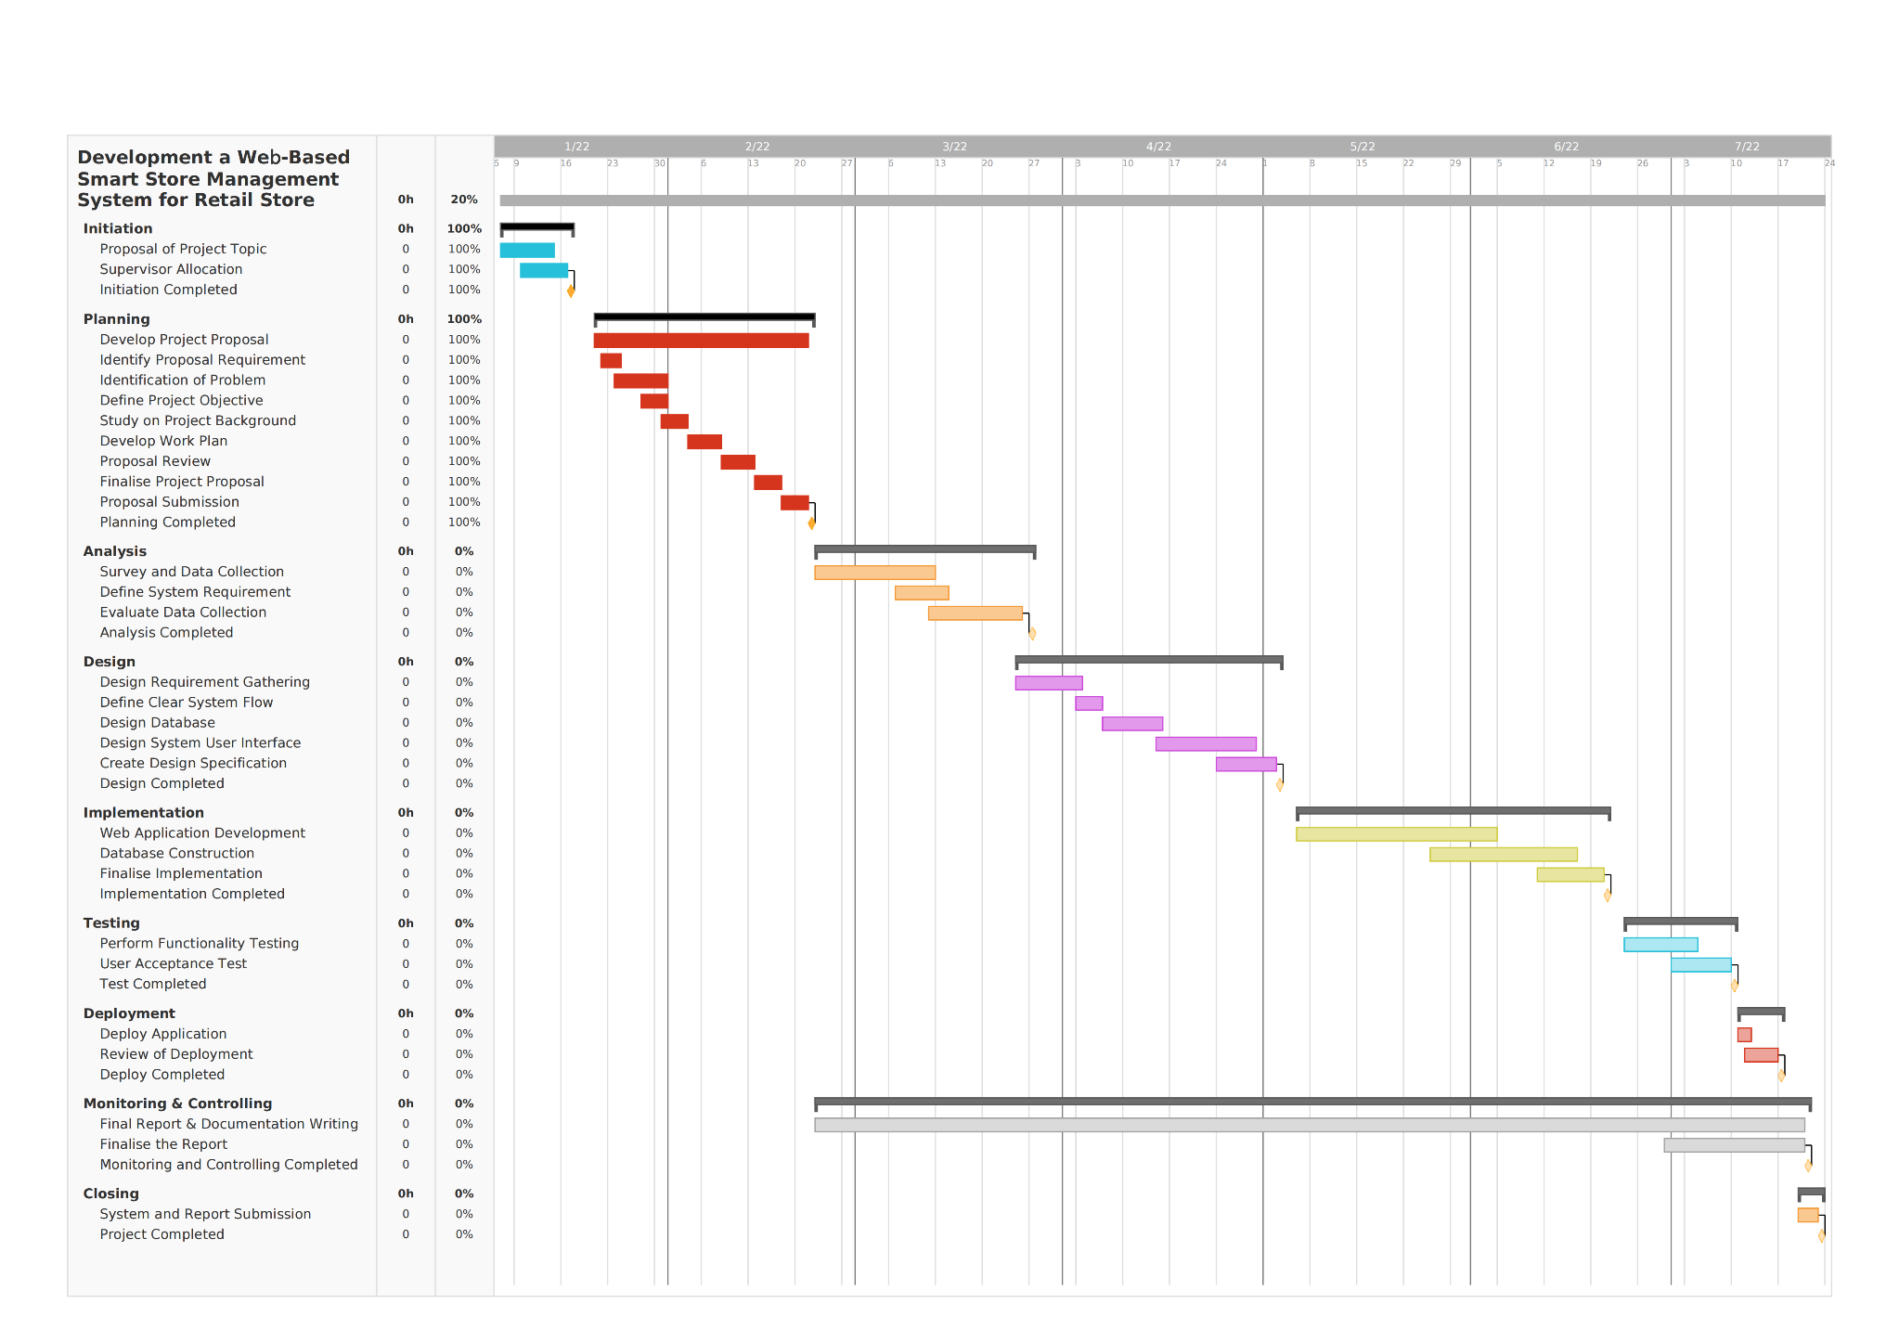

Figure 1.2 - Gantt Chart for Smart Store Management System

### Gantt Chart



### Gantt Chart

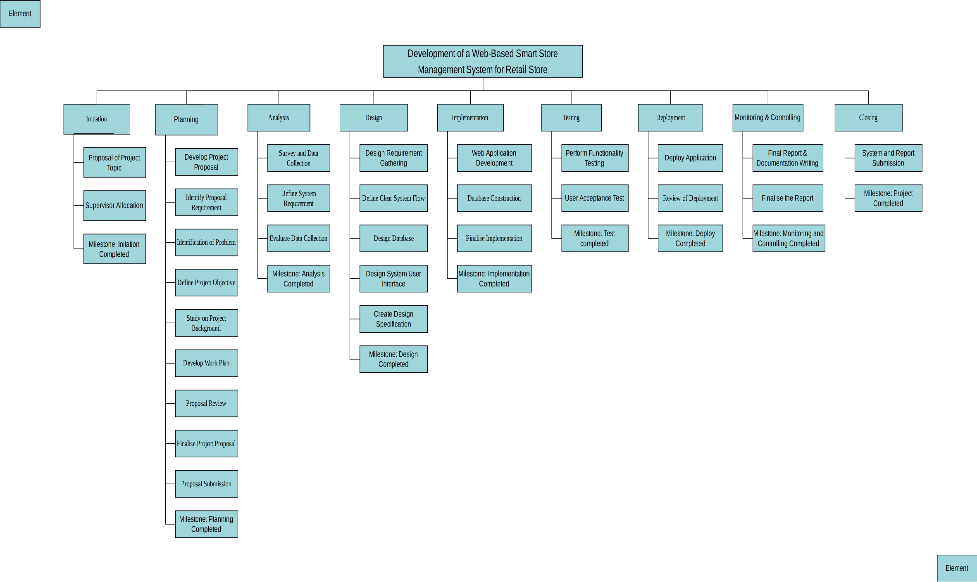

Figure 1.3 - Work Breakdown Structure for Smart Store Management System

### Work Breakdown Structure (WBS)

## Constraints and Assumptions

Any proposed system must have an obstacle and a constraint preventing it from being implemented, and the development of this system has some constraints. The following are some constraints and assumptions regarding the development of this project.

### System Constraints

* The system may not support multiple languages and multi-currency interface.
* The system's user account passwords may not be encrypted using any complex algorithms.
* The developed application requires a client device to connect to the Internet for access, and a browser application with the ability to receive data from the server.

### External Constraints

* Due to cost constraints, the project will not be developed on any high specification physical server and the developed web application will only use a regular PC as the base server for the application.
* The articles used in this study may not be in the best journal indexation status.

### Assumptions

* The working hours of this project are 09:00-18:00.
* Some tasks in the project may be worked on non-working days (weekends, holidays).
* The cost of resources such as equipment and software will be provided for the development of the project.

### System Assumptions

* The system will work properly.
* With the system, it will make the store management operation more efficient.

## Resources

This research and work were done using tools to support the implementation of this project, which required prototyping and documentation of the proposed application, as listed below.

### Hardware

The hardware used in the development of this project is 1 laptop with specifications:

Processor: Intel Core i7-11800H @ 2.30GHz

Graphics: NVIDIA GeForce RTX 3070 Laptop GPU

Memory: 16GB

Hard Disk: 1TB

### Software

The software used in this project are as follows:

**1) Windows 10 (64-bit operating system)**



Windows 10 is a cross-platform operating system released by Microsoft, which is applied to computers and used in the project for system development and runtime environment support.

**2) Microsoft Word 2021**



Microsoft Word was used as a word processor for writing project reports and research results in this project.

**3) Microsoft Project 2021**



Microsoft Project is a powerful and flexible project management tool that can be used to develop project plans, track and manage projects, control project progress, and more. In this project it is used to generate the project plan.

**4) Google Chrome**



Chrome is a web browser developed by Google. It is an application program for retrieving and displaying information resources on the World Wide Web, which can be web pages, pictures, videos or other content. In this project, browsers are used to search relevant journals and research, as well as tools for web page authoring and debugging.

**5) Visual Paradigm**



Visual Paradigm is a software application designed for software development to model business information systems and manage development processes. In this project, Visual Paradigm is used as a tool for drawing UML diagrams, WBS diagrams, ERD diagrams, etc.

**6) MySQL Community Server 8.0.28**



MySQL Community Server is a widely used open source relational database and the primary relational data store used by many common websites, applications, and commercial products. In this project MySQL is used as a database for storing store admin and item details.

**7) IntelliJ IDEA Enterprise Edition**



IntelliJ IDEA is a Java integrated development environment tool software developed by JetBrains software company. It provides the community version of Apache 2.0 open license and the enterprise version of proprietary software. Since the community edition does not support configuring web servers, the version I use in this project is the enterprise version, which is the main tool for the development of this project.

**8) Apache Tomcat 9.0.58**



Apache Tomcat server is a free and open-source Web application server, which is a lightweight application server. It is commonly used in small and medium-sized systems and occasions where there are not many concurrent users. It is used in this project to develop and debug JSP programs.

**9) Git 2.35.1**



Git is a free and open source distributed version control system. It is used to track changes in any set of files. In this project, it is used as a repository to store management code. It is used to track the code of different versions of the system, in order to check the system with specific version revisions in the future.

## Major Risk

Risks are issues that may or may not arise during our project management process. Although there is no way to control the potential risks of a project, considering them in advance can make the project safer and more secure, and it can have a positive or negative impact on the project [27].

There are also many possible major risks in this project, which are mainly in terms of time, cost, project scope, etc. Due to the lack of effective planning for the estimated implementation time and cost of the project, it means that the actual completion of the project may not be able to achieve expected, or there may be inaccurate estimates of the project cost, the following table shows the risks that need to be identified in developing this project.

Table 1.3 - Major Risk

|  |  |
| --- | --- |
| **Phase of the Project Life Cycle** | **Possible Risk Factors** |
| All phases | This phase encompasses all phases of the project lifecycle, and the risks to be identified during this phase are:  1. Insufficient time cycle in some phases of the project.  2. The project may not include all information.  3. The transition between each SDLC phase may not occur according to the project plan. |
| Plan | This phase is the project planning phase, which involves the planning of project development time and development cost, as well as validation and risk mitigation, etc. The risks to be identified in this phase are:  1. Unwritten information and plans.  2. Inadequate cost-benefit analysis.  3. Lack of knowledge of resource availability.  4. Inadequate system risk analysis.  5. Lack of documentation. |
| Defining | This phase is the stage of defining the system, which involves the requirements and scope documents related to system development, and the risks to be identified in this phase are:  1. non-written form of the plan.  2. Lack of planning documentation for the scope of the system development.  3. Incomplete execution of the plan. |
| Start | This is the start phase of the project, where the risks to be identified are:  1. Lack of relevant information to maintain the system.  2. The terms are being changed. |
| Carrying out | This is the stage where the project executes and the risks to be identified in this stage are:  1. Changes in customer needs and market conditions.  2. Incomplete or incorrect information related to the implementation plan.  3. change management without consistent analysis of the consequences that may affect the entire project.  4. Lack of reliable project progress reports.  5. Software and equipment failures.  6. Academic boundaries |
| End | This is the end phase of the project, where the risks to be identified are:  1. The final product may not be completed according to the expected schedule.  2. The final product may not meet the user's needs or achieve the expected results. |

## External Bodies Involved

### Supporting Sustainable Development Goals

Supporting Sustainable Development Goals (SDG) is a joint development agreement aimed at encouraging social, economic, and environmental development. It is announced by the United Nations (UN) on September 27, 2015, which is the present and future people and the world environment. Safety and prosperity provide a common action framework. There are 17 sustainable development goals (SDGs), all countries need to take action in the global partnership including developed countries and developing countries. The goals namely (1) No Poverty; (2) No Hunger; (3) Healthy and Rich Life; (4) Quality Education; (5) Gender Equality; (6) Clean Water and Appropriate Sanitation; (7) Cleaning and Affordable Energy; (8) Decent Labor and Economic Growth; (9) Industrial, Innovation and Infrastructure; (10) Reduce Gap; (11) Sustainable City and Settlement; (12) Responsible Consumption and Production; (13) Climate Change Management; (14) Marine Ecosystem; (15) Land Ecosystem; (16) Peace, Justice and Powerful Institutions; (17) Great Partnership [28].

This project provides store consumers with a more convenient and quick way to shop online, which gives consumers another option for shopping, buying goods through the browser of their own devices, which is more efficient than traditional offline shopping. It is convenient and brings a healthy and prosperous life to the majority of working people and improves the people's well-being. In addition, this web-based smart store management system application also helps retail store managers to improve management efficiency, it can also greatly reduce the workload of retail management practitioners, improve productivity, and reduce stress, and improve employee well-being. These are in line with the third goal of the Sustainable Development Goals, living healthy and prosperous lives, promoting well-being for all at all ages.



Figure 1.4 - Sustainable Development Goals

### Zhongke Zhuoxin Software Testing Technology Center

China Beijing Zhongke Zhuoxin Software Testing Technology Center was established on December 24, 2010. It is a national research institution directly under the Ministry of Industry and Information Technology. The company's business scope includes: software product testing, technology development, technical testing, technical consulting, computer system services, etc. In the field of testing, China Science and Technology Zhuoxin Assessment has obtained the qualification of laboratory accreditation from China National Accreditation Committee for Laboratories and has so far completed the testing of more than 10,000 software and hardware products and thousands of information system engineering projects, it is an authoritative software and hardware product and information system testing laboratory in China. In the field of testing, the unit has also formulated the index system for government website performance evaluation and carried out the performance evaluation of Chinese government websites for many years [29].



Figure 1.5 - Company Logo

In the testing phase of the system development life cycle, when the development of the smart store management system project is completed, it will cooperate with Zhongke Zhuoxin Software Testing Technology Center, which will run the system to conduct comprehensive user acceptance testing UAT, Quality Assurance Testing (QAT) to verify whether the project's objectives meet the requirements, and issue user acceptance testing reports, quality assurance testing reports, etc. to provide a basis for system acceptance. This allows any eventual bugs to be caught before the application is deployed, by making changes to the system to make it finally fit the environment and user requirements.

In addition, when testing is complete, the product will be deployed in partnership with new offline retail stores.

## Project Plan

Table 1.4 – Project Plan

|  |  |  |  |
| --- | --- | --- | --- |
| **Phase and Task Name** | **Duration** | **Start Date** | **Finish Date** |
| **Development of a Web-Based Smart Store Management System for Retail Store** | **202 days** | **Fri 7/1/22** | **Fri 28/7/22** |
| **Initiation** | **11 days** | **Fri 7/1/22** | **Fri 21/1/22** |
| Proposal of Project Topic | 4 days | Fri 7/1/22 | Tue 10/1/22 |
| Supervisor Allocation | 1 day | Tue 10/1/22 | Tue 10/1/22 |
| Initiation Completed | 0 day | Fri 21/1/22 | Fri 21/1/22 |
| **Planning** | **28 days** | **Fri 21/1/22** | **Tue 18/2/22** |
| Develop Project Proposal | 28 days | Fri 21/1/22 | Tue 18/2/22 |
| Identify Proposal Requirement | 2 days | Sat 22/1/22 | Sun 23/1/22 |
| Identification of Problem | 4 days | Sat 22/1/22 | Tue 25/1/22 |
| Define Project Objective | 4 days | Sat 22/1/22 | Tue 25/1/22 |
| Study on Project Background | 5 days | Fri 28/1/22 | Tue 1/2/22 |
| Develop Work Plan | 5 days | Fri 4/2/22 | Tue 8/2/22 |
| Proposal Review | 2 days | Sat 12/2/22 | Sat 13/2/22 |
| Finalise Project Proposal | 6 days | Sun 13/2/22 | Fri 18/2/22 |
| Proposal Submission | 1 day | Fri 18/2/22 | Fri 18/2/22 |
| Planning Completed | 0 day | Fri 18/2/22 | Fri 18/2/22 |
| **Analysis** | **30 days** | **Fri 22/2/22** | **Tue 22/3/22** |
| Survey and Data Collection | 14 days | Fri 25/2/22 | Tue 8/3/22 |
| Define System Requirement | 5 days | Mon 7/3/22 | Fri 11/3/22 |
| Evaluate Data Collection | 15 days | Tue 8/3/22 | Tue 22/3/22 |
| Analysis Completed | 0 day | Tue 22/3/22 | Tue 22/3/22 |
| **Design** | **39 days** | **Fri 25/3/22** | **Tue 3/5/22** |
| Design Requirement Gathering | 7 days | Fri 25/3/22 | Fri 1/4/22 |
| Define Clear System Flow | 4 days | Sat 2/4/22 | Wed 6/4/22 |
| Design Database | 7 days | Thu 7/4/22 | Thu 14/4/22 |
| Design System User Interface | 12 days | Fri 15/4/22 | Tue 26/4/22 |
| Create Design Specification | 7 days | Wed 27/4/22 | Tue 3/5/22 |
| Design Completed | 0 day | Tue 3/5/22 | Tue 3/5/22 |
| **Implementation** | **45 days** | **Fri 6/5/22** | **Tue 21/6/22** |
| Web Application Development | 20 days | Fri 6/5/22 | Thu 26/5/22 |
| Database Construction | 18 days | Thu 26/5/22 | Mon 13/6/22 |
| Finalize Implementation | 7 days | Tue 14/6/22 | Tue 21/6/22 |
| Implementation Completed | 0 day | Tue 21/6/22 | Tue 21/6/22 |
| **Testing** | **17 days** | **Fri 24/6/22** | **Mon 11/7/22** |
| Perform functionality testing | 7 days | Fri 24/6/22 | Fri 1/7/22 |
| User Acceptance Test | 10 days | Fri 1/7/22 | Mon 11/7/22 |
| Testing Completed | 0 day | Mon 11/7/22 | Mon 11/7/22 |
| **Deployment** | **5 days** | **Mon 11/7/22** | **Thu 15/7/22** |
| Deploy Application | 1 day | Mon 11/7/22 | Mon 11/7/22 |
| Review of Deployment | 5 days | Mon 11/7/22 | Fri 15/7/22 |
| Deploy Completed | 0 day | Fir 15/7/22 | Fri 15/7/22 |
| **Monitoring & Controlling** | **150 days** | **Sun 22/2/22** | **Mon 20/7/22** |
| Final Report & Documentation Writing | 138 days | Sun 20/2/22 | Fri 10/7/22 |
| Finalize the Report | 12 days | Fri 10/7/22 | Mon 20/7/22 |
| Monitoring and Controlling Completed | 0 days | Mon 20/7/22 | Mon 20/7/22 |
| **Closing** | **1 day** | **Tue 21/7/22** | **Tue 22/7/22** |
| System and Report Submission | 1 day | Fri 21/7/22 | Fri 22/7/22 |
| Project Completed | 0 day | Fri 22/7/22 | Fri 22/7/22 |

# CHAPTER 2: INFORMATION GATHERING

## Chapter Introduction

The purpose of this chapter is to introduce the reader to the information gathering for the work related to this research topic, for the literature survey of the work related to this research topic (in section 2.1), which focuses on five aspects, The Existing research on store management applications and their value creation (in section 2.1.1) The Impact of Internet Technology on Today's Retail Industry Pattern (in section 2.1.2), The Limitations of the Traditional Retail Model (in Section 2.1.3), The Influence of Online and Offline Interaction Experience on Consumers' Purchase Intention in the Context of New Retail (in Section 2.1.4), and The Research on the Development Status and Trends of New Retail (in Section 2.1.5), and then in the Systematic Review Section (in Section 2.2), we select four popular store management applications currently available in the market for discussion, and then we present and discuss the features of the Proposed System (in Section 2.3), and finally conclude with a summary of this chapter (in Section 2.4)

## Literature Review

A general summary of the existing scientific research results on a given topic is called a literature review. This method refers to the investigation of specific scientific research papers, materials and other articles, which summarizes the existing theories and can be used to guide subsequent research work at the theoretical level. After investigating the information on this topic, find the concepts, methods and differences in the current results, and then summarize the defects and deficiencies under the existing system [17]。

### Existing research on store management applications and their value creation

There are many researches on store management strategies, and it covers a wide range of academic results, including academic works, journal papers, and so on, which include not only the research on online and offline combined brick-and-mortar store management strategies, but also the research on web server-based store management solutions from the perspective of new retail.

G Divya Jyothi, K Navya from Department of Computer Science and Engineering, MLR Institute of Technology, Hyderabad, Telangana. The system proposed by the author is a Store Management System Web Application developed based on a web server. In order to overcome the problem of out-of-stock in stores, the author proposes Store management framework. The store management framework is very beneficial to both the customer's shopping background and the knowledge provided by the retailer. Store management framework means that inventory can be authorized and replenished by store administrators in case of stock shortage [13].

Fan Wei and Qian Zhang of Xi'an Shiyou University, China, designed the system for the online store. The system is developed on the Web side, using JSP language, Spring framework, and B/S Model to integrate the system to complete the control layer management, including processing data access, etc. The author describes in detail how the system will implement these functions, how to design the relationship between various entities, the attributes of each table and the relationship between them. And a detailed database design is carried out. The visual modeling tool of the system is composed of use case diagram diagrams, which are created using the Unfiled Modeling Language [14].

Md. Abdur Rahim and Rafat Ara from Department of Computer Science & Engineering, German University Bangladesh, Bangladesh. They propose implementing point-of-sale software, which is widely used in retail operations. The app generates all necessary reports for buying and selling, reducing human errors and paperwork. The software is designed using an incremental model, developed using technologies such as HTML, CSS, JavaScript, Ajax and PHP, and MySQL server is used as the database to store data. Authorized users can use the app anywhere in the world, and business owners can also monitor their business from home. The system was trialed at Farhan Traders (Bangladesh mobile showroom) and researchers provided positive feedback on the software. In the research, the author uses Unfiled Modeling Language to construct the visual modeling of the system, and uses the activity diagram to construct the basic architecture of the system [15].

### The Impact of Internet Technology on Today's Retail Industry Pattern

In the new era of the Internet landscape, the integration of online and offline interactions is both a new way to drive innovation in consumption and business models and a new trend in the industry. An analysis by Steve Burt and Leigh Sparks (2003) [30] concluded that the largest retailers are now pursuing the advantages of the Internet and lower operating costs, which may translate into a competitive position in terms of processes, structures, and relationships. Given this changing retail landscape, researchers are increasingly interested in the implications of the evolution of the business models of traditional brick-and-mortar retailers, and the results of earlier studies such as these may not be generalizable to today's retail environment. After interpreting the signals of permanent restructuring in the retail industry, Silvia Van Riper, Soo Hyun Kim, and Sabrina Helm (2020) [31] state that it is clear that we cannot completely fix the traditional offline retail business and that such changes will largely cause changes in the consumer base, the industry, and society at large. Furthermore, in the conclusions of Thomas Reardon & Rose Hopkins (2010) [32] and Ian Mac Kenzie, Chris Meyer and Steve Noble (2013) [33], it is also confirmed that traditional retailers will not escape extinction under the impact of digital technologies. In these studies, consistent evidence shows that with the advancement and development of Internet technologies, information and network technologies have changed the way people live, changed the business operating environment, changed the rules of competition, and gradually become the new infrastructure that changes the way people live. Around the world, traditional retail business models need to be changed and innovated. Nevertheless, there is a lack of strong research on the new retail business models (OMO) that are becoming increasingly popular today.

### The Limitations of the Traditional Retail Model

In today's new era of rapid online development, the traditional retail industry is facing a huge impact. Many studies have shown that the traditional retail model faces many limitations.

The analysis of Guoyuan Chen and Xiaoyong Xu concluded that the traditional retail model requires too high additional costs compared to the e-commerce business model, and consumers are easily affected by the location of the store, counter location, etc., when they choose to purchase products, which cannot attract consumers who are far from the store [34]. Accordingly, many researchers, such as Liu Chao from the University of Science and Technology of China, have suggested that customers are the most important business resource for retail stores, and that the operation of retail must be customer-centered, and that the primary problem of traditional retail stores is the flow of customers and the customer experience [35]. To address the methods of attracting customer flow, Lei Zhu and Xianghong Deng proposed optimization strategies for the problem of customer flow in traditional retail stores, such as strengthening the ability to attract customers by optimizing promotional programs [36]. In addition, Gillpatrick Tom from Portland State University also proposed strategies to enable the transformation of physical stores to digitalization by sharing product information through digital tools in stores so that merchants can keep track of product inventory and sales [37], which not only helps to promote customer traffic as well as transaction rates for retail store merchants, but also opens up the process of digital merchandising.

### The Influence of Online and Offline Interaction Experience on Consumers' Purchase Intention in the Context of New Retail

As society progresses, the increasingly challenging market environment has led to more and more demands that are difficult to be met by traditional retail businesses, resulting in the growth and development of new retail formats. Diversification of shopping channels is one of the characteristics of the new retail model. In the context of retail channel diversification strategy, Joan and Wallace et al. analyzed customer loyalty cultivation measures and found that product portfolio diversification and the integration of physical and online channels helped to indirectly increase customer loyalty and satisfaction with their products [38]. Many subsequent studies have shown that multichannel retailing is an effective strategy in fostering loyalty between customers and retailers, which helps to foster customer relationships. Forman, Ghose, and Goldfarb showed that the characteristics of the online marketing model do not allow customers to have personal experience and have certain shortcomings in terms of rights, so a large proportion of customers do not fundamentally view both channels equally and tend to go to brick-and-mortar stores when both channels exist. In addition, in brick-and-mortar stores customers are less sensitive to price [39]. In order to distinguish the multichannel mix strategy of the retailer, Lee (2010) and other researchers based on the following five aspects: customer evaluation of store services, integration of physical and online channels, the ability to apply e-marketing, the autonomy and freedom of the consumer group to choose the consumption channel and the consistency of information under different channels. On the one hand, it responds to customers' demand for product differentiation and diversity, and on the other hand, it pays due attention to the "social" and "entertainment" consumption scenarios, so as to adapt to and meet the continuously escalating consumer demand [40].

In addition, Chinese scholars Qiu Zihao and Wang Guoshun in 2012 suggested that the most reasonable development model for the retail industry is to pay equal attention to both online and offline channels and to achieve synergistic development of both [41]. It can be seen that the "dual-channel" model has become a distinctive feature of the new retail, and the trend of diversification of shopping channels is inevitable, and may develop into dual-channel and even cross-channel shopping in the future. Under the "new retail" model, the Internet makes online channels important, and the optimization of online consumption also improves the shopping experience of the corresponding consumers, and the combination of "dual channels" makes consumers' needs for convenience and experience satisfied.

### Research on the Development Status and Trends of New Retail

At this stage, there are still different views in the research and practice fields in defining the concept of "new retail". Jiang Kan and Du Ruiyun define it as a new retailing model: using the Internet as a carrier, optimizing the manufacturing, flow and marketing processes of products with the help of cutting-edge technologies, achieving deeper integration of physical and online consumer experiences and modernizing logistics [42]. Xu Xiaohong and Zhao Shuhai define it as: all acts of final sales of products and services to the target audience based on advanced ideas and theories [43]. In conclusion, new retailing refers to the innovation of retailing model, which is a way for economic agents and natural persons to optimize the manufacturing, flow and marketing process of products with the help of online channels, and ultimately achieve the goal of optimizing the product structure and ecosystem.

Liu Rongwei (Shanghai University of Technology) illustrates the operation of the new retail industry through the results of his study. This model is a natural trend for the future evolution of the retail industry, and after users shift their consumption behavior to online, they want to have a different consumption experience while pursuing to buy the goods themselves. The traditional e-commerce can only reduce the channel problem between the user and the product, and these needs of the user must be met by new technological means [44]. However, Han Caizhen pointed out that this new model has just sprung up, and because of the lack of sufficient audience for the operation of new retail, it has not become a mainstream choice for consumers, and it occupies a small share of the financial statements of major e-commerce companies [45]. In addition, Shucui Wang from Hangzhou Normal University points out the current development prospect of new retail, which proposes that the unmanned operation of new retail brings the liberation of manpower and the reduction of operation cost. In the future new retail model, users can directly check the availability of nearby stores through mobile apps without verbal communication, and it also liberates merchants from labor costs and operation costs [46]. In addition, Hu Xiangpei points out that the interconnection of offline retail and e-commerce is the basis for the proliferation of new retail. The combination of offline retail and e-commerce is a trend, and in the future, the infrastructure of new retail will be diversified to connect with the large platform of new retail, and the separation of offline and online will no longer exist [47].

In summary, the current development of new retail is not mature, and although these future retail concepts based on emerging technologies are still at a low level of development, in the future, with the popularity of Internet technology, innovation in financial models and development of logistics technology, the "new retail" model will bring about changes in the way consumers shop. The new retail industry will become the main body of the retail market and a useful attempt for traditional retail enterprises to achieve self-innovation and development.

## Systematic Review

Systematic Review introduces an iterative, systematic approach to sifting, identifying and critically evaluating all relevant research by sorting through and summarizing existing results on specific topics, and then examining and comparing the scholarly results and information in the review. In this section, four popular store management applications currently on the market are selected for discussion and comparison, by summarizing and comparing the features and limitations of existing systems in order to gain some ideas for my proposed project here, and to identify their significant contribution to my research, which will be used in the new project to be developed and to determine the current state of the system to be developed.

### Existing Store Management Applications in the Current Market

#### iQmetrix

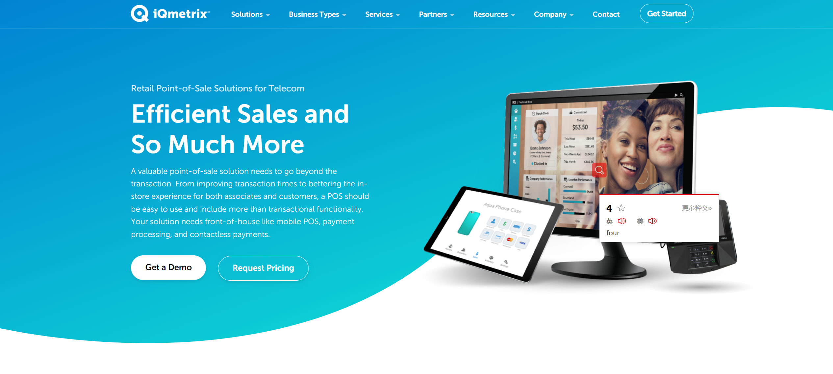

Figure 2.1 - IQmetrix's Official Website Home Page [48]

iQmetrix's main business lies in providing IT and services for retail solutions for other enterprises. iQmetrix provides solutions for multi-location retailers with a cloud-based point-of-sale and sales management core. Functions include mobile POS, maintenance and in-depth reporting and analytics, CRM, marketing and loyalty, advanced inventory management, and more. In addition, RQ involves front-end and back-end succession, including biometric security, marketing automation, payment processing, vendor managed inventory, etc. Retailers can meet users' multi-channel consumption needs with the channel direct marketing and e-commerce integration capabilities it offers, and get the consumption experience in multiple channels. Centralized internal communication using Intranet enables information sharing and communication among employees within the enterprise. Employees can learn the latest product information, corporate business planning, and promotional activities through the Intranet. In the marketing process, e-mail and telephone can be used as promotional channels to meet the promotion needs of many marketing activities. Combined with the characteristics of the campaign to contact the corresponding customers, to achieve precision marketing. iQmetrix can meet the service needs of more than 2,000 retail points, retailers can get the same service in all channels and contact points [48].

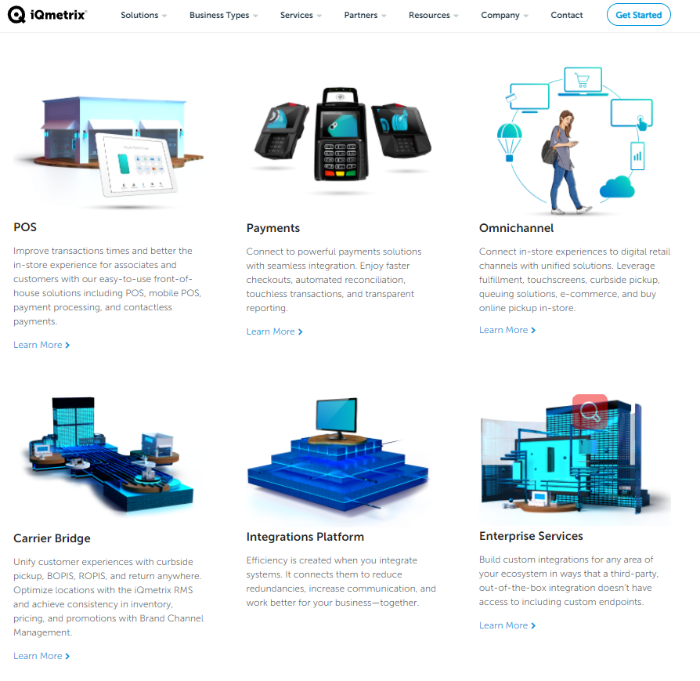

Figure 2.2- Solutions provided by IQmetrix [48]

iQmetrix is a suite of interactive retail and remarketing management solutions presented in the medium of a centralized commerce platform. Based on this concept, iQmetrix is integrated with third-party API to provide a communication platform for customers to develop partners. When the metrics library covers all of these, retailers can use it as a driving force for their own development, improving business efficiency and profitability, and no longer perceiving and understanding customers based on a single point of view. iQmetrix solutions can circumvent the gap between physical and virtual retailing, and thus better integrate the two to meet the development needs of the retail industry and provide consumers with an omnichannel consumer experience [48].

#### Retail Pro

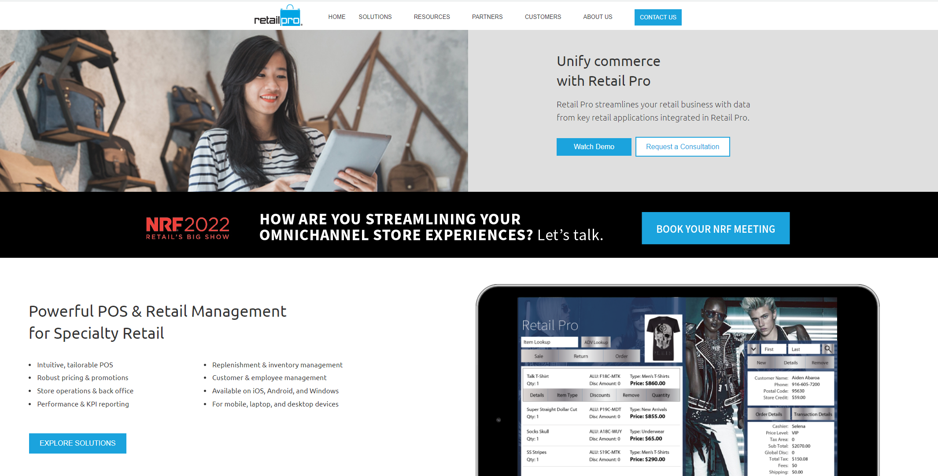

Figure 2.3 - Retail Pro's Official Website Home Page [49]

Retail Pro is a retail management software platform that provides many retail management functions, such as KPI reporting, inventory management, customer management, back office, and performance statistics. Retailers can use the platform to collect retail data, arrange specific workflows with data analysis, and develop business development plans that fit with the advantages Retail Pro offers. Retailers can extend the functionality of the platform by introducing third-party solutions such as marketing, ERP, loyalty, and HR systems through the APIs provided by the platform, and Retail Pro has an adaptive user interface that allows retailers to tailor their business activities, develop workflows that are tailored to their business characteristics, and deliver brands to customers with precision. The solution leverages over 150 pre-built functional reporting templates to provide ad-hoc reporting. Functions such as gift cards, store credit, and gift certificates are issued throughout the chain as an effective means to expand product sales and increase user loyalty. Also, specific products and franchised items can enjoy discounts for reaching a certain purchase size at the time of purchase. Automatic purchase orders can meet the needs of stores and warehouses for minimum inventory products and achieve effective control of product quantities. Accounting, marketing, and e-commerce applications are referenced to meet users' needs for managing their own information. Companies can design and decorate their online stores with built-in E-Commerce functions to display and promote their products online, while providing online payment capabilities, user loyalty rewards and product information tracking. This solution meets the needs of many retailers, such as multi-subsidiary retailers, franchises, outlets, etc. [50].

#### ChainDrive

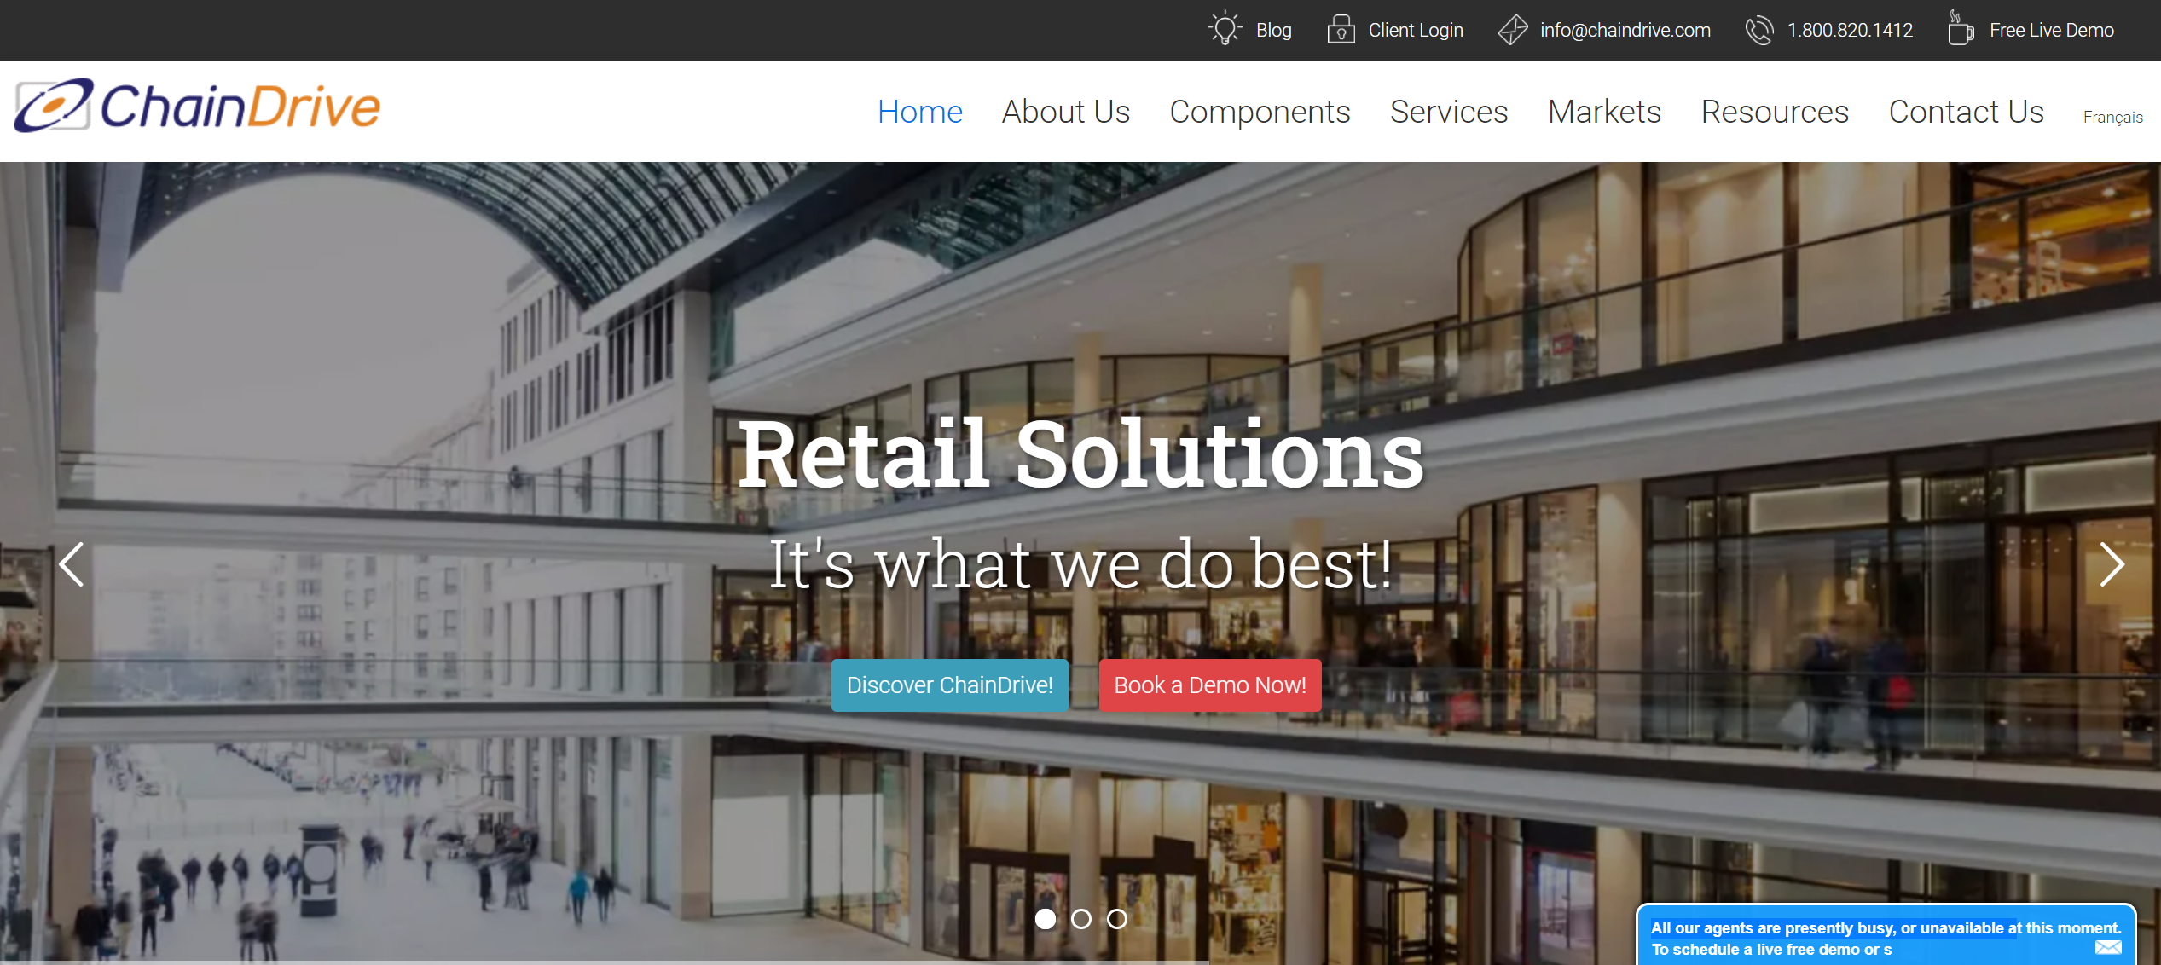

Figure 2.4 - ChainDrive's Official Website Home Page [51]

ChainDrive's omnichannel retail management solution serves retailers, wholesalers and e-tailers. Specific industry sectors include department stores, apparel, specialty retailers, footwear, home furnishings, and more. ChainDrive enables retailers to capture customer data, manage customer relationships, develop effective offers based on customer characteristics, and improve customer retention. Analysis and reporting functions can meet users' promotion options for products.

ChainDrive's store budgeting capabilities meet the needs of retailers for performance monitoring, store ranking, evaluating store performance levels, and charting data. ChainDrive integrates operations in both physical and digital sales environments to achieve integrated operations and form a complete and unified system. ChainDrive provides services in point-of-sale, merchandising, and financial management, and performs statistical operations under the whole system, which makes the solution suitable for the current retail environment and provides many functions to facilitate retailers' business development. ChainDrive also provides email and online forms services for users [52].

#### Springboard

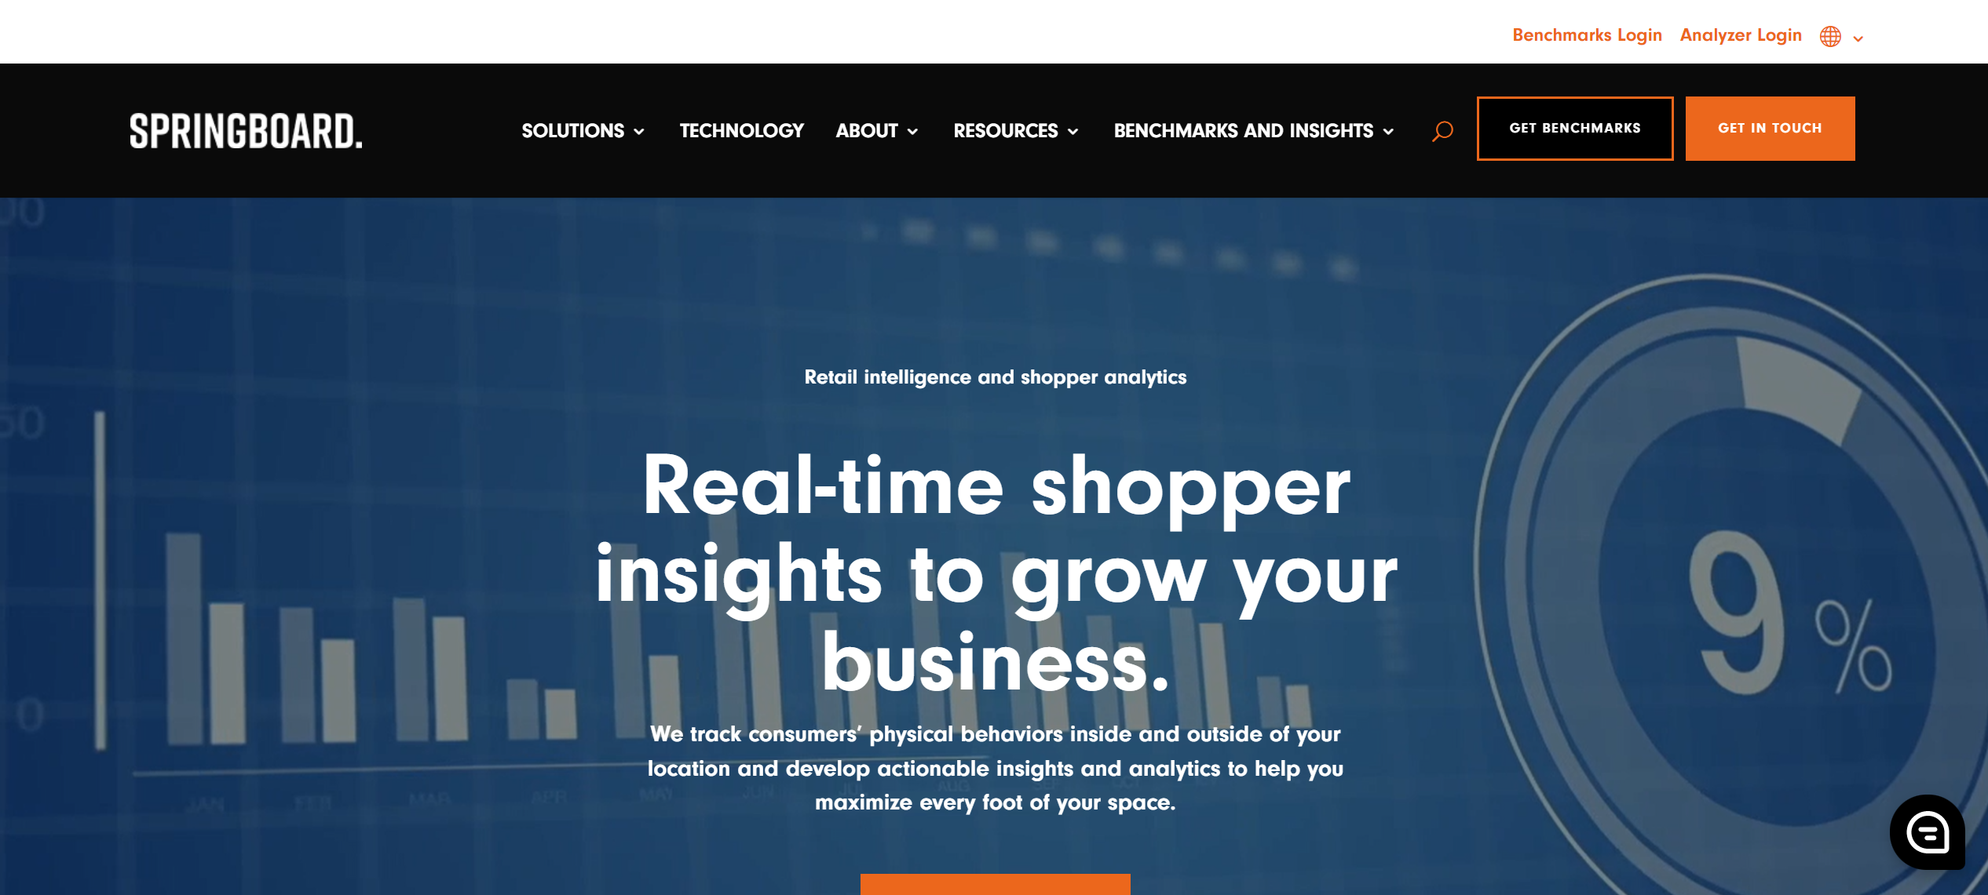

Figure 2.5 - Springboard's Official Website Home Page [53]

The Springboard Retail platform is all about retail management and cloud-hosted point of sale. The software provides the business and tools that retailers need in a variety of areas and was designed by retailers based on their own development experience and brand development needs. ChainDrive's mobile POS and retail management system was developed with retailers in mind, thus helping them to maximize their resources and efficiency. Springboard Retail's intuitive mobile POS provides retailers with more functionality for their sales because of its connection to the Internet. The cloud-based software provides real-time visibility into customer location and shopping behavior, and retailers can collect and analyze this data to develop appropriate sales campaigns to maximize sales. Springboard Retail also offers comprehensive inventory management capabilities that allow retailers to monitor and understand inventory across all sales channels. The software runs on the cloud, so users can achieve the requirement of monitoring inventory through the club basket network. Retailers can also gain insight into sales performance, while extracting the details they need to know to form extensive reports [53]. All of these features help retailers with sales, enabling rapid collection and analysis of information to make scientific and rational decisions.

### Comparison on existing System

The table 2.1 below compares the existing systems mentioned above:

Table 2.1 - Comparison Table of existing Systems

|  |  |  |  |  |
| --- | --- | --- | --- | --- |
| **No** | **System Title** | **Advantage Features** | **Bottom Line** | **User Evaluation (out of 10 points)** |
| 1 | IQmetrix | 1. Scalable  The inventory management, CRM, reporting and analytics provided by iQmetrix are all designed to better serve retailers, meet retail management needs, and help retailers achieve online and offline integration to serve consumers' needs in multiple channels [48].  2. Easy to use  It enables specialty retail teams to serve customers faster, more efficiently, and with more confidence than ever before, creating a superior experience for customers.  3. Advanced Security  An advanced combination of encryption, tokenization, PCI compliance and EMV protection.  4. API  No more outdated systems or technologies that don't communicate with each other [48]. | iQmetrix provides integrated POS, retail management and software solutions that help wireless, repair and specialty retailers create an outstanding customer experience [48]. | 6.4 points |
| 2 | Springboard | 1. Data driven  Improve refinement, delve into the data and use it to make the right decisions  2. Built-in flexibility  Seamlessly scale up or down, it also ensures that your software version is always in sync with the latest version  3. Export  Easily export to CSV, PDF or shared URL | Springboard Retail's point-of-sale and retail management software is integrated with the needs of retailers, providing them with data to support a more rational sales strategy and improve profitability [53]. | 9.0 points |
| 3 | Retail Pro | 1. Internationalization  The system supports up to 18 different languages and multi-currency interface  2. Mining complex data  Slicing, dicing and sorting of data independent of the original data layout-  3. Inventory management  The inventory management system automatically updates inventory data when purchases or returns are made, allowing for easy monitoring of inventory status [50]. | Retail Pro is the global leader in retail management software and is known worldwide for its rich functionality, multinational capabilities and unmatched flexibility [50]. | 7.2 points |
| 4 | ChainDrive | 1. Mobile Friendly: Interact and communicate with employees anywhere across the enterprise.  2. Loss Prevention: Take action on any discrepancies or policy violations.  3. Employee Productivity: Understand the data and metrics related to employee productivity, detect, track and maintain.  4. Store Performance: Data involved in tracking and monitoring store status, sales history and management.  5. System is capable of querying, linking, listing, pivoting, drilling down and charting data using sophisticated data mining techniques [52]. | ChainDrive is composed entirely of retail process components and is a single-source omnichannel software on which users can base their management activities and implement many operations [52]. | 6.4 points |

## Proposed Web-based Store Management Application

The proposed system will be a web-based smart store management system application. With the help of this application, it can help retail store managers to accomplish the easiest and effective store management, thus helping to help retail store managers to improve management efficiency and performance. The retail store manager can manage the order information, purchase information, inventory information, and user information of the store in real time and accurately. In addition, the system will have features such as store delivery and store pickup, which allows store consumers to shop at any time and in any way, which not only solves the problem of limited number of customers reached by traditional retail stores, but also helps offline retail sellers to increase their sales and profits. In addition, the proposed system also has excellent statistical aggregation capabilities, for example, inventory information can be entered into the system online in real time, which also effectively prevents unexpected inventory situations from occurring. By strictly controlling all aspects of the system, store managers will have a clearer understanding of the store situation, which also helps merchants to manage their stores more efficiently. Finally, the system will be able to perform statistics on store data, such as store sales statistics and product statistics functions, it can help store managers to analyze what types of products most customers buy, analyze what products customers like the most, and in this way monitor store data in real time and analyze it to give advice to merchant stores, these help merchants to manage their stores more easily and make improvements to their stores

## Chapter Summary

In summary, this chapter presents a literature survey about the work related to this research topic, this chapter also compares and analyzes popular store management applications currently available in the market in the Systematic Review section, then we present and discuss the features of the proposed system, complete the information collection of the application to be developed, identify the development requirements of the application to be developed, and then conclude with the summary of this chapter.

# CHAPTER 3: ANALYSIS

## Chapter Introduction

To determine the current state of the application or system to be developed, we used a pre-development questionnaire, first we explained the Sample Size and Target Participants of the survey (in Section 3.1), then we analyzed the results obtained from the questionnaire and summarized them, including The Analysis of Demographic Profile of Respondents (in Section 3.2), The Analysis of Related Questions on people's Expectations and Perceptions of New Retail Business Models (in Section 3.3), The Scale Questionnaire Analysis on Issues Related to Retail Store Management System Requirements (in Section 3.4), and finally our conclusions based on the survey in this chapter, which are presented in Chapter Summary (in Section 3.5).

## Sample Size and Target Participants

In this study, a randomized questionnaire will be used. The sample will include retail store managers or store owners in various countries or regions, collecting a large amount of information such as the store owner's personal view of the existing business management, user satisfaction analysis, etc., to determine the current state of the application or system to be developed. 110 respondents were invited to fill in the questionnaire, and the data were analyzed and summarized based on the respondents' responses. In order to obtain accurate findings, some anomalous data may be removed from it, which may affect the accuracy of the results. In addition, the survey will be published on social media platforms such as Facebook, Twitter, and the questionnaire will be distributed and data analyzed through google forms.

## The Analysis of Demographic Profile of Respondents

### Age

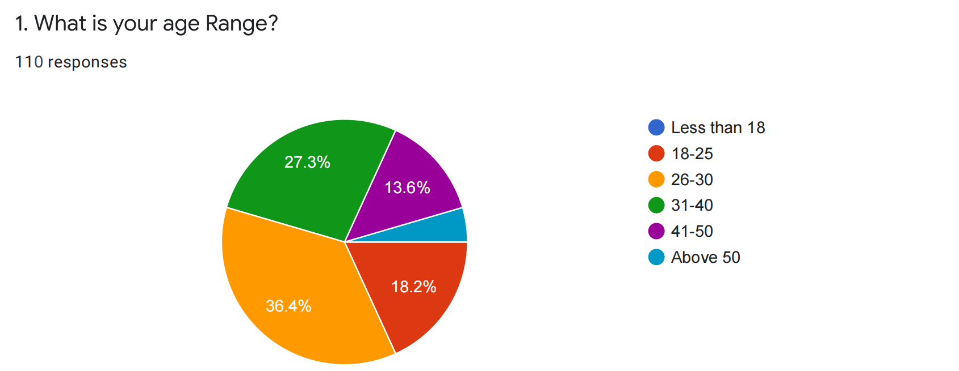

Figure 3.1 Pie chart on the age distribution of respondents

The pie chart in Figure 3.1 above compares the age distribution of respondents, and it is obvious that among the total respondents of the survey, we can see that 36.4% of the respondents are aged 26-30, the highest proportion, and 27.3% of the respondents are aged 31-40, compared to only a small percentage of respondents over 40 years old, so the conclusion I draw from this chart is that in the context of the current development of the new retail environment Retail executives aged 26-40 are gradually becoming the mainstay of the retail industry, which shows that the retail industry has entered a younger age in an all-round way.

### Gender

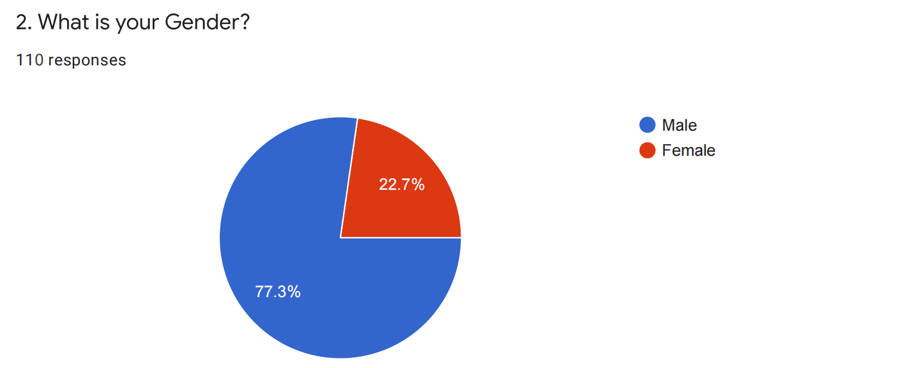

Figure 3.2 Pie chart on the gender distribution of respondents

This pie chart in Figure 3.2 above compares the gender distribution of respondents and it is clear that 77.3% of the total respondents in the survey are male, the highest percentage, while in comparison, only 22.7% of the respondents are female, which is less than 1/3 of the number of male respondents, showing that the number of male executives in today's retail industry is much larger than the number of female executives.

### Role

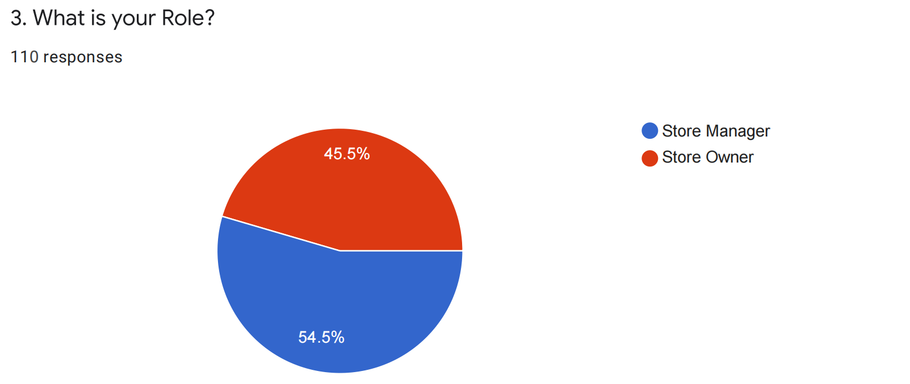

Figure 3.3 Pie chart on the role distribution of respondents

This pie chart in Figure 3.3 above compares the distribution of the roles of the respondents and it is clear that out of the total respondents of the survey, we can see that 45.5% of the respondents are the owners of the store, who as investors have full ownership over the store . In contrast, 54.5% of the respondents are store administrators, who are the managers of the store and must be responsible to the owner of the store as the overall person in charge of the store's business activities.

### Educational Background

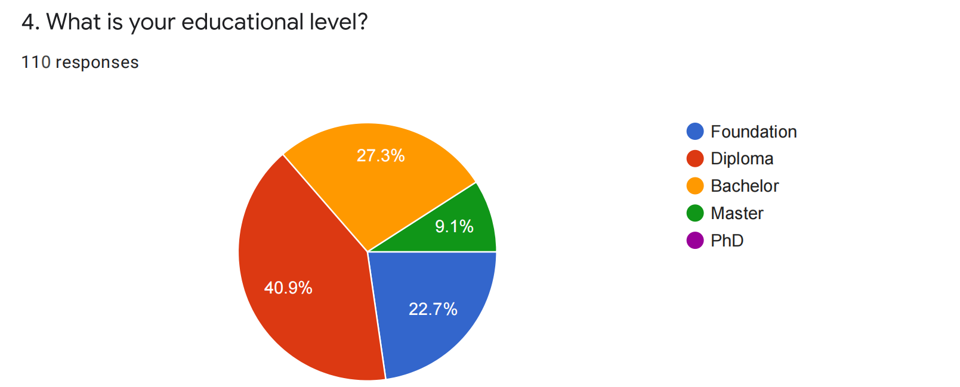

Figure 3.4 Pie chart on the educational background of the respondents

This pie chart in Figure 3.4 above compares the educational background of the respondents, among the total respondents of the survey, we can see that the proportion of which Diploma degree is the highest of the total number of respondents, occupying a full 40.9% , followed by retail store managers or store owners with Bachelor degree, which occupies 27.3%, while in comparison, only very few Master as retail store managers or store owners, accounting for 9.1%, and no relevant practitioners with doctoral degrees. The conclusion that can be seen from this chart is that the per capita education of practitioners in the current retail industry is general.

### Country / Region

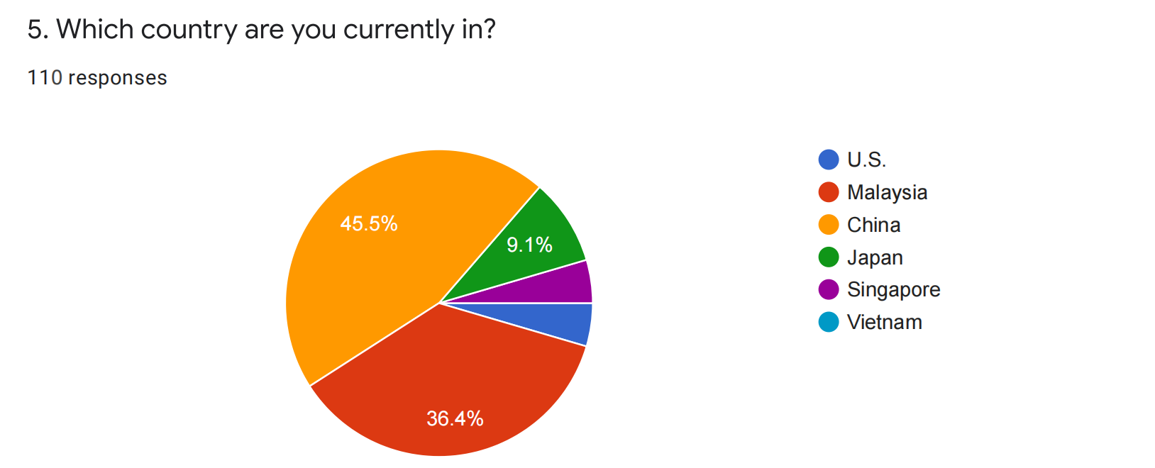

Figure 3.5 Pie chart on the distribution of respondents by country

This pie chart in Figure 3.5 above shows the number of respondents from each country/region as a percentage of the total number of respondents in the sample. Since the survey was conducted mainly in Malaysia and China, we can see that the Chinese have the highest percentage of the total respondents in the survey with 45.5%, followed by Malaysia with 36.4 %, in addition as that survey also has some minority respondents from Japan, Singapore and the United States.

### Monthly Income

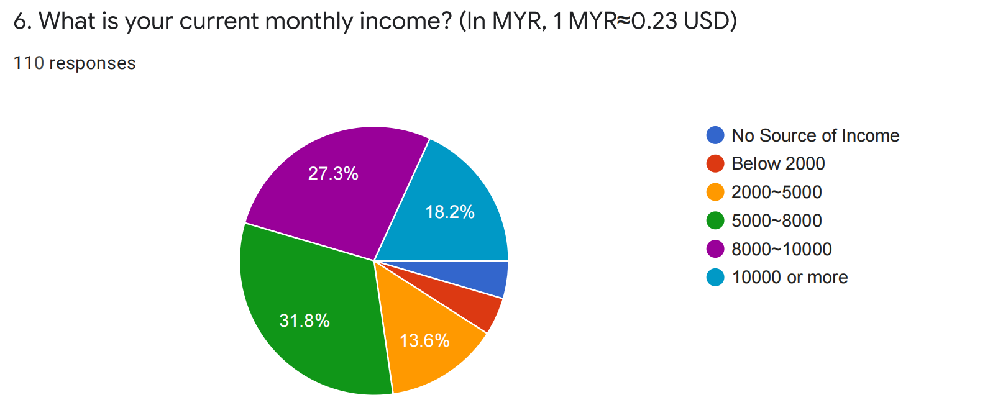

Figure 3.6 Pie chart on the distribution of respondents' monthly income

This pie chart in Figure 3.6 above shows the percentage distribution of monthly income among the respondents, among the total respondents of the survey, we can see that 31.8% of the respondents have a monthly income of RM5,000 to RM8,000, which is the highest percentage, followed by respondents with a monthly income of RM8,000 to RM10,000, they account for 27.3%, while respondents with a monthly income of RM10,000 or more account for 18.2%. In contrast, respondents with a monthly income of less than RM2,000 or no source of income only account for a small percentage. What we can conclude from this chart is that there is a wide range of high and low income for those currently working in the retail industry due to the different price and development levels in different regions, countries and cities.

## The Analysis of Related Questions on people's Expectations and Perceptions of New Retail Business Models

### Types of Retail Businesses Currently Operating

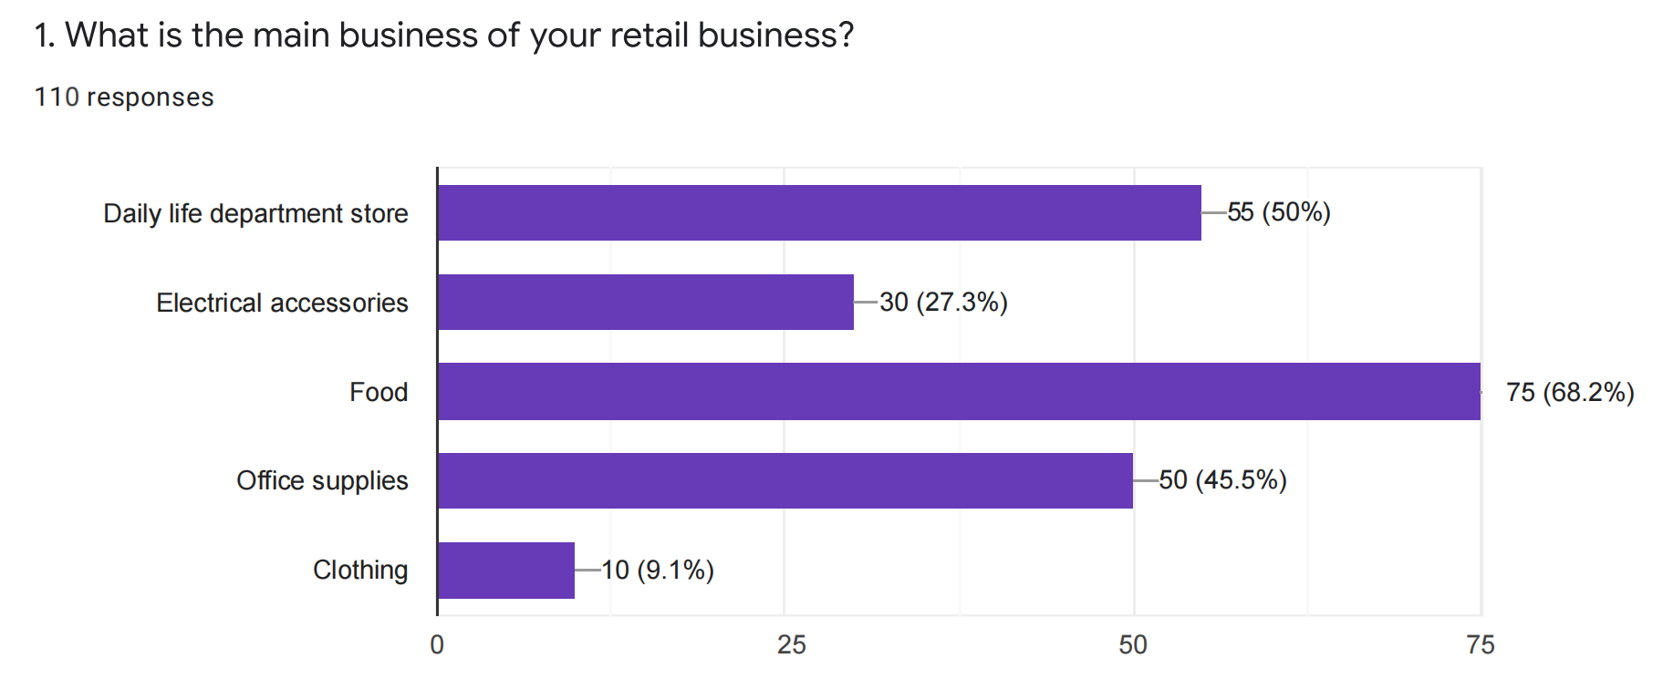

Figure 3.7 Bar chart on the types of retail businesses currently operating

This is a horizontal bar chart that represents the type of retail business they currently operate among the total number of retail store managers or store owners surveyed, where each retail business may carry multiple types of merchandise. Here we can clearly see that the largest proportion of retail businesses sell food, with 68.2%, while it is also worth noting that the second and third largest retail business types are Daily life department store and office supplies, with 50% and 45.5% of the market respectively and they have a very similar proportion. In contrast, we can also see that only 9.1% of the total respondents operate in the apparel category, and only 10 out of 110 retail store managers or store owners surveyed. From this chart, we can conclude that there are a large number of retailers that mainly deal with food and daily necessities, and since they are all necessities of life and fast-moving consumer goods, it is a marketable and high growth prospect industry in any location.

### The Public's Perception of the New Retail Business Model

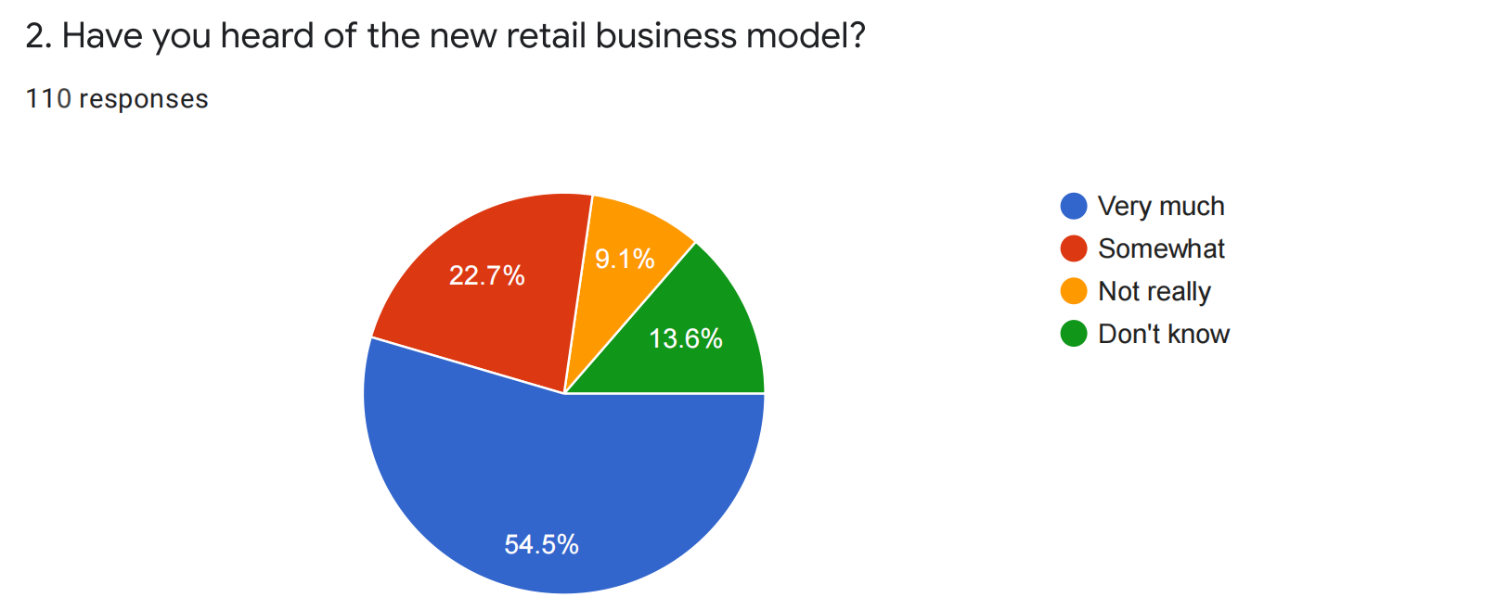

Figure 3.8 Pie chart on the public's perception of the new retail business model

This pie chart in Figure 3.8 above shows the awareness of the new retail business model among all respondents. We can clearly see that the majority of respondents said they know a lot about the new retail business model, accounting for 54.5% of the total number of respondents, more than half of the total number of respondents, while 22.7% said they know a little about the new retail business model. In contrast, a small number of 13.6% of respondents said they had no understanding of the new retail business model at all. From this, we can conclude that with the concept of new retail business models being introduced and the development of new retail in recent years, it has been gradually accepted as a representative innovation in the modern business system and is now well known by many retail managers.

### The Public's Perception of the Combined Online and Offline Shopping Model

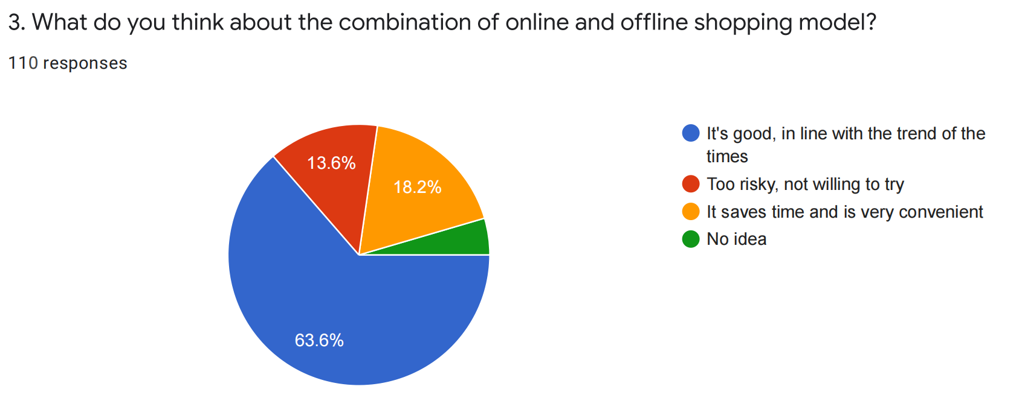

Figure 3.9 Public's perception of the combined online and offline shopping model

This pie chart in Figure 3.9 above shows how all the respondents in the survey feel about the combination of online and offline shopping. Here, we can clearly see that the majority of respondents think that combining online and offline shopping is a good idea and that it caters to the trend of the times, with 63.6% of the total number of respondents and 18.2% of the retail store managers or owners surveyed also think that this business model can help them save time and it is very convenient. However, in contrast, a small number of 13.6% of respondents said they were afraid to try this new online and offline shopping model and a small number of respondents said they had no idea. We can conclude from this that although some retail managers or store owners are conservative in their business thinking, it seems that this marketing model has been gradually accepted by everyone under the trend of gradual integration of offline and online channels, and most retail managers or store owners are willing to try this new shopping model and hope to increase online marketing model and get new resources through transformation and upgrading.

### The Views on the Advantages of a Combined Offline and Online Shopping Model Over Direct Online Shopping

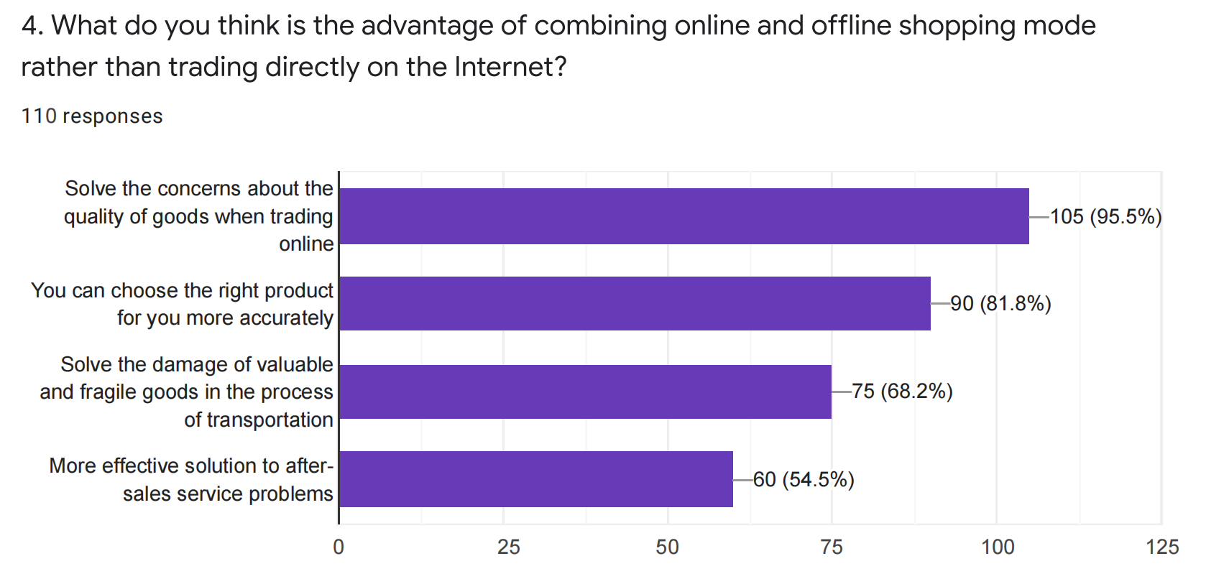

Figure 3.10 About the advantages of this shopping model over direct online shopping

This horizontal bar chart represents the perceptions of the surveyed population of all respondents on the advantages of a combined offline and online shopping model over direct online shopping, where it is clear to see that 95.5% of all respondents believe it addresses concerns about the quality of goods when transacting online, as direct online transactions may face delivery of products that are not what the customer expects. Another 81.8% of respondents believe that a combined offline and online shopping model allows customers to choose the right product for them more accurately, as they can also go directly into the store to make a purchase. In addition, 68.2% of respondents also believe that retaining the offline shopping model solves the problem of damage to valuable and fragile items during transportation, and 54.5% of respondents also believe that this solves the problem of after-sales service more effectively. Therefore, we can conclude from this that many respondents have concerns about online shopping because there are problems such as buyers and sellers cannot meet in person and goods cannot be inspected in person, while the main advantage of combining offline and online shopping mode than direct online shopping is that it solves the problem of product quality and customers can choose the right products more accurately in the store, which is a good solution for some retail businesses. Therefore, the store management application I developed will also provide support for offline retailing in stores. Store customers can not only make online purchases of goods, but also make online reservations and pick up goods in stores to increase the selectivity of purchase methods for store customers and provide a better experience for merchants to manage their stores and customers to purchase goods.

### The Views on the Advantages of Combining Offline and Online Shopping Models Over Shopping in Brick-And-Mortar Stores

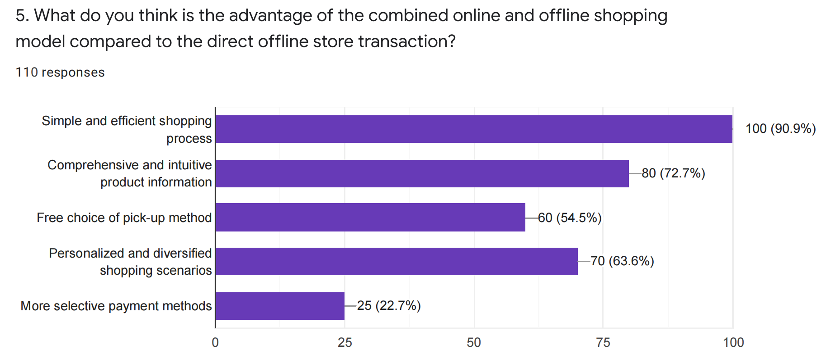

Figure 3.11 The advantages of this shopping model over shopping in brick-and-mortar stores

This horizontal bar chart shows the views of all respondents on the advantages of combined offline and online shopping over brick-and-mortar shopping, where we can clearly see that 90.9% of respondents believe that combined online and offline retailing is simpler and more efficient than shopping in brick-and-mortar stores only. In addition, 72.7% of respondents believe that through the online retail mode, customers can browse more comprehensive and intuitive product information, 63.6% of respondents believe that this combined online and offline retail mode allows stores to provide customers with more personalized and diversified shopping scenarios, and 54.5% of respondents believe that retaining the online shopping mode allows customers to freely choose their pickup method. In addition, 22.7% of the respondents believe that this provides customers with more choice in payment methods. Therefore, we can conclude from this that online shopping is a more relaxed purchase process compared to brick-and-mortar stores, and because its shopping behavior is not restricted by time and place, it also makes the shopping time cost of store customers relatively less, which is an advantage of online shopping itself and a condition that traditional retailers do not have at present. Therefore by implementing a combined offline and online shopping model, it makes the customer's purchasing process easier and more efficient, and the information about the products more intuitive and transparent, and users can browse more comprehensive and intuitive product information through online shopping to choose the right product for them, which is a good solution for some traditional retail companies. Therefore, the store management application I developed will use the Internet as the background to help merchants integrate online and offline retail channels and upgrade the traditional retail business model in order to provide store customers with a seamless shopping experience between these two channels.

### The Survey on the Acceptance Level of New Business Models

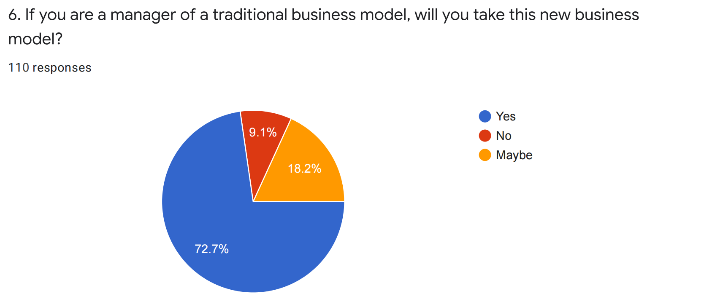

Figure 3.12 The survey on the acceptance level of new business model

This pie chart in Figure 3.12 above shows how all respondents in the survey feel about the new business model of combining online and offline. Here, it is clear that the majority of respondents, 72.7%, are willing to adopt this new business model as retail store managers or owners, while 18.2% said they might adopt this model. In contrast, only 9.1% of respondents said they would not be willing to adopt this model. Therefore, we can conclude that although some retail managers or store owners are still conservative in their business thinking, most of them are willing to adopt this new business model with the popularity of Internet technology, and it is expected to change the way consumers shop and become the mainstay of the retail market.

### The Future Consumption Model Preferred By the Public

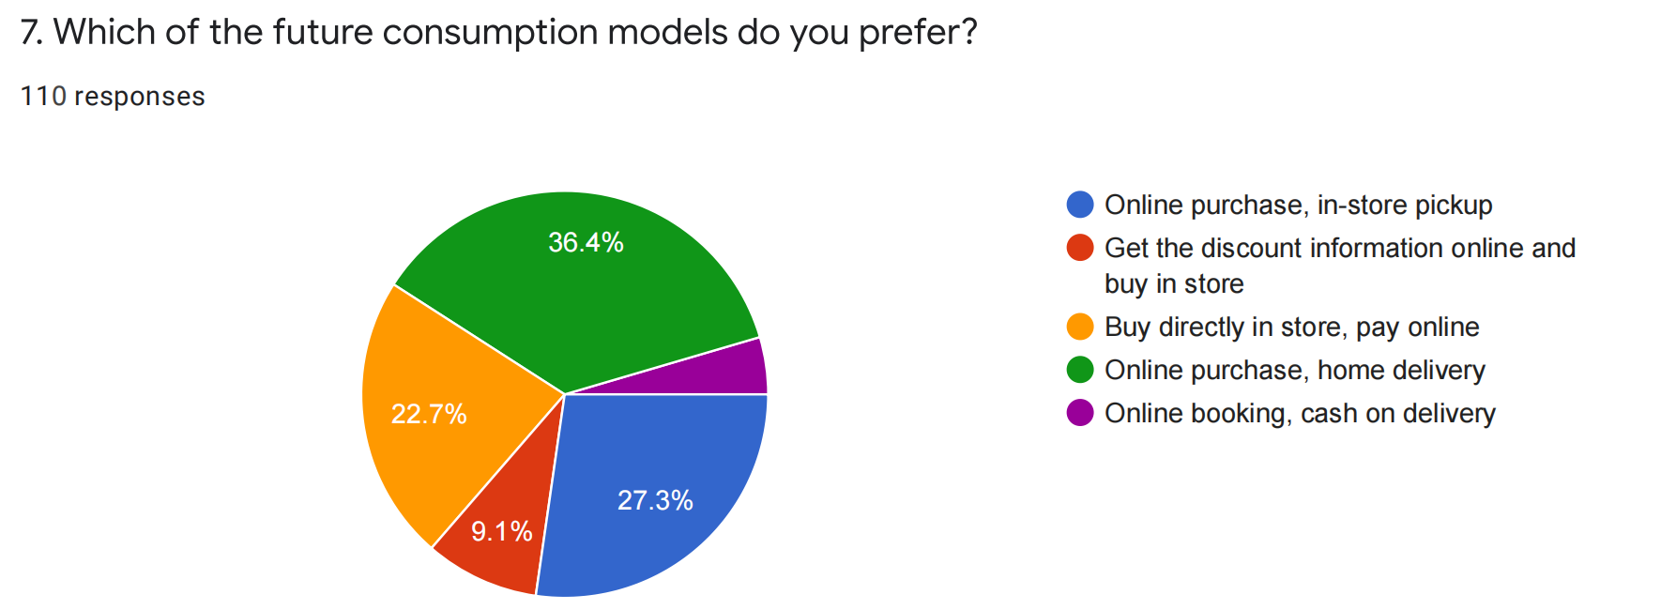

Figure 3.13 Pie chart on the future consumption model preferred by the public

This pie chart in Figure 3.13 above shows which future consumption mode is preferred by all respondents in the survey. Here, we can clearly see that 36.4% of respondents prefer online purchase, home delivery, which accounts for more than 1/3 of the total number of respondents, while it is also worth noting that the second and third most popular consumption modes are online purchase, in-store pickup and buy directly in store, pay online, with 27.3% and 22.7% respectively. In contrast, we can also see that only a small percentage of the total respondents are interested in Get the discount information online and buy in store, and Online booking, cash on delivery. Therefore, from this chart, we can conclude that more retailers are now primarily interested in buying online and home delivery, followed by buying online and picking up in-store. Therefore, the store management application I developed will not only support the online retail channel of the store, but also support the offline retail channel of the store. Store customers should not only be able to purchase goods online, but also should be able to book online and pick up goods from the store, in order to increase the choice of purchasing methods for store customers, as well as provide a better experience for merchants to manage the store and customers to purchase goods.

### The Opinion Survey on the Most Likely Future Problems of New Retail Business Models

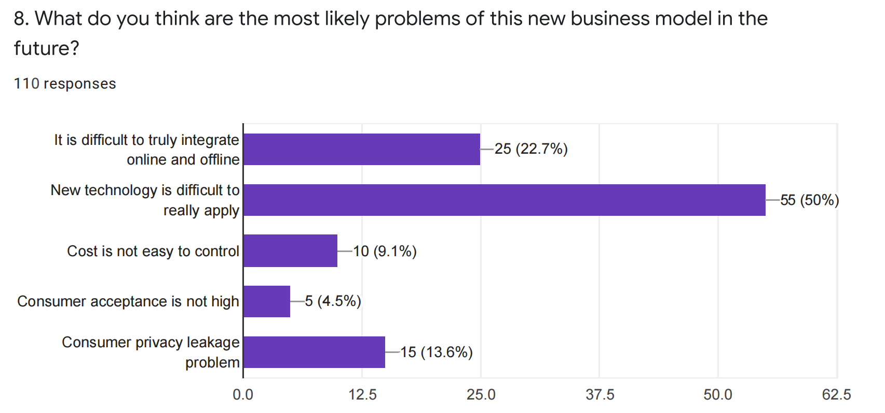

Figure 3.14 The most likely future problems of new retail business models

This horizontal bar chart in Figure 3.14 above represents the opinions of the surveyed population of all respondents on the most likely future problems of the new retail business model. Here, we can clearly see that 50% of respondents believe that New technology is difficult to really apply, which accounts for half of the respondents, while 22.7% of respondents believe that this The real and most likely problem with this business model in the future is that it is difficult to really integrate online and offline, and 13.6% of the respondents think that this business model will lead to consumer privacy leakage problems. In contrast, we can also see that 9.1% of the respondents believe that the new retail business model may lead to less control of costs, and a very small percentage of respondents believe that this business model is not well accepted by consumers, which accounts for 4.5%. Therefore, we can conclude from this that the implementation of online and offline integration model will still face risks and challenges in the future, as it involves two types of business entities, online platforms and offline physical businesses, and there are differences in operation systems, marketing strategies and merchandise layout, and there will always be one party that is dominant in the online and offline cooperation model. Therefore, in the process of implementing the online and offline integration model It is also urgent to further innovate the business model, such as creating new consumption scenarios offline, adopting different operation and experience methods from traditional offline enterprises, and providing a new consumption experience for store customers, in order to make this business model sustainable.

### The Views on the Future of the New Omnichannel Retail Model

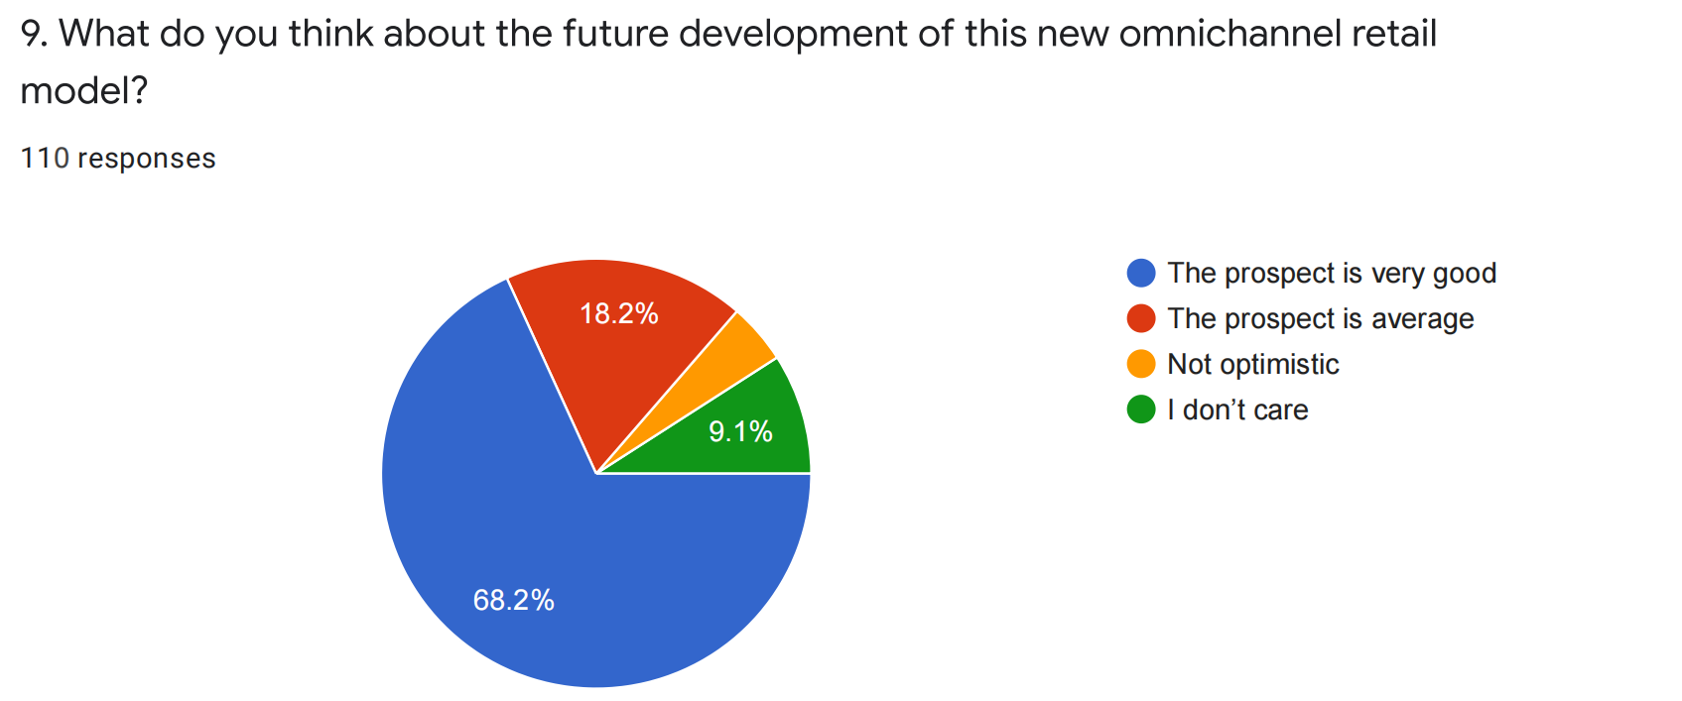

Figure 3.15 Pie chart on the views of the future of the new omnichannel retail model

This pie chart in Figure 3.15 above shows how all respondents in the survey think about the future prospects of the new omnichannel retailing model. Here, we can clearly see that most of the respondents think that the future of this new omnichannel retail model is very good, 68.2%, and 18.2% think that the future is very average, while only a small percentage of the total respondents are not optimistic or not interested in this new omnichannel retail model. Therefore, from this chart, we can conclude that most retail managers or store owners are still very optimistic about the prospects of this new omnichannel retail model, even though these future retail concepts based on emerging technologies are still at a relatively low level of development. But in my opinion, in the future, with the popularization of Internet technology and the innovation of financial models, this new omnichannel retail model will definitely bring about a change in the way consumers shop and become the mainstay of the retail industry, becoming a good opportunity for traditional retail companies to achieve self-innovation and development.

## The Scale Questionnaire Analysis on Issues Related to Retail Store Management System Requirements

### Statement: “I believe that traditional retail store management relies too much on manual operation control, which is not only difficult to operate, but also inefficient”

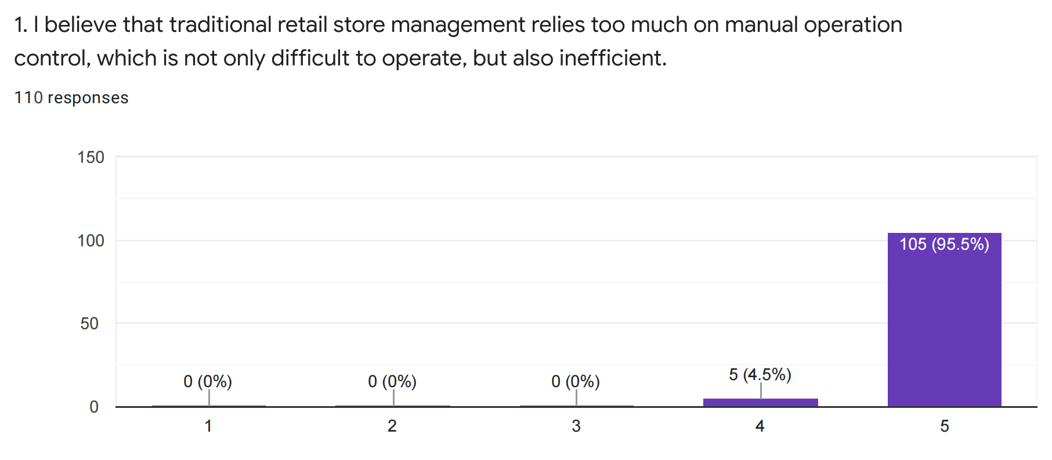

Figure 3.16 Level of agreement with the statement: It is difficult to manage traditional retail stores

This linear scale in Figure 3.16 above indicates the extent to which all respondents agreed with the statement “Traditional retail store management relies too much on manual controls, which are not only difficult to operate but also inefficient”. Here, we can clearly see that the majority of respondents strongly agreed with this statement, 95.5%, while a very small percentage agreed more or less, and no respondents disagreed. From this chart, we can conclude that most retail managers or store owners currently feel that traditional retail store management is often inefficient, therefore, the store management application I will develop will be considered to provide a more efficient way for traditional retailers to replace the inefficient retail model and achieve better store management for stores.

### Statement: “I believe that traditional retail stores rely too much on a single revenue method and have limited access to customers”

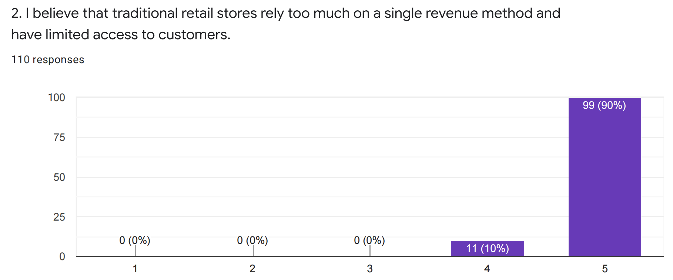

Figure 3.17 Level of agreement with the statement: Traditional retail store have single revenue channel

This linear scale in Figure 3.17 above indicates the extent to which all respondents to the survey agreed with the statement “I believe that traditional retail stores rely too much on a single revenue method and have limited access to customers”. Here, we can clearly see that the majority of respondents strongly agree with this statement, accounting for 90% of all respondents, while a small percentage of respondents agree more, accounting for 10%, and no respondents disagree. From this chart, we can conclude that most retail business managers or store owners currently feel that the offline retail channel is too homogeneous in terms of revenue in traditional retail stores, and that consumers can only buy the goods that exist in the store at a defined time and place, which makes the number of customers that traditional offline retail stores can reach limited, therefore, the solution provided by the author is to develop store delivery through the system, store Self-pickup and other functions, so that stores allow consumers to shop at any time, any place, in any way, which extends the revenue channels of traditional retail companies, which not only brings great convenience to consumers, but also helps offline retail sellers to increase sales and profits.

### Statement: “I think the merchandise statistics of traditional retail stores are prone to miscalculation”

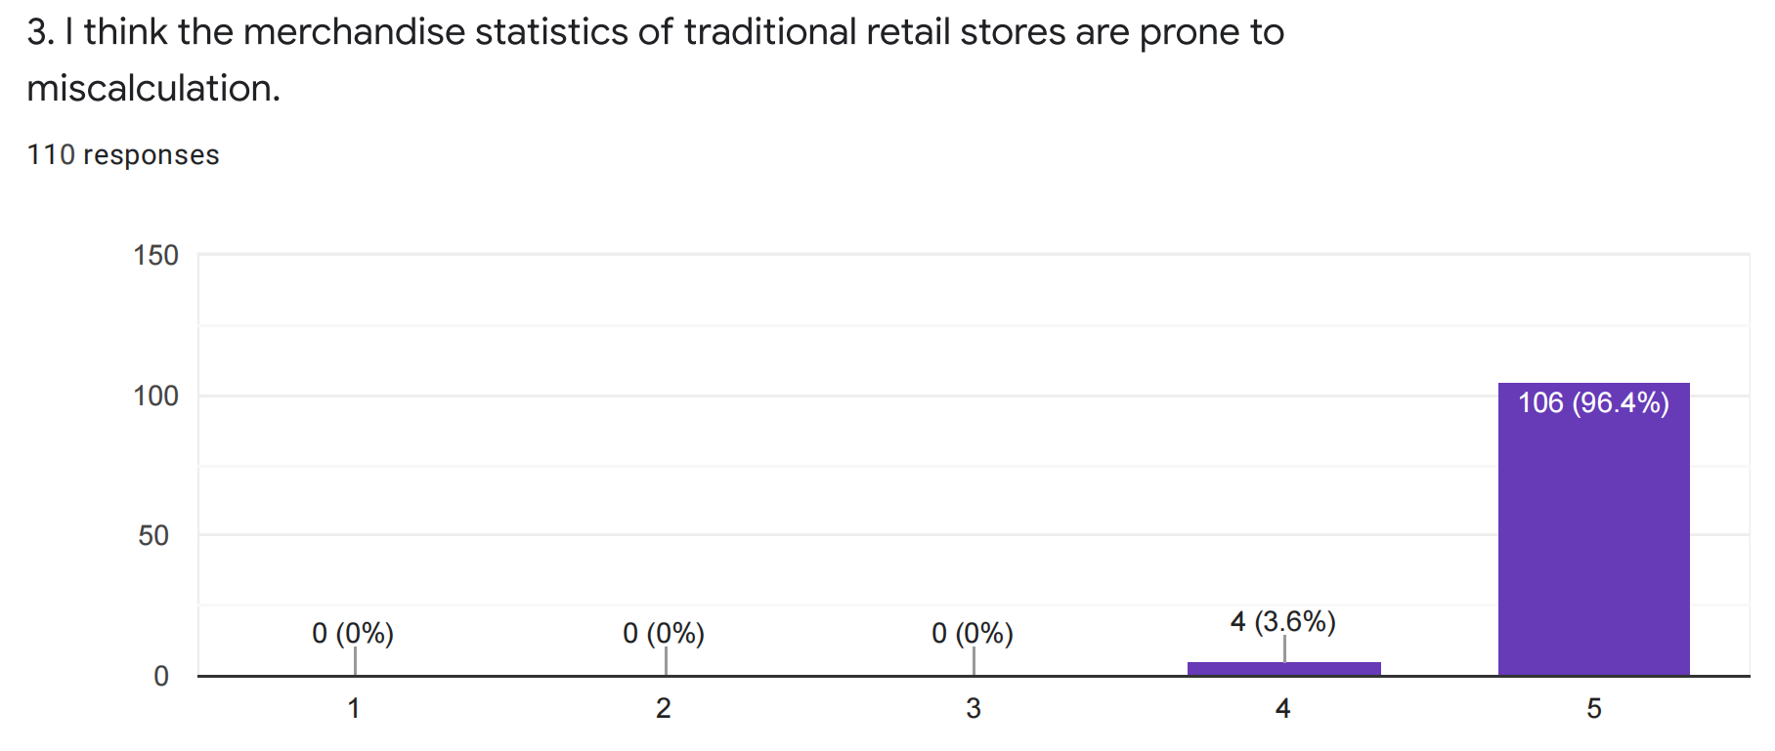

Figure 3.18 Level of agreement with the statement: Error-prone product statistics in traditional stores

This linear scale in Figure 3.18 above indicates the extent to which all respondents agree with the statement “I think the merchandise statistics of traditional retail stores are prone to miscalculation”. Here, we can clearly see that most of the respondents strongly agree with this opinion, accounting for 96.4% of all respondents, while a small number of respondents agree more, accounting for 3.6%, and no respondents disagree. From this chart, we can conclude that in the current management of traditional retail stores, due to their mostly manual business operations and large volume of merchandise purchases, which leads to easy calculation errors in merchandise inventory statistics, the wrong quantity of merchandise is a major management problem faced by many retail companies. Therefore, the solution I provide is to help improve store management efficiency by developing online real-time entry and update functions for inventory information through the system, making it easier for merchants to manage their stores and operate them more easily.

### Statement: “I want tools that can help me improve the management efficiency and performance of my store”

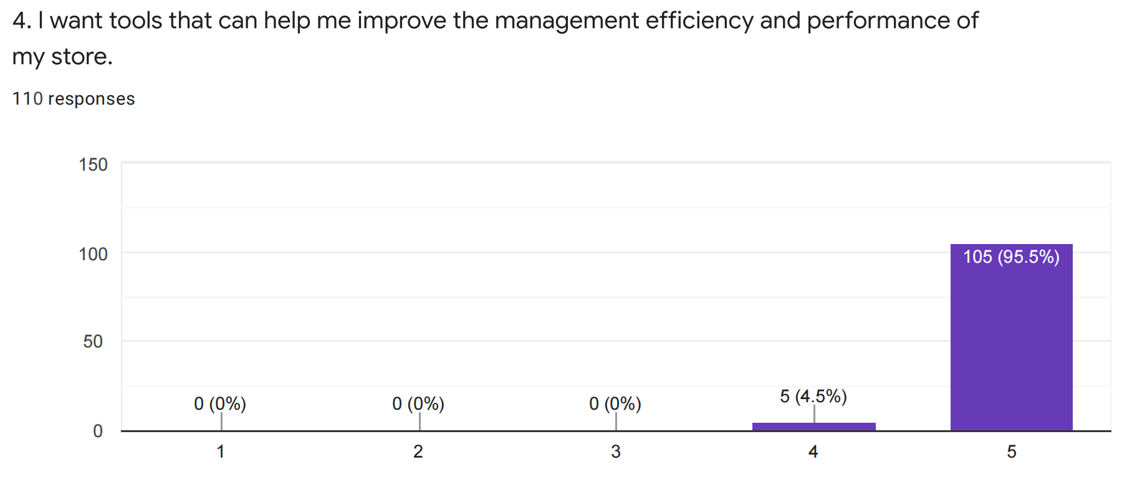

Figure 3.19 Level of agreement with statement: I want tool to improve the efficiency of store management

This linear scale in Figure 3.19 above indicates the extent to which all respondents agree with the statement "I want tools that can help me improve the management efficiency and performance of my store". Here, we can clearly see that most of the respondents strongly agree with this view, accounting for 95.5% of all respondents, and a small percentage of respondents agree with this view more or less, accounting for 4.5%, and there are no respondents who disagree. From this chart, we can conclude that current retail business management is often inefficient, and most retail business managers or store owners would like a better tool to help them manage their stores and improve store management efficiency and performance. Therefore, the store management application I will develop will be considered to provide a more efficient retail management model for retail businesses and this as a tool to achieve better store management.

### Statement: “I want my store to be able to sell more of my products through online channels to adapt to the future market environment”

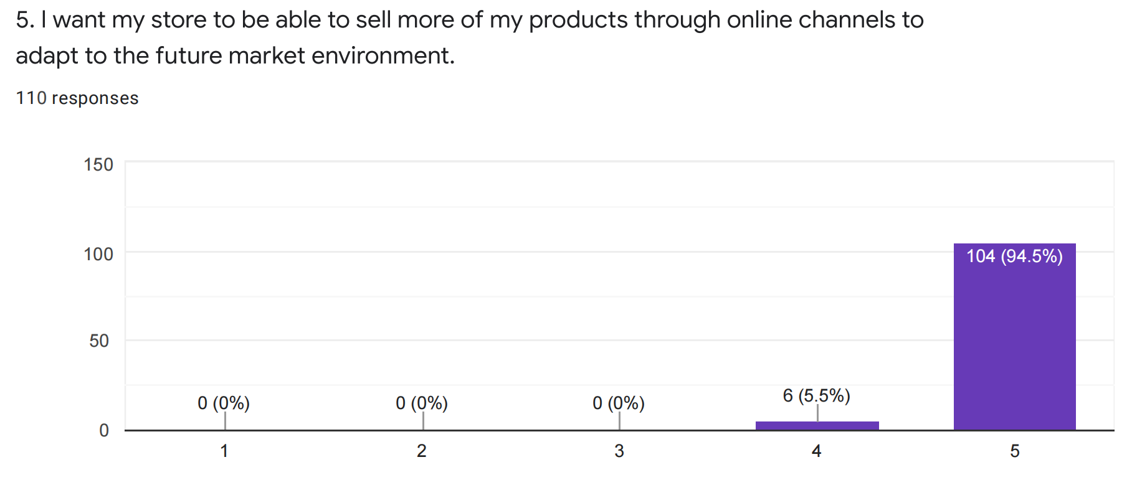

Figure 3.20 Level of agreement with statement: I want to add online channels to sell more products

This linear scale in Figure 3.20 above indicates the extent to which all respondents to the survey agreed with the statement “I want my store to be able to sell more of my products through online channels to adapt to the future market environment”. Here, we can clearly see that the majority of respondents strongly agree with this statement, accounting for 94.5% of all respondents, while a small percentage of respondents agree more, accounting for 5.5%, and no respondents disagree. From this chart, we can conclude that since the sales channels of general retail stores are too single, most retail managers or store owners want their stores to sell more products through online channels, which will help them to increase their sales and profits. Therefore, for the store management application I am going to develop, I will consider providing retailers with more sales channels, such as online retail channels, so that they can sell their products through more channels and also provide multiple options for store customers to buy, which will lay the foundation for retailers to better adapt to the future market environment.

### Statement: “I am not satisfied with the existing store management system on the market”

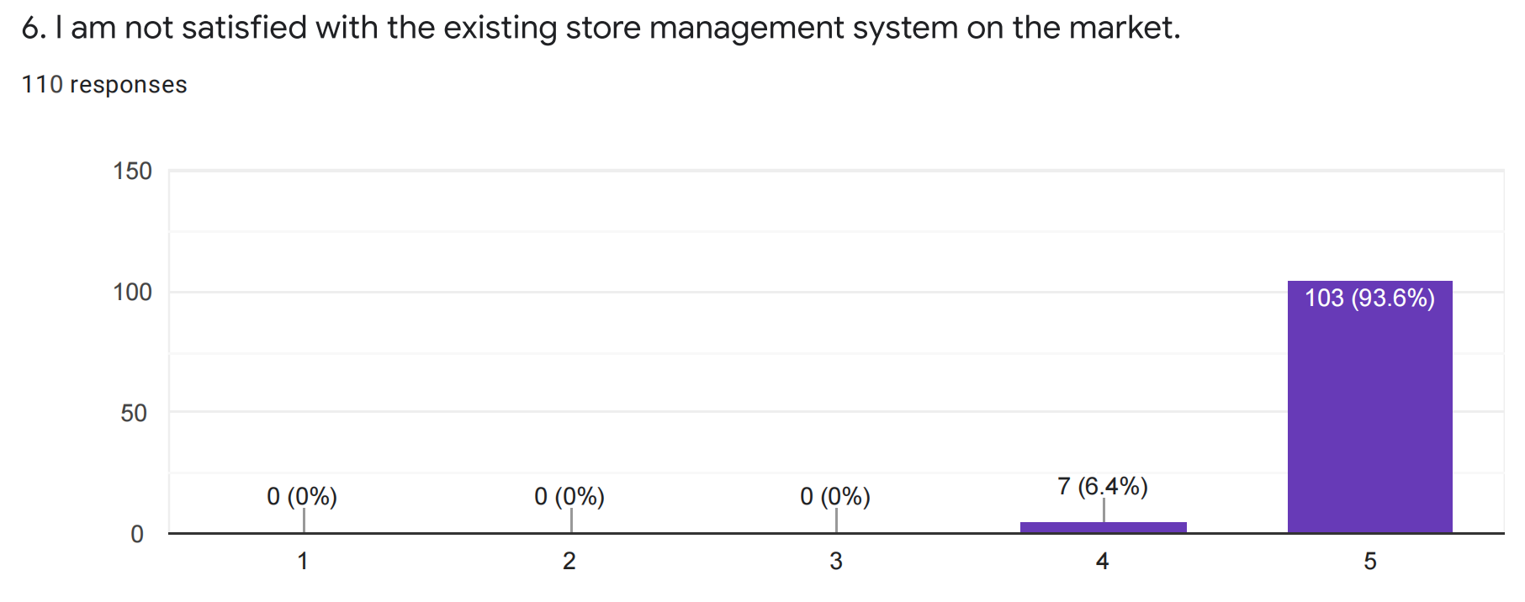

Figure 3.21 Level of agreement with statement: I am not satisfied with the existing store management system

This linear scale in Figure 3.21 above indicates the extent to which all respondents agree with the statement "I am not satisfied with the existing store management system on the market". Here, we can clearly see that most of the respondents strongly agree with this statement, accounting for 93.6% of all respondents, while a small number of respondents agree more, accounting for 6.4%, and no respondents disagree. From this chart, we can conclude that most of the retail managers or store owners are not satisfied with the existing store management system in the market for various reasons, therefore, for the store management application I will develop, I will need to consider a solution for retail companies to make the users as store managers more satisfied, in order to help stores achieve better store management.

### Statement: “I want the store management application to be able to manage the inventory information of the products and update the stock information of the products in real time”

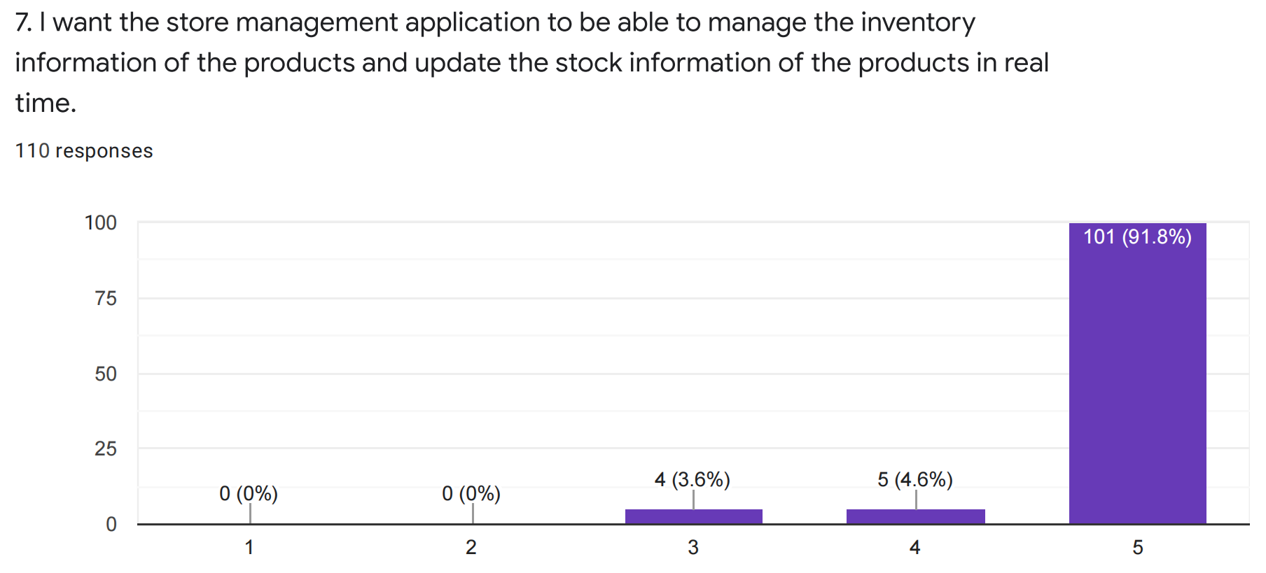

Figure 3.22 Level of agreement with statement: Expect applications to manage inventory efficiently

This linear scale in Figure 3.22 above indicates the extent to which all respondents to the survey agreed with the statement “I want the store management application to be able to manage the inventory information of the products and update the stock information of the products in real time”. Here we can clearly see that the majority of respondents strongly agree with this statement, 91.5% of all respondents, while a small percentage of respondents agree more, 4.6%, while 3.6% of respondents remain neutral and no respondents disagree. From this chart, we can conclude that, since most of the current inventory management is manual-based, merchandise purchases are large, and merchandise statistics are prone to calculation errors, more retail business managers or store owners want tools to help them achieve better management of product inventory information. Therefore, for the store management application I am going to develop, I need to consider a solution for retail companies to develop a function of online real-time inventory entry and update through the system, as well as the function of replenishment, return and exchange from suppliers through the system, and strictly control every step of the process. This can help retail business managers or store owners to manage store inventory more easily and give them a clearer picture of the store's status.

### Statement: “I want store management apps to help brick-and-mortar retailers reduce their retail operating costs”

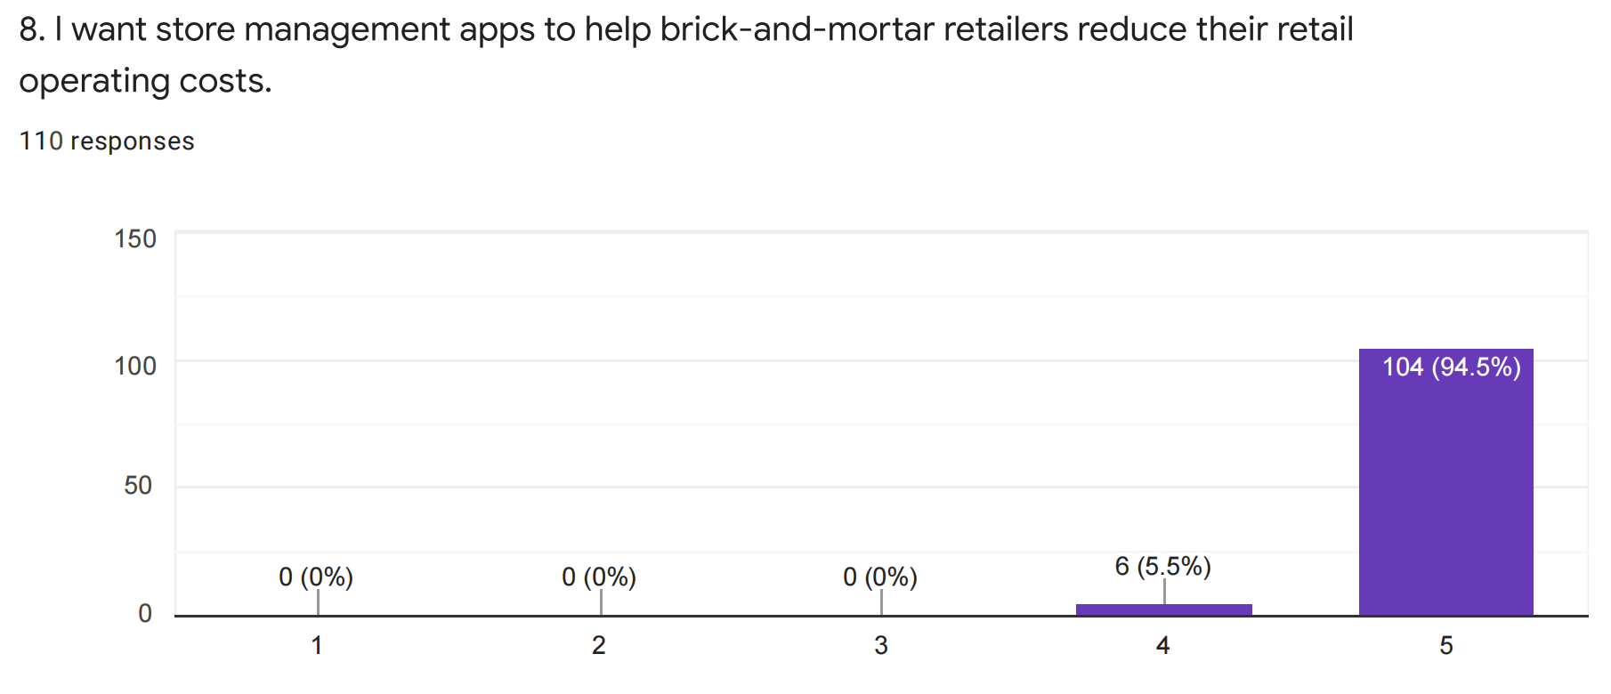

Figure 3.23 Level of agreement with statement: I want the application to reduce retail operating cost

This linear scale in Figure 3.23 above indicates the extent to which all respondents to the survey agreed with the statement “I want store management apps to help brick-and-mortar retailers reduce their retail operating costs”. Here, we can clearly see that most respondents strongly agree with this statement, accounting for 94.5% of all respondents, while a few respondents agree more, accounting for 5.5%, and no respondents disagree. From this chart, we can conclude that as the operating cost of physical stores is getting higher and higher nowadays, the rising cost of store rent and labor year by year, coupled with the impact of Internet e-commerce, makes the customer flow of physical stores less and less, which brings a lot of pressure to the merchants, so more and more retail managers or store owners are looking for store management applications to help reduce the retail operating cost of their stores. Therefore, for the store management application I am going to develop, I need to consider a suitable solution for retail businesses to help retail managers or store owners to accomplish the easiest and most effective store management by developing a combined online and offline store management system. In addition, a good inventory management system should also be developed, which can greatly enhance the merchant's supply efficiency, reduce the cumbersome warehousing business, and reduce money costs and labor costs, making store operations more efficient.

### Statement: “I think store management applications should help save store managers' work time”

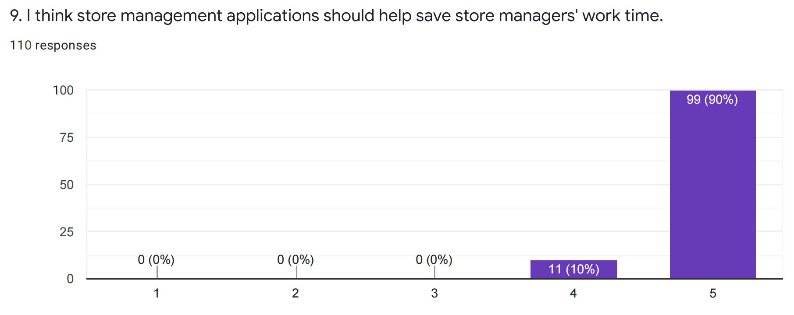

Figure 3.24 Level of agreement with statement: The application should save the store staff's work time

This linear scale in Figure 3.24 above indicates the extent to which all respondents to the survey agreed with the statement “I think store management applications should help save store managers' work time”. Here, we can clearly see that most respondents strongly agree with this statement, accounting for 90% of all respondents, while a few respondents agree more, accounting for 10%, and no respondents disagree. From this chart, we can conclude that most of the respondents agree that a good store management application should be helpful to save the store manager's working time and thus the store employees' time and effort as well. Therefore, for the store management application I am going to develop, I need to consider a suitable solution for retail companies which revamps and optimizes the tedious task management process, helps to improve the management efficiency of retail managers or retail store owners, and helps retail companies to save time cost greatly in their operation and make store operation more efficient.

### Statement: “I think a good user interface will make it easier for store managers to manage their stores”

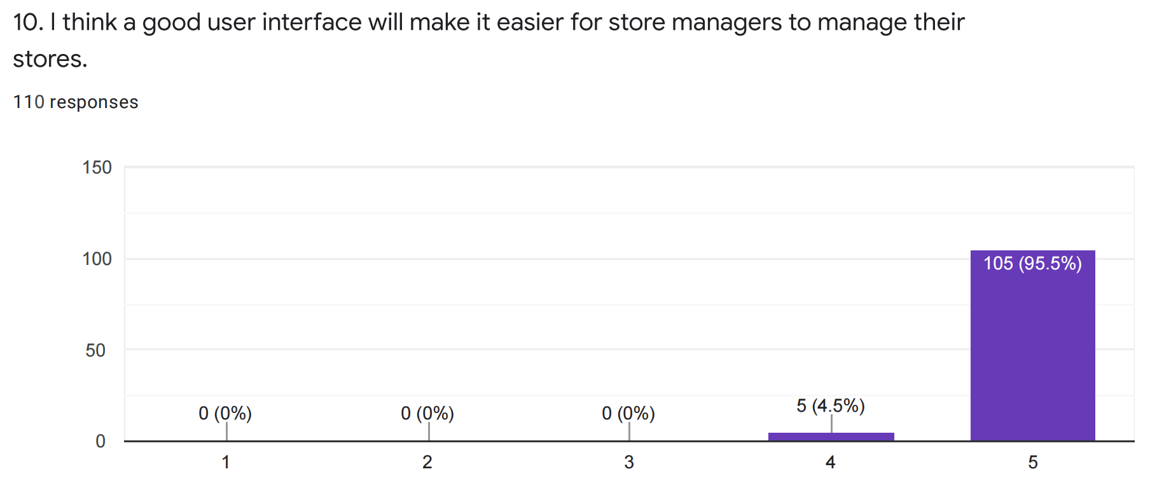

Figure 3.25 Level of agreement with statement: Good user interface makes it easy to manage the store

This linear scale in Figure 3.25 above indicates the extent to which all respondents to the survey agreed with the statement “I think a good user interface will make it easier for store managers to manage their stores”. Here, we can clearly see that most respondents strongly agree with this statement, accounting for 95.5% of all respondents, while a few respondents agree more, accounting for 4.5%, and no respondents disagree. From this chart, we can conclude that most store managers want to use a store management system that has a good user interface because it helps them to manage their stores more easily. Therefore, for the store management application I am going to develop, I will consider designing a good user interface by continuously exploring the user's needs to improve the overall experience of the store manager in performing browsing and management operations, which will not only facilitate the management of the system by the individual retail manager but also help to improve the operational efficiency of the retail business.

## Chapter Summary

Based on this survey, it can be concluded that most retail business managers or store owners would like to have a better tool to help them achieve effective management of their stores, thus improving store management efficiency and performance and reducing the retail operation cost of their stores. In addition, most participants also want their stores to be able to sell their products through online channels. For example, the current operation of traditional retail stores is labour-based for the most part, and as store rent and labour costs rise year by year, coupled with the impact of Internet e-commerce, it makes physical stores less and less patronage, and this program will be able to help them greatly by enabling store managers to synchronize online and offline merchandising and develop marketing strategies that maximize results, which not only can provide store customers with more choices of purchasing methods, but also help to increase store sales and profits.

# CHAPTER 4: SYNTHESIS

## Chapter Introduction

This chapter explains the functional and non-functional requirements of this store management application. To better illustrate the requirements, UML diagrams and storyboards have been drawn, which include Use Case Diagram (in Section 4.1), Activity Diagram (in Section 4.2), Interface Design (in Section 4.3) and Chapter Summary (in Section 4.4). All of the diagrams in each of the section in this chapter are explained in detail.

## Use Case Diagram

To better understand the system, a use case diagram for this store management application was created, using use case diagrams to explain the scope of this project. A use case diagram is a diagram used to show a set of use cases, actors, and the relationships between them. It describes how users want to use the system. The use case diagram allows us to know who the relevant users of the system are or what the system provides to them. Figure 4.1 below shows the use case diagram for this smart store management application.

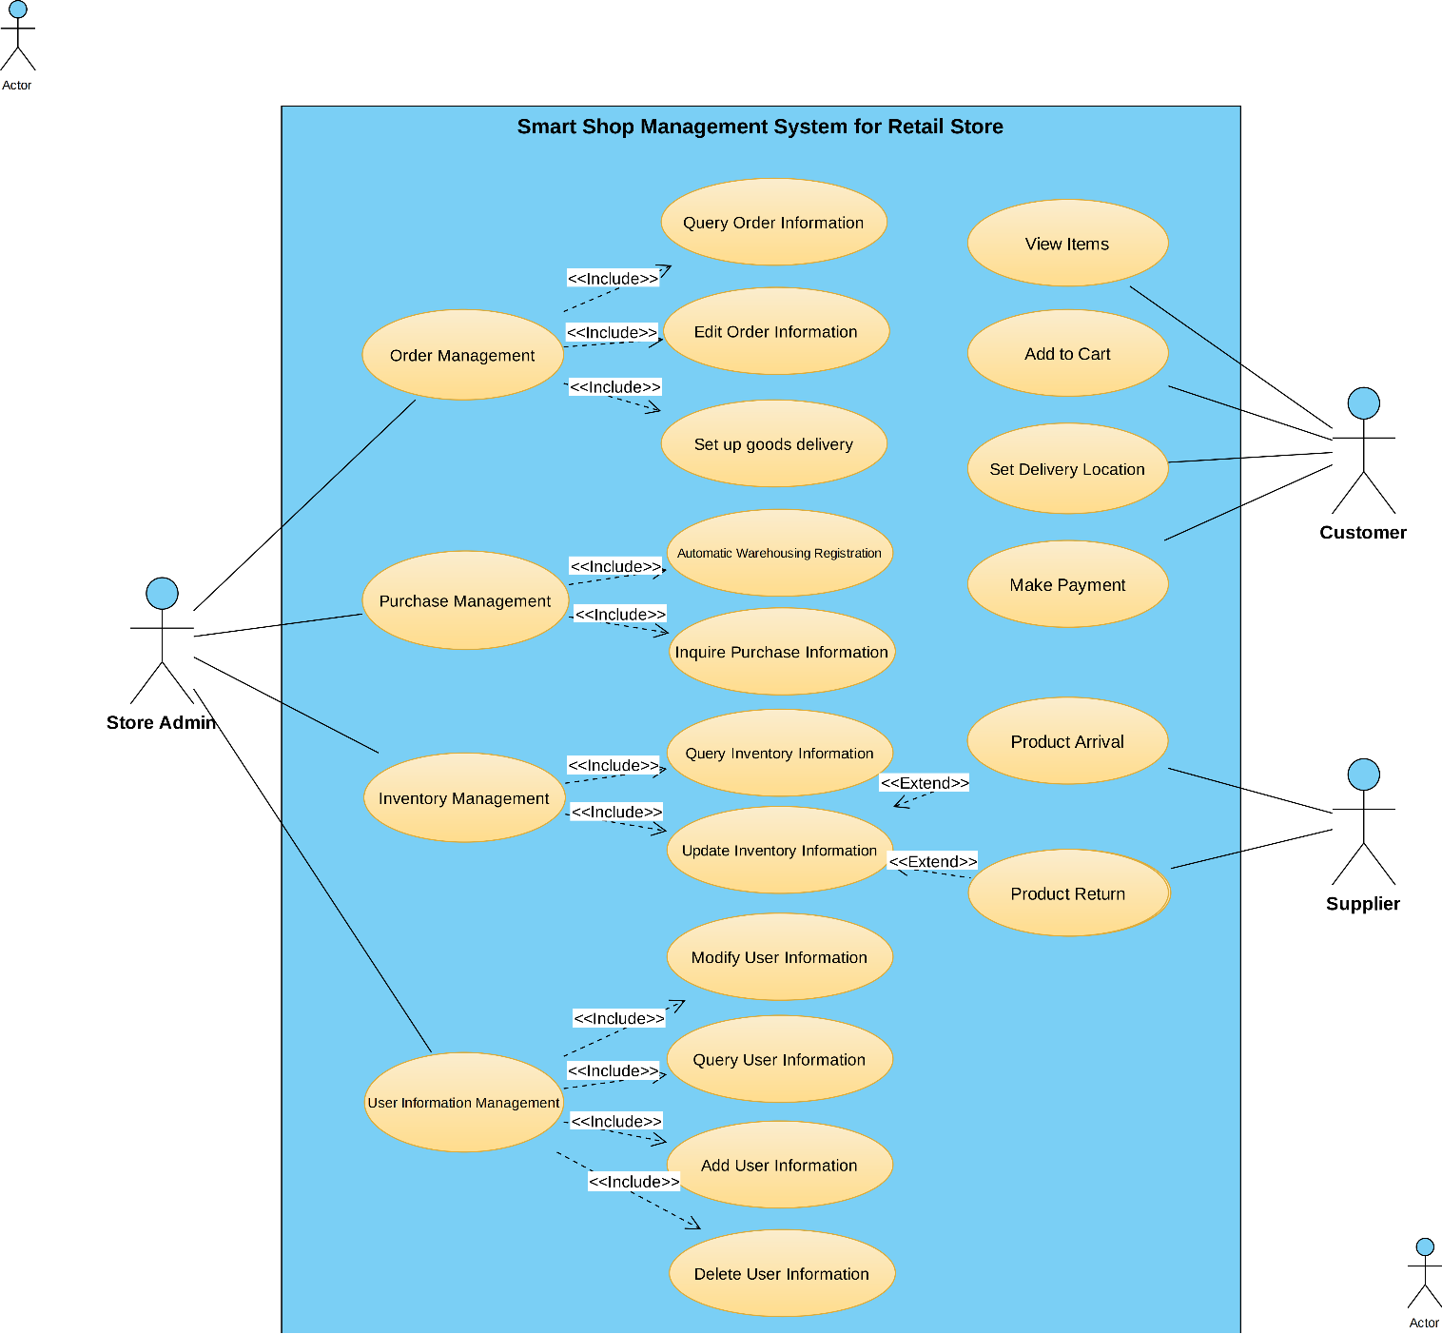

Figure 4.1 User Case Diagram for Smart Shop Management System

In this use case diagram, the three roles represent the store administrator user, the customer user and the vendor. The Store Admin user represents the person in charge of the store, such as the store owner or the core management of the store. The customer user is the person who comes to the store to buy goods or request services, while the supplier is the company that provides goods or services to the retail organization. In this smart store management system, the store administrator's authority should include order management, purchase management, inventory management, and user information management. For order management, the store administrator should be able to query and modify product order information and arrange product delivery for orders submitted by customers. For purchase management, the store administrator should be able to inquire and modify the purchase information of products and register the information of products purchased from suppliers. For inventory management, store administrators should be able to query product information in the inventory and modify or delete product information in the inventory. In addition, store administrators should be able to manage all logged-in user information, including modifying user information, querying user information, creating new user information through the management system, or deleting an existing user information in the system. In addition, for customer users, they can view the products through the product list of the system, including the corresponding thumbnail, price and other attributes of each product. In addition, users can add multiple products to the shopping cart at the same time and perform the purchase operation, and of course, users can set the shipping method and the delivery address of the products when they purchase the products so that the merchant can arrange the delivery of the products. When the purchase operation is completed and the customer submits the order to the merchant, they can make payment for the order. In addition, for the supplier, it is possible to provide goods directly to the retailer, and in the case of a return or exchange, the retailer's store administrator can also return the goods purchased from the supplier.

## Activity Diagram

Activity diagram is a behavior diagram, which describes the behavior of the system. Activity diagrams describe the flow of control from the starting point to the end point, showing the various decision paths that exist in the execution of an activity. Activity diagrams are the key and foundation of UML software development process diagrams. Project planners use this activity-by-activity description of system operating procedures to make the design phase of implementation clearer and easier. The activity diagrams included in this section are Query Order Information (in Section 4.2.1), Delete Order Information (in Section 4.2.2), Set up Goods Delivery (in Section 4.2.3) and Warehousing Registration (in Section 4.2.4). In addition, activity diagrams such as Query Purchasing Information (in Section 4.2.5), Query Stock Information (in Section 4.2.6), Update Stock Information (in Section 4.2.7), Query Employee Information (in Section 4.2.8), Add Employee Information (in Section 4.2.9), Modify Employee Information (in Section 4.2.10), and Delete Employee Information (in Section 4.2.11) are also created.

### Query Order Information

Figure 4.2 below shows the activity diagram for the query order information flow in this store management system.

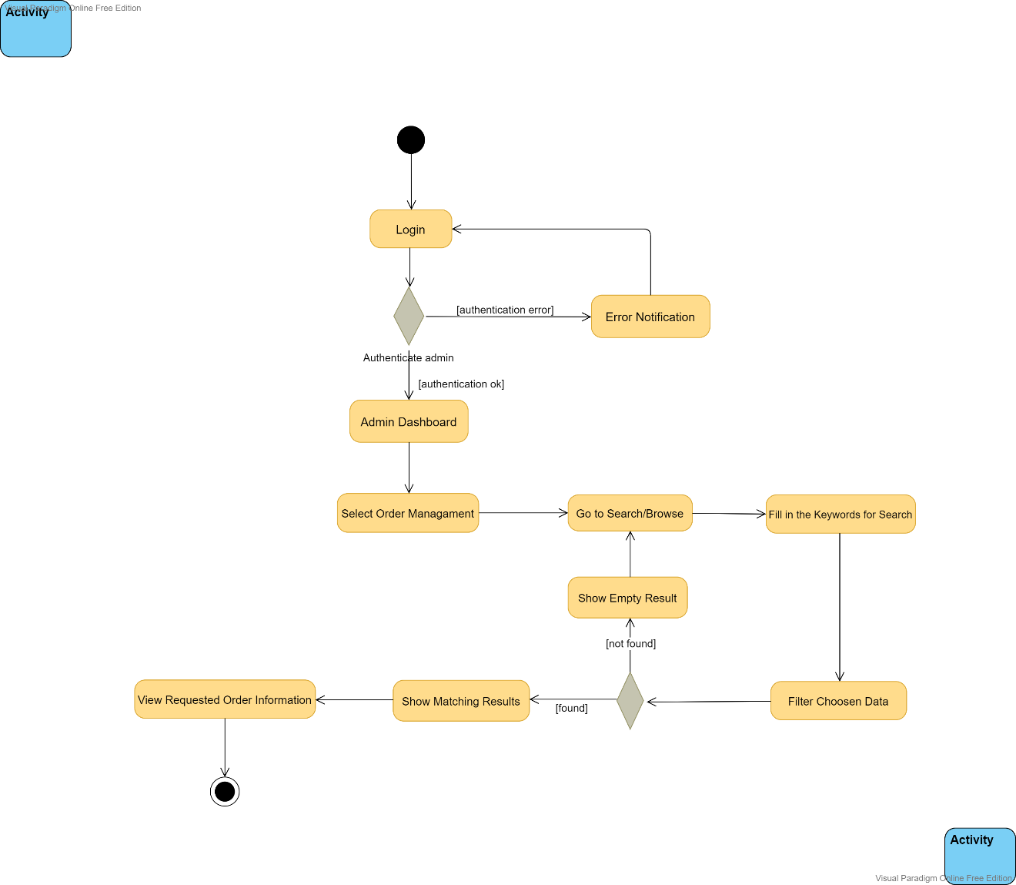

Figure 4.2 Activity diagram for the flow: Query Order Information

In order to search for order information, the store administrator needs to first enter the appropriate account name and password to log into the management system, then click on the login button, after that the system will check if the user is registered in the database, if there is no matching authentication data, then it will indicate that the account does not exist, if the account is valid, then the system will redirect to the home page, at this time the administrator can select the order management module and all the order information will be displayed on this page, and the administrator can search or browse for order information, then the administrator can enter the number of the order they want to search for from the filter, or search based on the time when the order was created, and the system will retrieve the corresponding order entry in the database based on the filtered criteria, and display the obtained data on this page, and the store administrator can browse to the requested order information, as well as the relevant order details. Otherwise, if no order data is retrieved under the filtered criteria, the list will show that there are no relevant order entries under that filtered criteria, the filtered criteria will be reset and the user will be returned to the page where all order information is displayed on the page and they can then re-enter the filtered criteria for the order they want to search for to find the corresponding order information.

### Delete Order Information

Figure 4.3 below shows the activity diagram for the delete order information flow in this store management system.

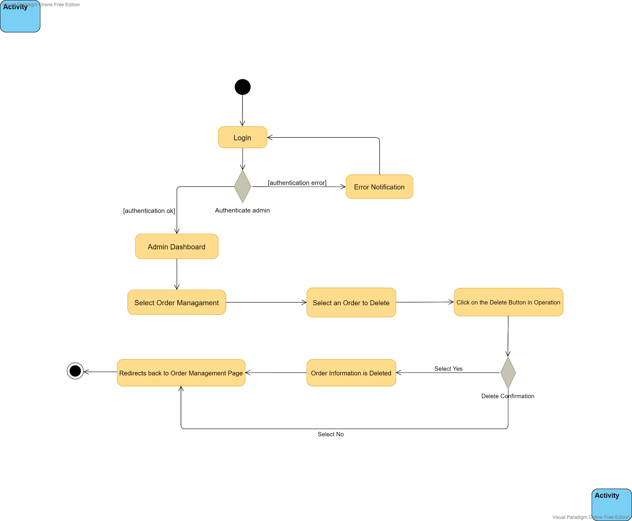

Figure 4.3 Activity diagram for the flow: Delete Order Information

In this activity, in order to delete the order information, the store administrator needs to first enter the appropriate account name and password to log in to the management system, then they click the Login button, after that the system will check if the user is registered in the database, if there is no matching authentication data, then they will be prompted that the account does not exist, if the account is valid, then the system will redirect to the home page, at this point the administrator can select the Order Management module, at this time all order information will be displayed on this page, the administrator can select any order information and perform the delete operation, when the user clicks the delete button, the user will be prompted to confirm the deletion, when they click the Yes button, the verification is passed and the next process will be sent to the database to perform the request to delete the data, when the selected data is already in the database, the order information will be successfully deleted from the database and then the user will be redirected to the page where all the order information is displayed on the page, otherwise, the order will not be deleted.

### Set up Goods Delivery

Figure 4.4 below shows the activity diagram for the set-up goods delivery flow in this store management system.

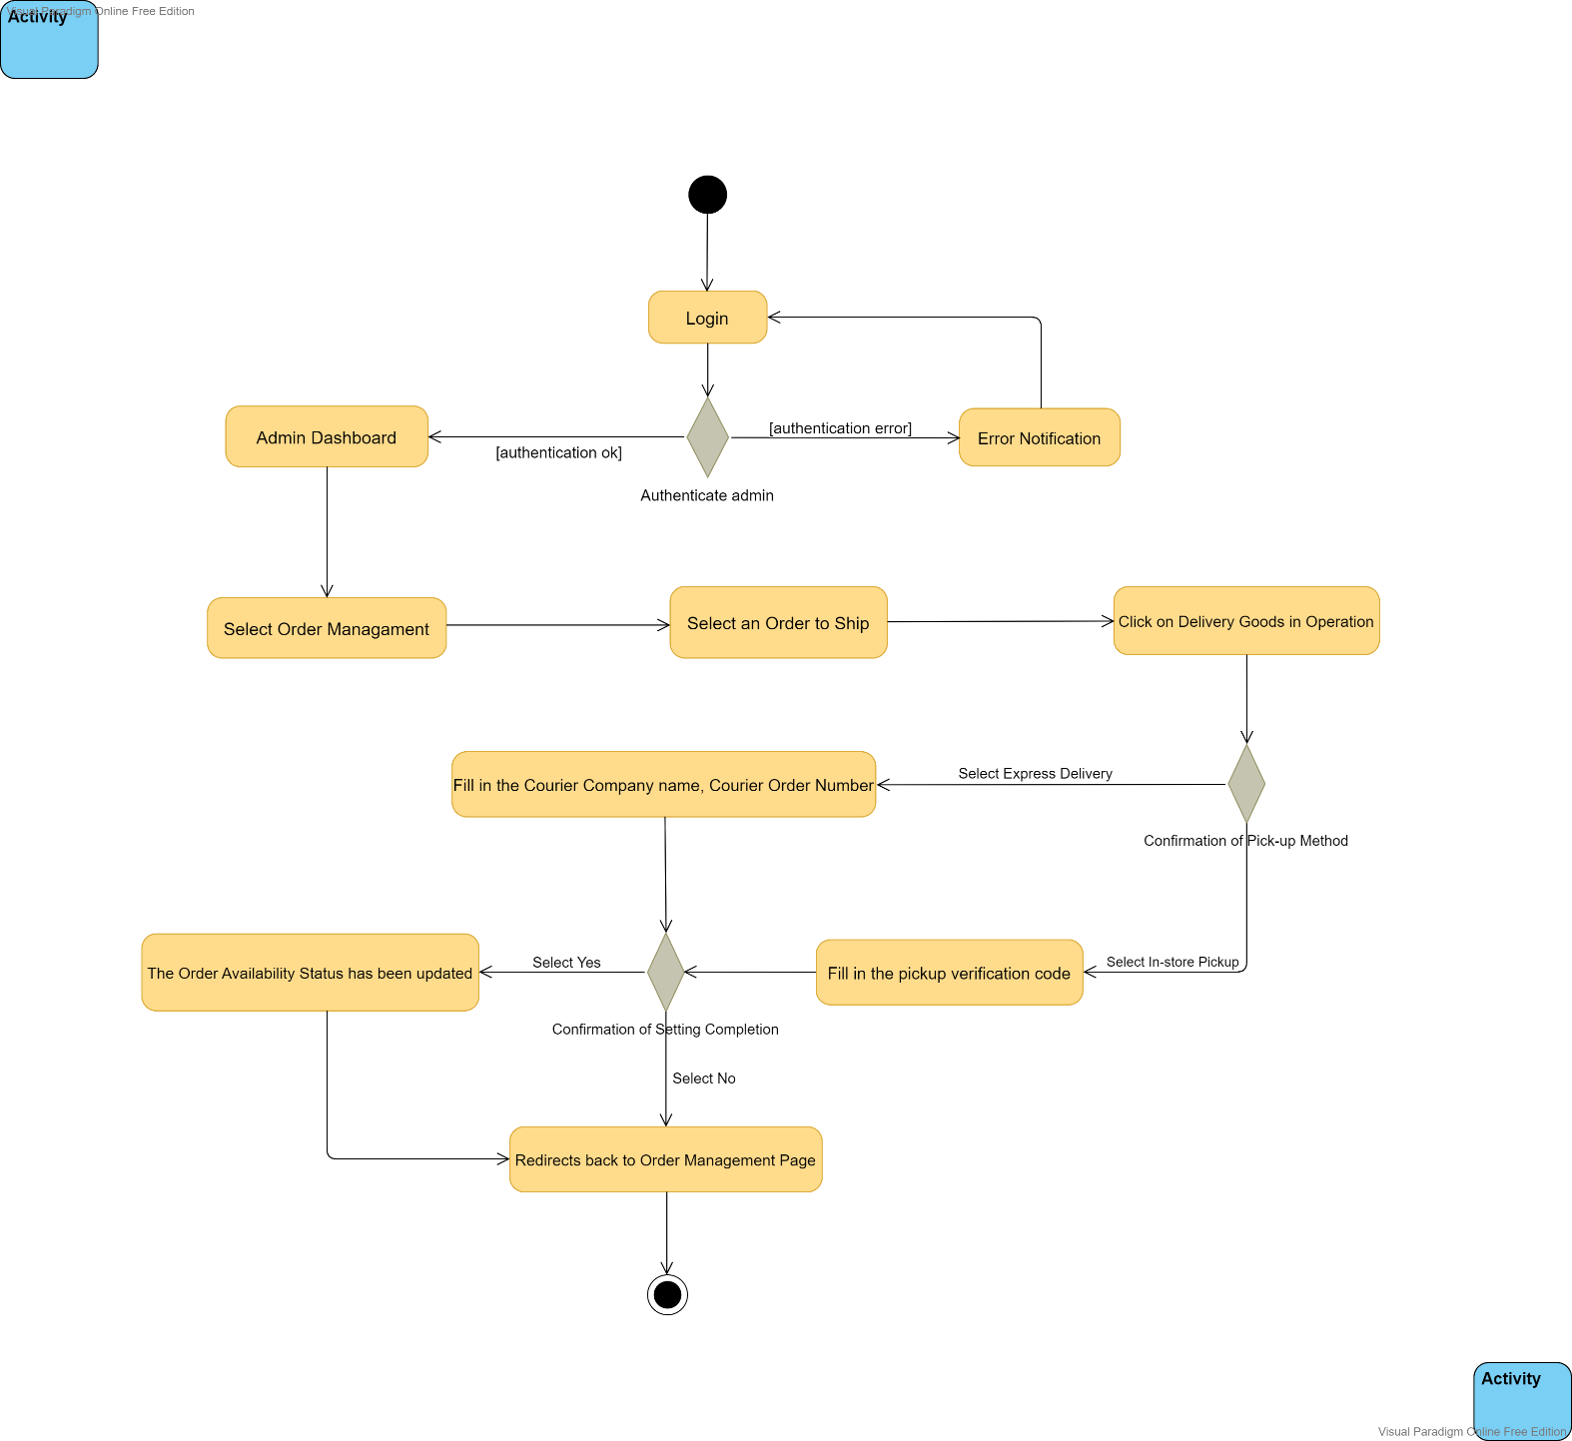

Figure 4.4 Activity diagram for the flow: Set up Goods Delivery

In this activity, in order to set up the delivery of goods, the store administrator needs to first enter the appropriate account name and password to log into the management system, then they click on the Login button, after that the system will check if the user is registered in the database, if there is no matching authentication data, then they will be prompted that the account does not exist, if the account is valid, then the system will redirect to the home page, at this point the administrator can select the Order Management module, then all the order information will be displayed on the page, the administrator can select any order information and perform the shipping operation, when the user clicks the Delivery Goods button, the user will be prompted to confirm the delivery method, they can choose Express Delivery or in-store pickup, if the administrator chooses Express Delivery for delivery, then they will need to fill in the details of Courier Company name, Courier Order Number, or if the administrator chooses in-store pickup for delivery, they will need to fill in the details of the pickup verification code details, after all the information is filled in, they will be prompted to confirm that the setup is complete. When they click Yes, the order availability status has been updated and the shipment is ready to be scheduled, then the user will be redirected to the order management page, which all the order information is displayed on the page, otherwise, if they click No then the order will not be scheduled for shipment

### Warehousing Registration

Figure 4.5 below shows the activity diagram for the warehousing registration flow in this store management system.

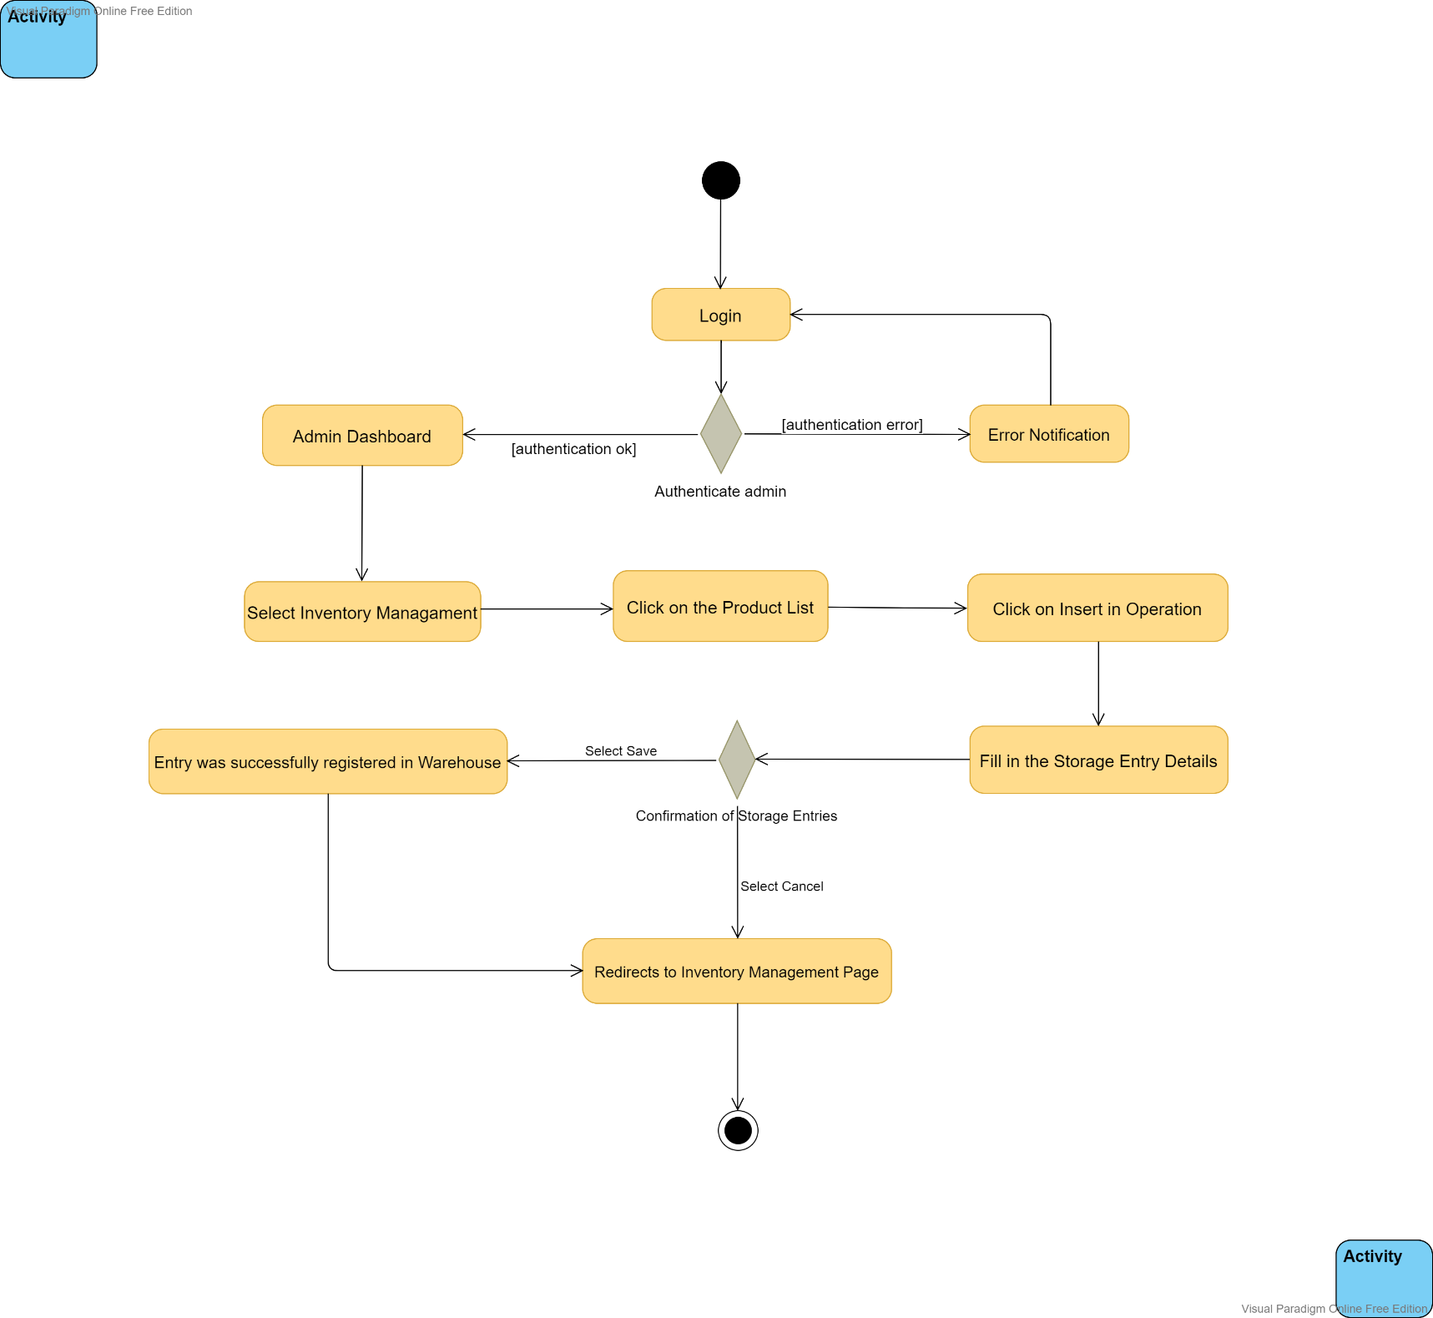

Figure 4.5 Activity diagram for the flow: Warehousing Registration

In this activity, in order to complete the Warehousing Registration, the store administrator needs to first enter the appropriate account name and password to log into the management system, then they click on the Login button, after that the system will check if the user is registered in the database, if there is no matching authentication data, then it will indicate that the account does not exist, if the account is valid, then the system will If the account is valid, the system will redirect to the home page, then the administrator can select the inventory management module and click on the product list, then all the product information will be displayed on the page, the administrator can add a new product storage entry by clicking on the Insert button in the Operation column, then the user will be prompted to upload the product details including product picture, product name, product category, product price, product Status (On/Shelf), Product Description, Product Inventory Remaining, Cost Price, Virtual Sales, and Virtual Views, etc. After all the information is filled in, they will be prompted to confirm the storage entry, and when they click Save button, the entry will be successfully registered to the warehouse, at which point the product have been successfully registered, and then the user will be redirected to the Inventory Management page where all in-stock product information is displayed, otherwise, if they click Cancel button, then the entry will not be registered in the warehouse.

### Query Purchasing Information

Figure 4.6 below shows the activity diagram for the query purchasing information flow in this store management system.

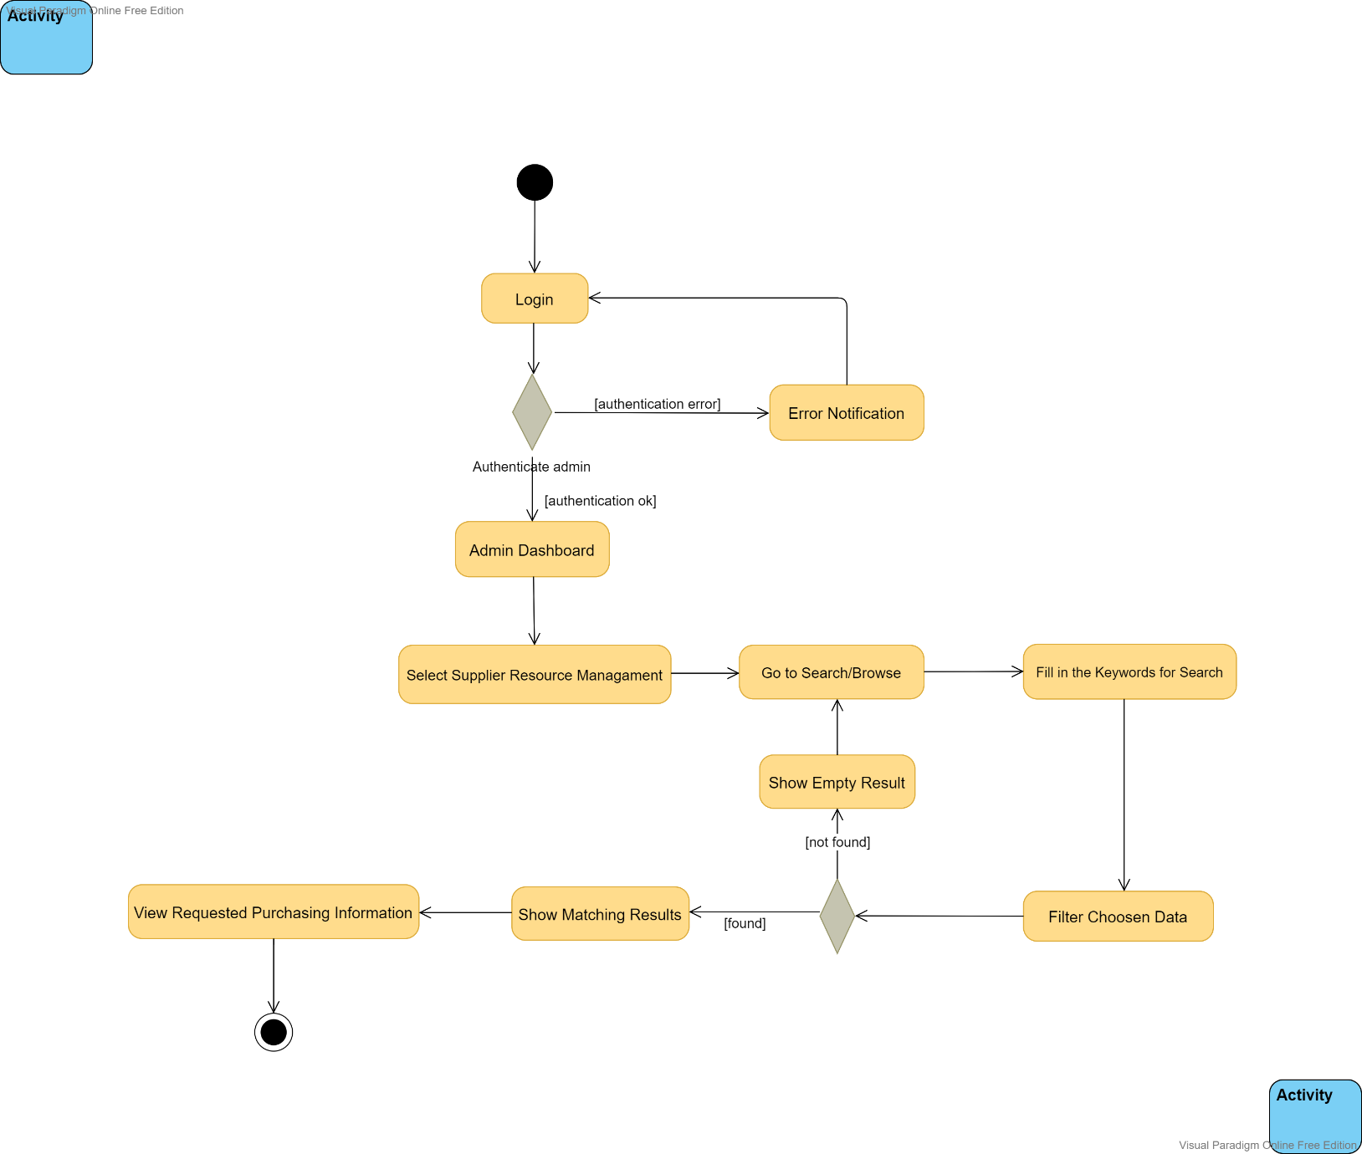

Figure 4.6 Activity diagram for the flow: Query Purchasing Information

In order to search purchasing information, the store administrator needs to first enter the appropriate account name and password to login to the management system, then click the login button, after that the system will check if the user is registered in the database, if there is no matching authentication data, then it will indicate that the account does not exist, if the account is valid, then the system will redirect to the home page, then the administrator can go to the Inventory Management module, then select Supplier Resource Management, all the stores' purchases from suppliers will be displayed on this page, and administrators can search or browse for purchasing information, then administrators can enter a part of Item Name from the filter they want to search for purchasing information, or search according to the incoming time of the purchased products, and the system will retrieve the corresponding items in the database according to the filtered conditions and display the obtained data on that page, where the store administrator can browse to the requested purchase information, as well as the related purchase details. Otherwise, if no purchase item is retrieved under the filtered criteria, the list will show that there are no relevant entries under that filtered criteria, the filtered criteria will be reset and the user will be returned to the page where all purchase information is displayed on the page and they can then re-enter the filtered criteria for the purchase information they want to search for to find the corresponding purchase information.

### Query Stock Information

Figure 4.7 below shows the activity diagram for the query stock information flow in this store management system.

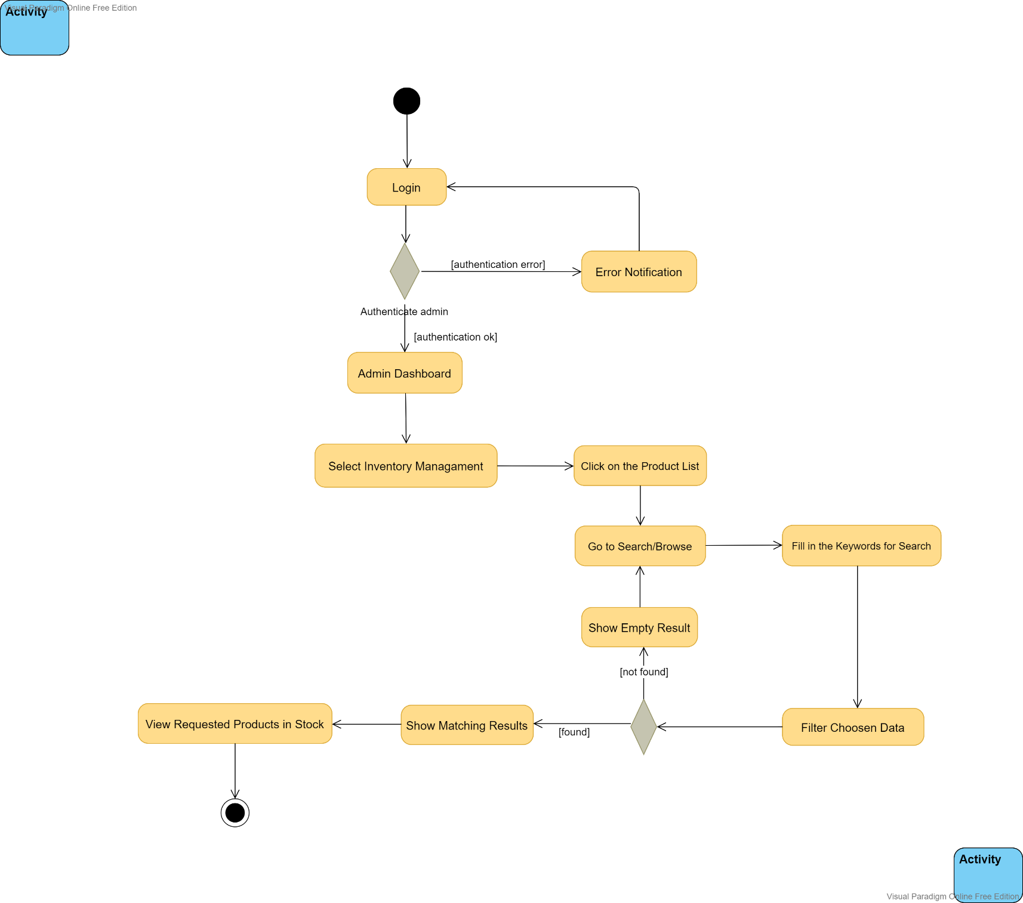

Figure 4.7 Activity diagram for the flow: Query Stock Information

In this activity, in order to query stock information, the store administrator needs to first enter the corresponding account name and password to log in to the management system, and then click the login button, then the system will check whether the user has been registered in the database, if there is no matching authentication data, then it will prompt that the account does not exist. If the account is valid, the system will redirect to the home page. At this time, the administrator can enter the inventory management module, and then select Product List. All the product information in the inventory will be displayed on this page. The administrator can search or browse the information of the products in these stocks. Then, the administrator can enter the Product Name, Product introduction, Product price of the product information they want to query from the filter, and according to the status of the product they want to search for in the stock perform a query, the system will retrieve the corresponding product entry in the database according to the filtering conditions, and display the obtained data on this page, the store administrator can browse to the product information in the requested inventory, as well as the relevant product details. Otherwise, if no product information is retrieved under the filtered condition, the list will show that there are no related entries under that filter condition, the filter condition will be reset, and the user will be returned to the page where all the product information in the stock is displayed, they can then re-enter the filter criteria for the in-stock product information they want to search to find the corresponding in-stock product information.

### Update Stock Information

Figure 4.8 below shows the activity diagram for the update stock information flow in this store management system.

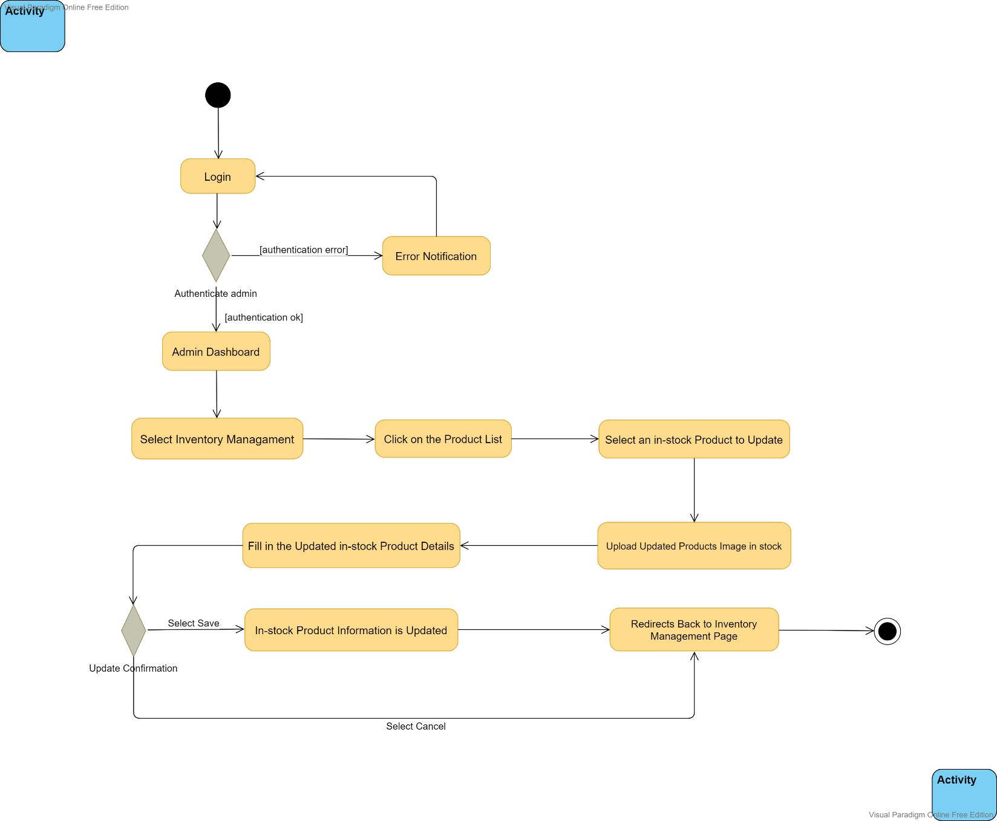

Figure 4.8 Activity diagram for the flow: Update Stock Information

In this activity, in order to update the stock information, the store administrator needs to first enter the corresponding account name and password to log in to the management system, and then click the login button, then the system will check whether the user has been registered in the database, if there is no matching authentication data, then it will prompt that the account does not exist. If the account is valid, the system will redirect to the home page. At this time, the administrator can enter the inventory management module, and then select Product List. All the product information in the inventory will be displayed on this page. The administrator can update the information of the products in these stocks. First, check a product in the stock that needs to be updated, and then click the modify button. At this time, an interface will pop up for us to enter the updated information. We first start from our device uploads the updated product image, and then fills in the details of the product in the updated inventory, including product image, product name, product category, product price, product sort, product status, product description, product remaining inventory, product cost price, product virtual sales, product virtual pageview information, after filling in, we can click the save button to save, at this time the information of the products in the inventory has been updated, the system will redirect back to the inventory management page, in addition, if we click the cancel button , the system will redirect directly back to the inventory management page, and the information we just updated will not be saved.

### Query Employee Information

Figure 4.9 below shows the activity diagram for the query employee information flow in this store management system.

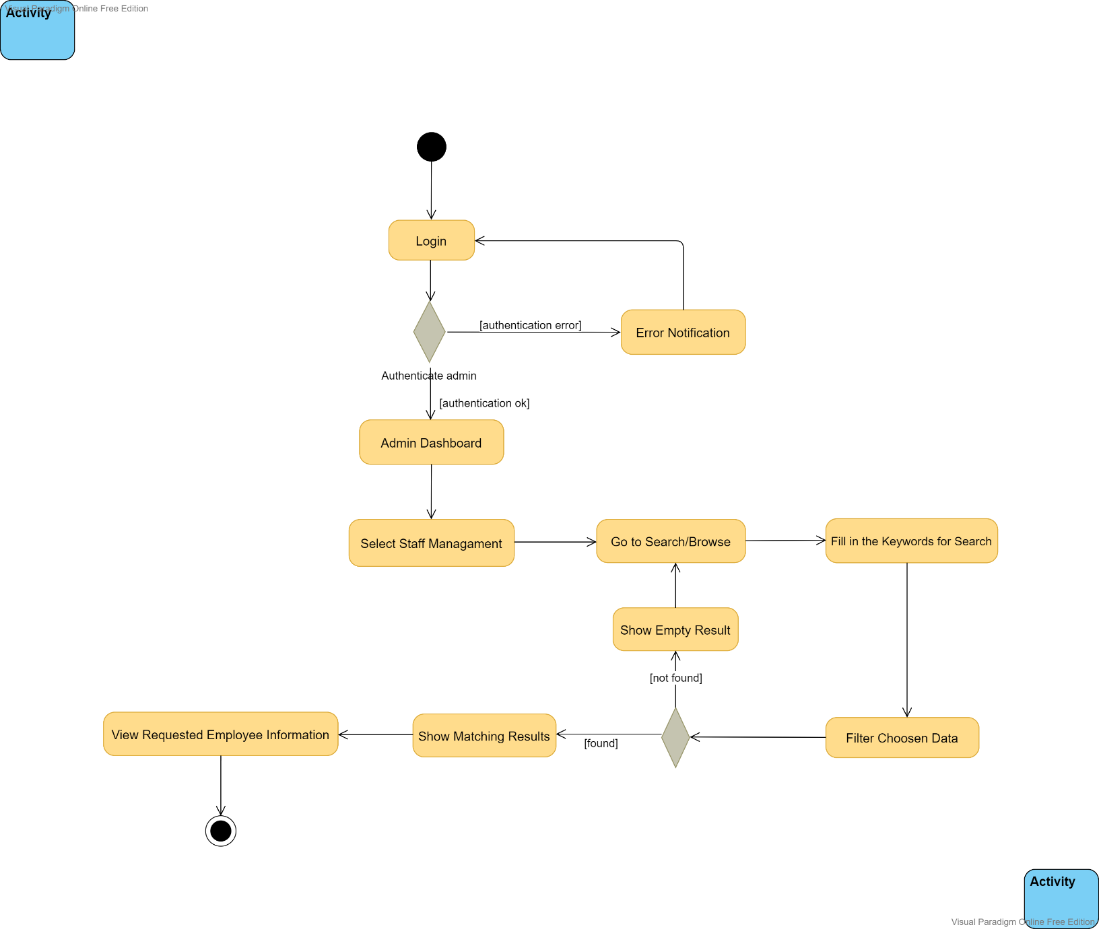

Figure 4.9 Activity diagram for the flow: Query Employee Information

In this activity, in order to search staff information, the store administrator needs to first login to the management system by entering the appropriate account name and password, then click on the Login button, after that the system will check if the user is registered in the database, if there is no matching authentication data, then it will indicate that the account does not exist, if the account is valid, then the system will redirect to the home page, at this point the administrator can access the User Management module, then select Staff Management, all the staff information will be displayed on that page, the administrator can search or browse for the staff information, then the administrator can enter the part of User Name from the filter that they want to search for the staff information, or search according to the status of the staff, or the creation time of the staff account in the system, the system will search according to the filtered conditions to retrieve the corresponding employee information in the database and display the obtained data on this page, where the store administrator can browse to the requested employee information, and the related employee details. Otherwise, if no employee data is retrieved under the filtered criteria, the list will show that there are no relevant entries under that filtered criteria, the filtered criteria will be reset, and the user will be returned to the page where all employee user information is displayed, and they can then re-enter the filtered criteria for the employee information they want to search for to find the appropriate employee information.

### Add Employee Information

Figure 4.10 below shows the activity diagram for the add employee information flow in this store management system.

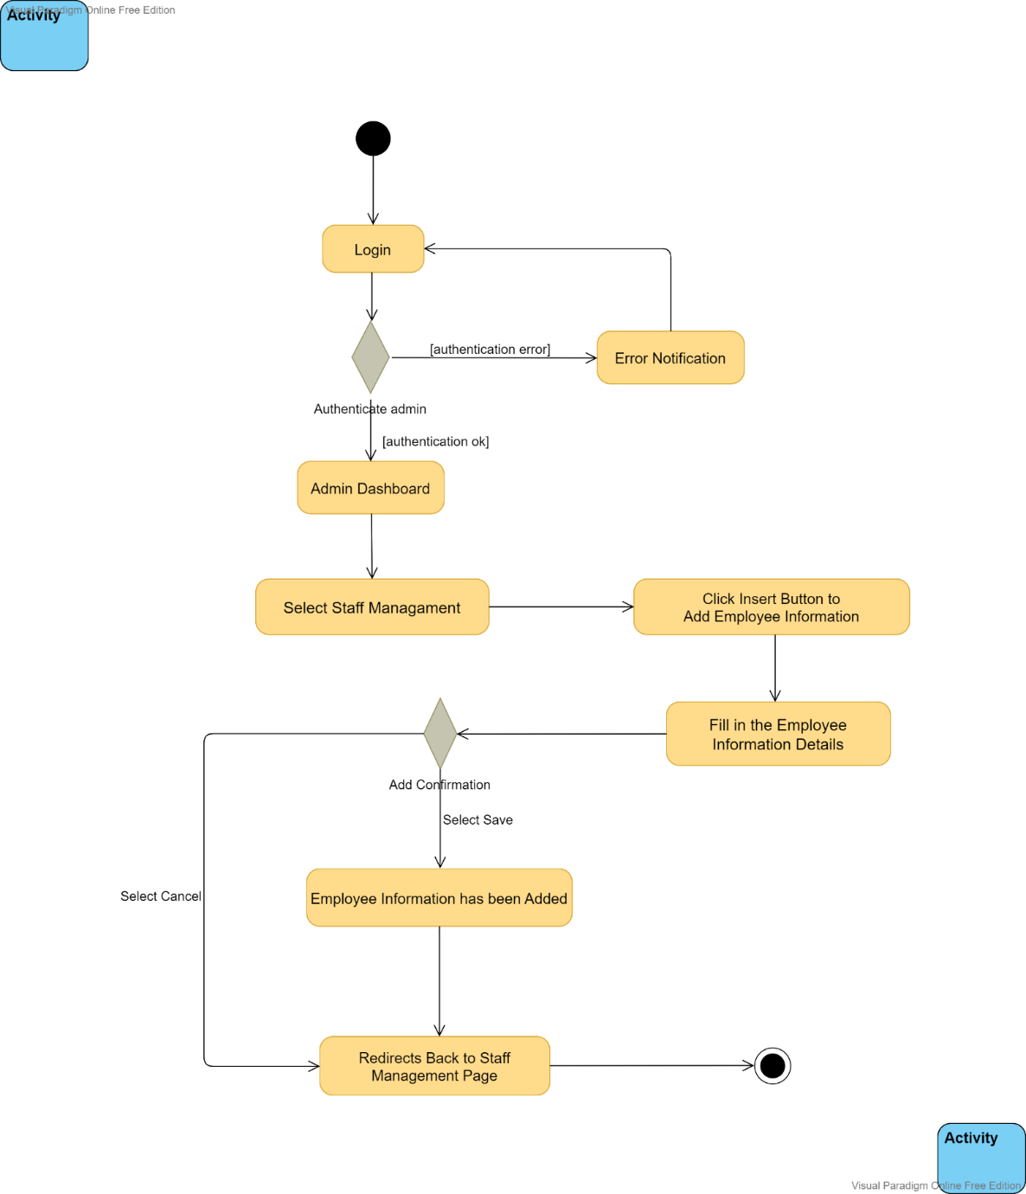

Figure 4.10 Activity diagram for the flow: Add Employee Information

In this activity, in order to add employee information, the store administrator needs to first enter the corresponding account name and password to log in to the management system, and then click the login button, then the system will check whether the user has been registered in the database, if there is no matching authentication data, then It will prompt that the account does not exist, if the account is valid, the system will redirect to the home page. At this time, the administrator can enter the user management module, and then select Staff Management, at this time, all employee information will be displayed on this page. Administrator can add new employee information, first click the Insert button, an interface will pop up for us to enter the account details of the new employee, the required information includes the employee's username, the department name the employee belongs to, the employee's phone number, the employee's email address, the employee's gender, the employee's status, the employee's position, the employee's permissions, and other remark information, etc. After filling in, we can click the save button to save. At this time, the new employee account information has been created, and the system will redirect back to the Staff management page. In addition, if we click the cancel button, the system will redirect directly back to the Staff management page, and the employee information we just added will not be saved.

### Modify Employee Information

Figure 4.11 below shows the activity diagram for the modify employee information flow in this store management system.

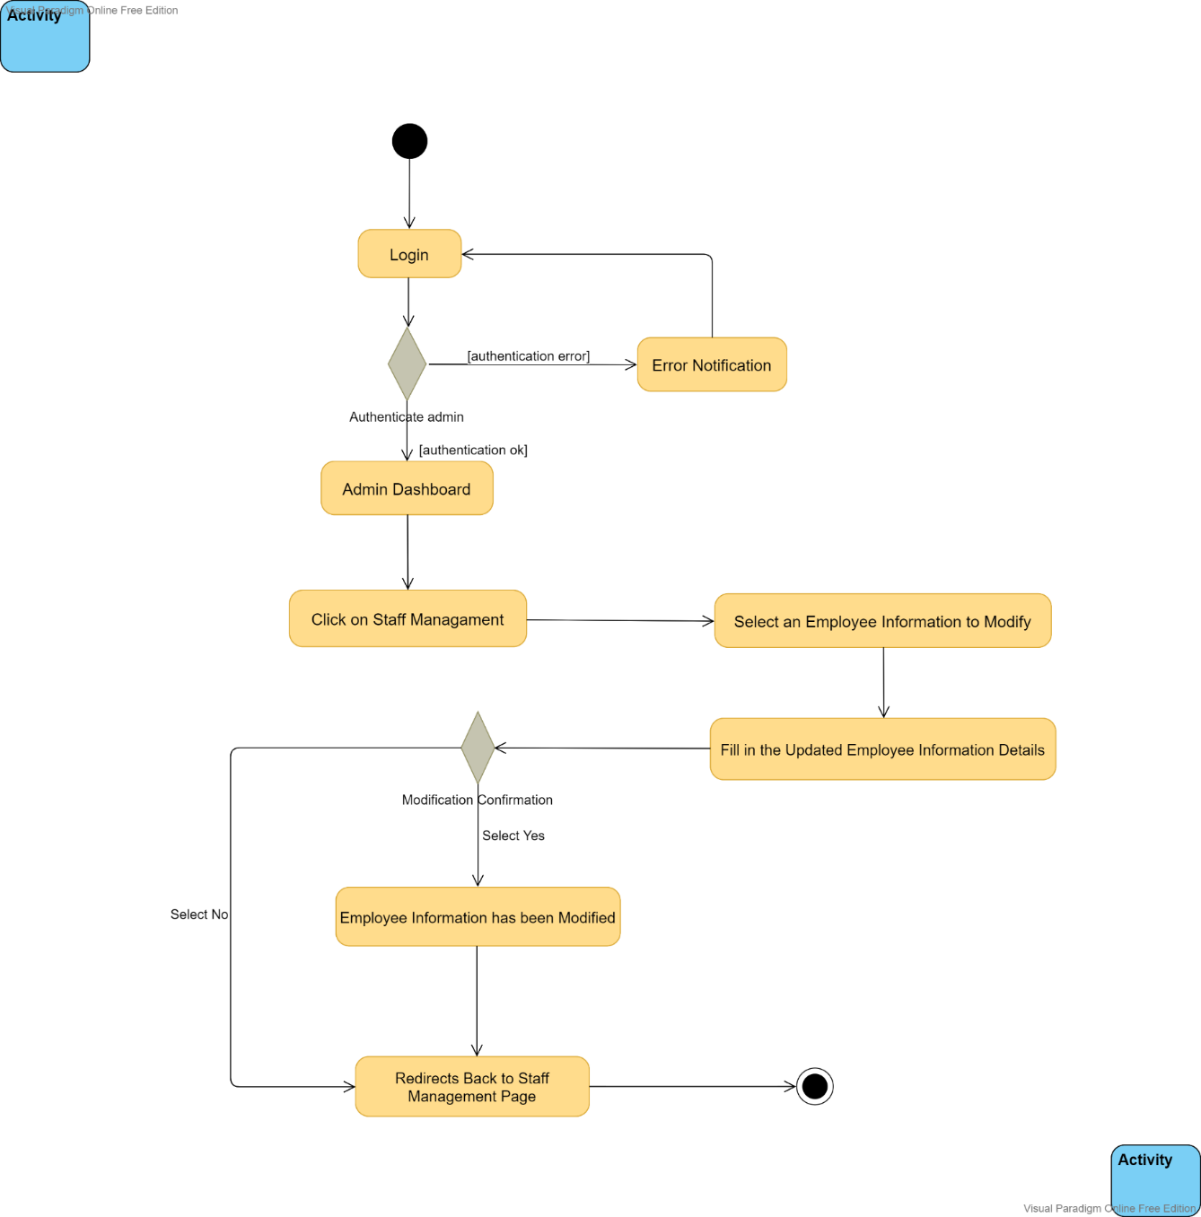

Figure 4.11 Activity diagram for the flow: Modify Employee Information

In this activity, in order to modify the employee information, the store administrator needs to first enter the corresponding account name and password to log in to the management system, and then click the login button. After that, the system will check whether the user has been registered in the database. If there is no matching authentication data, then it will prompt that the account does not exist. If the account is valid, the system will redirect to the home page. At this time, the administrator can enter the user management module, and then select Staff Management, at this time, all employee information will be displayed on this page, and the administrator can modify the information of these employees. First, check an employee entry that needs to be modified, and then click the modify button, at this time, an interface will pop up for us to enter the modified employee account details, the modifiable information includes the employee's username, the name of the department the employee belongs to, the employee's phone number, the employee's email address, the employee's gender, the employee's status, the employee's position, the employee's authority, and other remark information, etc. After the modification is completed, we can click the Yes button to save, at this time, the information of the employee account has been updated, and the system will redirect back to the Staff management page. In addition, if we click the No button, the system will redirect directly back to the Staff management page, and the employee information we just modified will not be saved.

### Delete Employee Information

Figure 4.12 below shows the activity diagram for the delete employee information flow in this store management system.

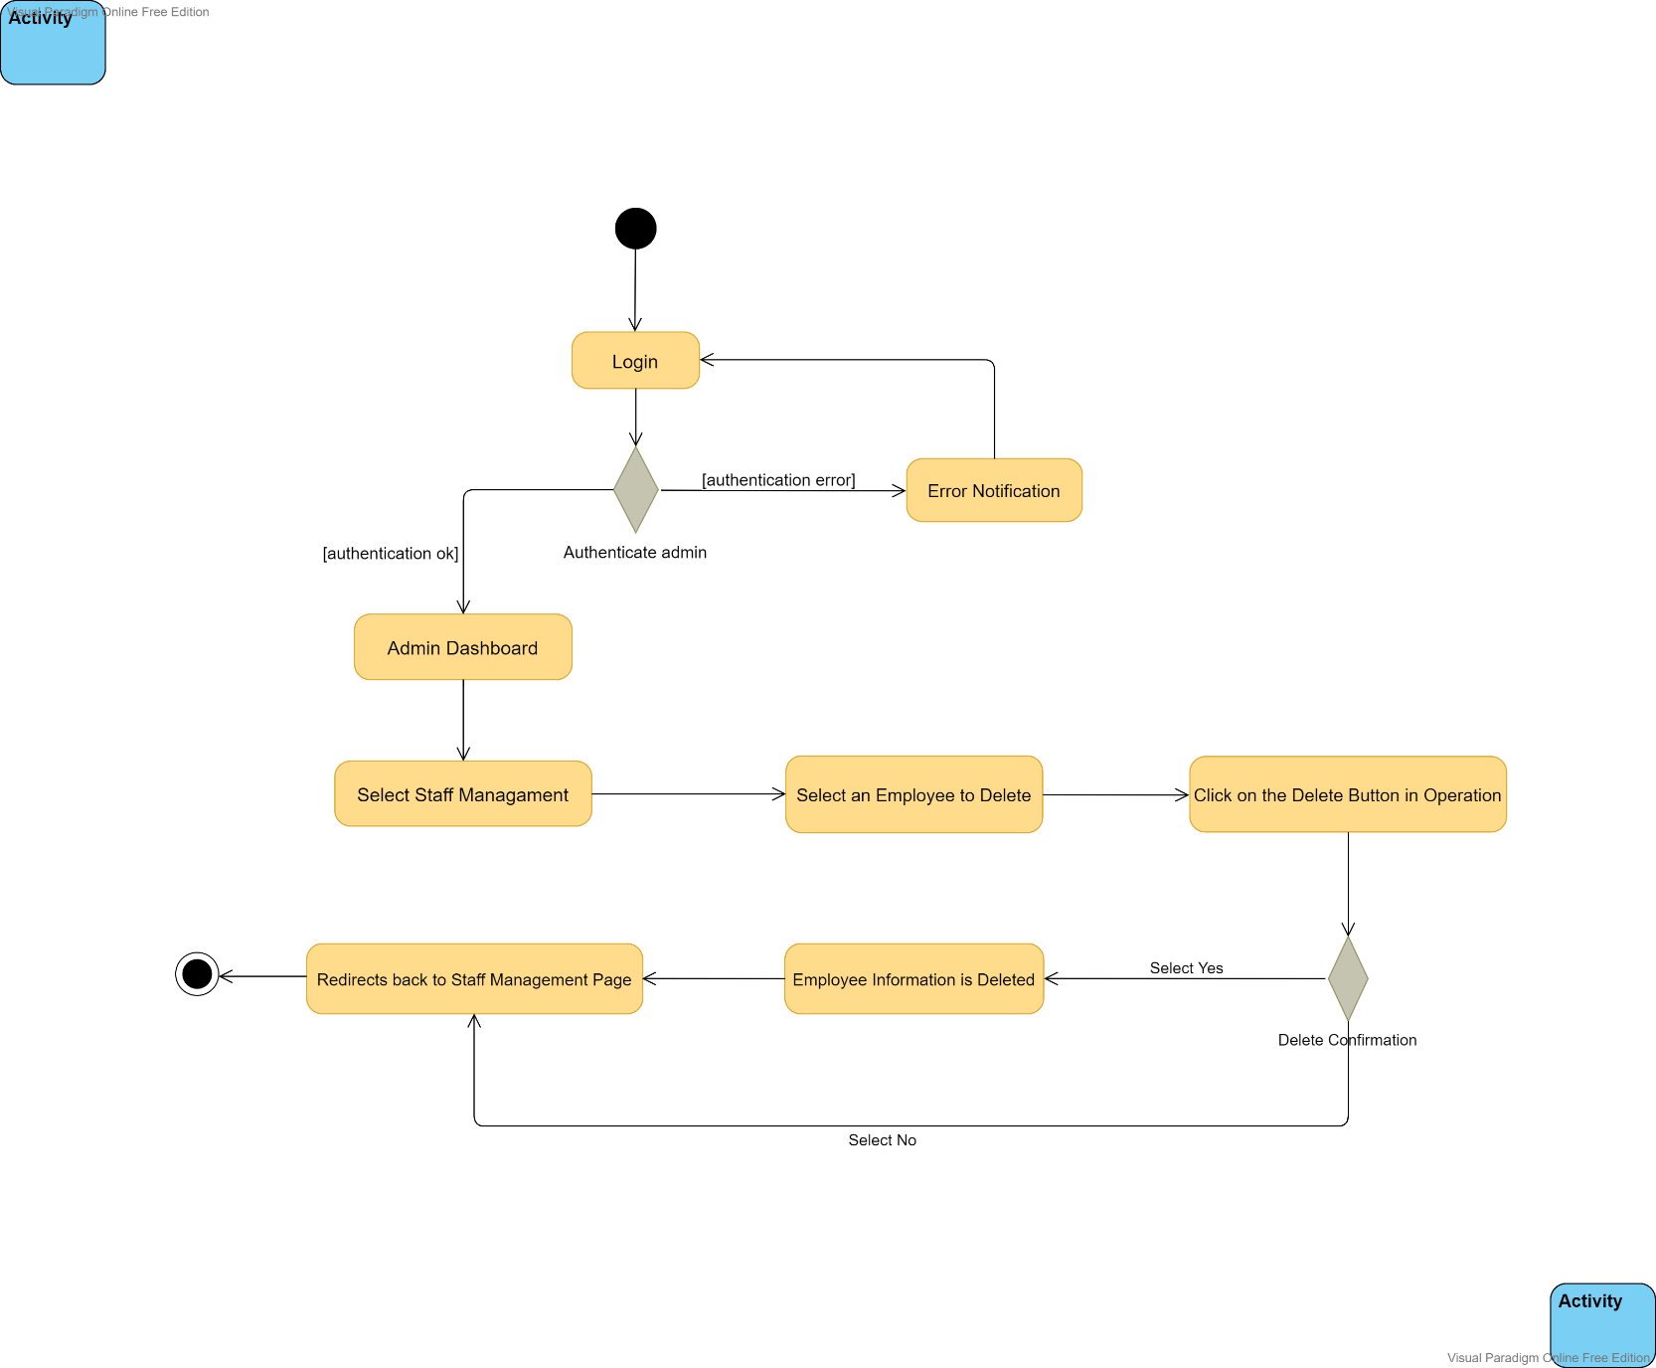

Figure 4.12 Activity diagram for the flow: Delete Employee Information

In this activity in order to delete employee information the store administrator needs to first enter the appropriate account name and password to log in to the management system, then they click on the login button, after that the system will check if the user is registered in the database, if there is no matching authentication data then they will be prompted that the account does not exist, if the account is valid then the system will redirect to the home page, at this point the administrator can select Staff Management module, at this time all staff information will be displayed on this page, the administrator can select any staff account information and perform the delete operation, when the user clicks the delete button, the user will be prompted to confirm the deletion, when they click Yes, the verification is passed and the next process will be sent to the database to perform the request to delete the data, when the selected data is already in the database, the staff information will be successfully deleted from the database and then the user will be redirected to the page where all employee information is displayed, otherwise, that employee information will not be deleted.

## Interface & Contents Design

An interface is an integral part of the system that connects or bridges the system and the user. With an interface, users can interact with the system more easily. This section includes the design of each interface in this store management system to show how the application's interface should be developed, including content such as validation messages, alert messages, error and exception handling messages. A detailed description of the interfaces for all developed systems is provided below.

### Web Application Logo for Smart Shop Management System

Figure 4.13 below shows the Web Application Logo for Smart Shop Management System



Figure 4.13 Web Application Logo for Smart Shop Management System

### The Layout of the Application Login Page

Figure 4.14 below shows the layout of the store management application login page

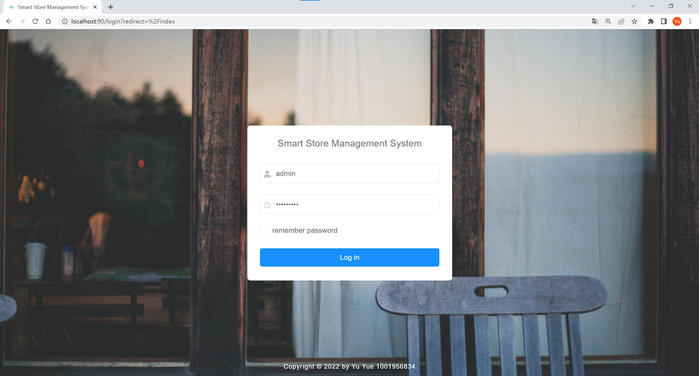

Figure 4.14 The Layout of the Application Login Page

### The Home Page of the Store Management System

Figure 4.15 below shows the layout of the home page of the store management system

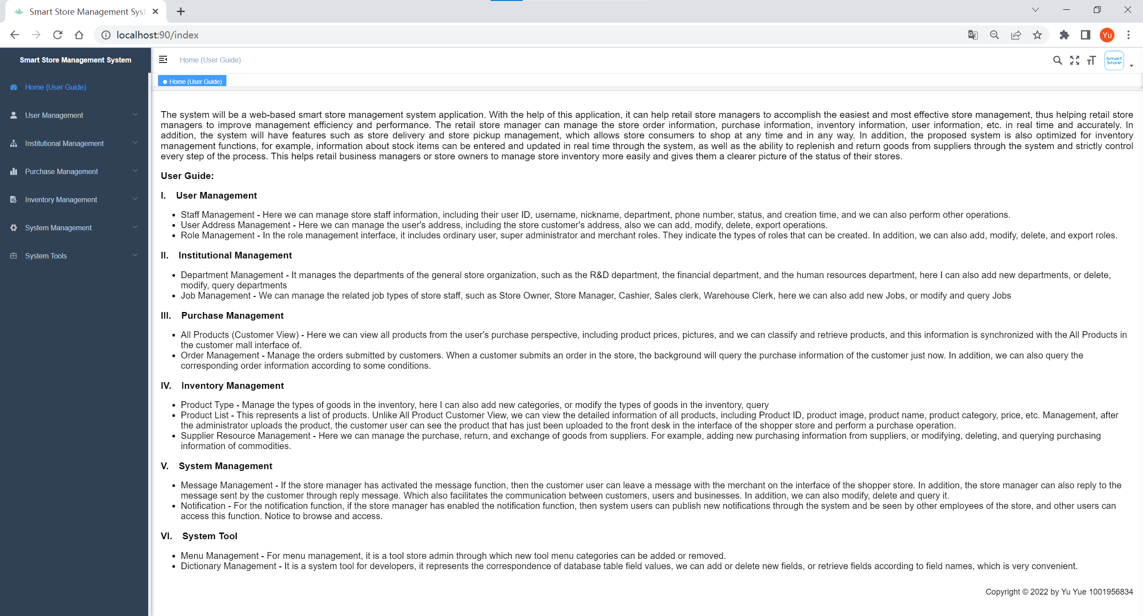

Figure 4.15 The Layout of the Application Home Page

### The User Management Module: Staff Management

Figure 4.16 below shows the layout of the Staff Management Page for the User Management module of the Store Management System

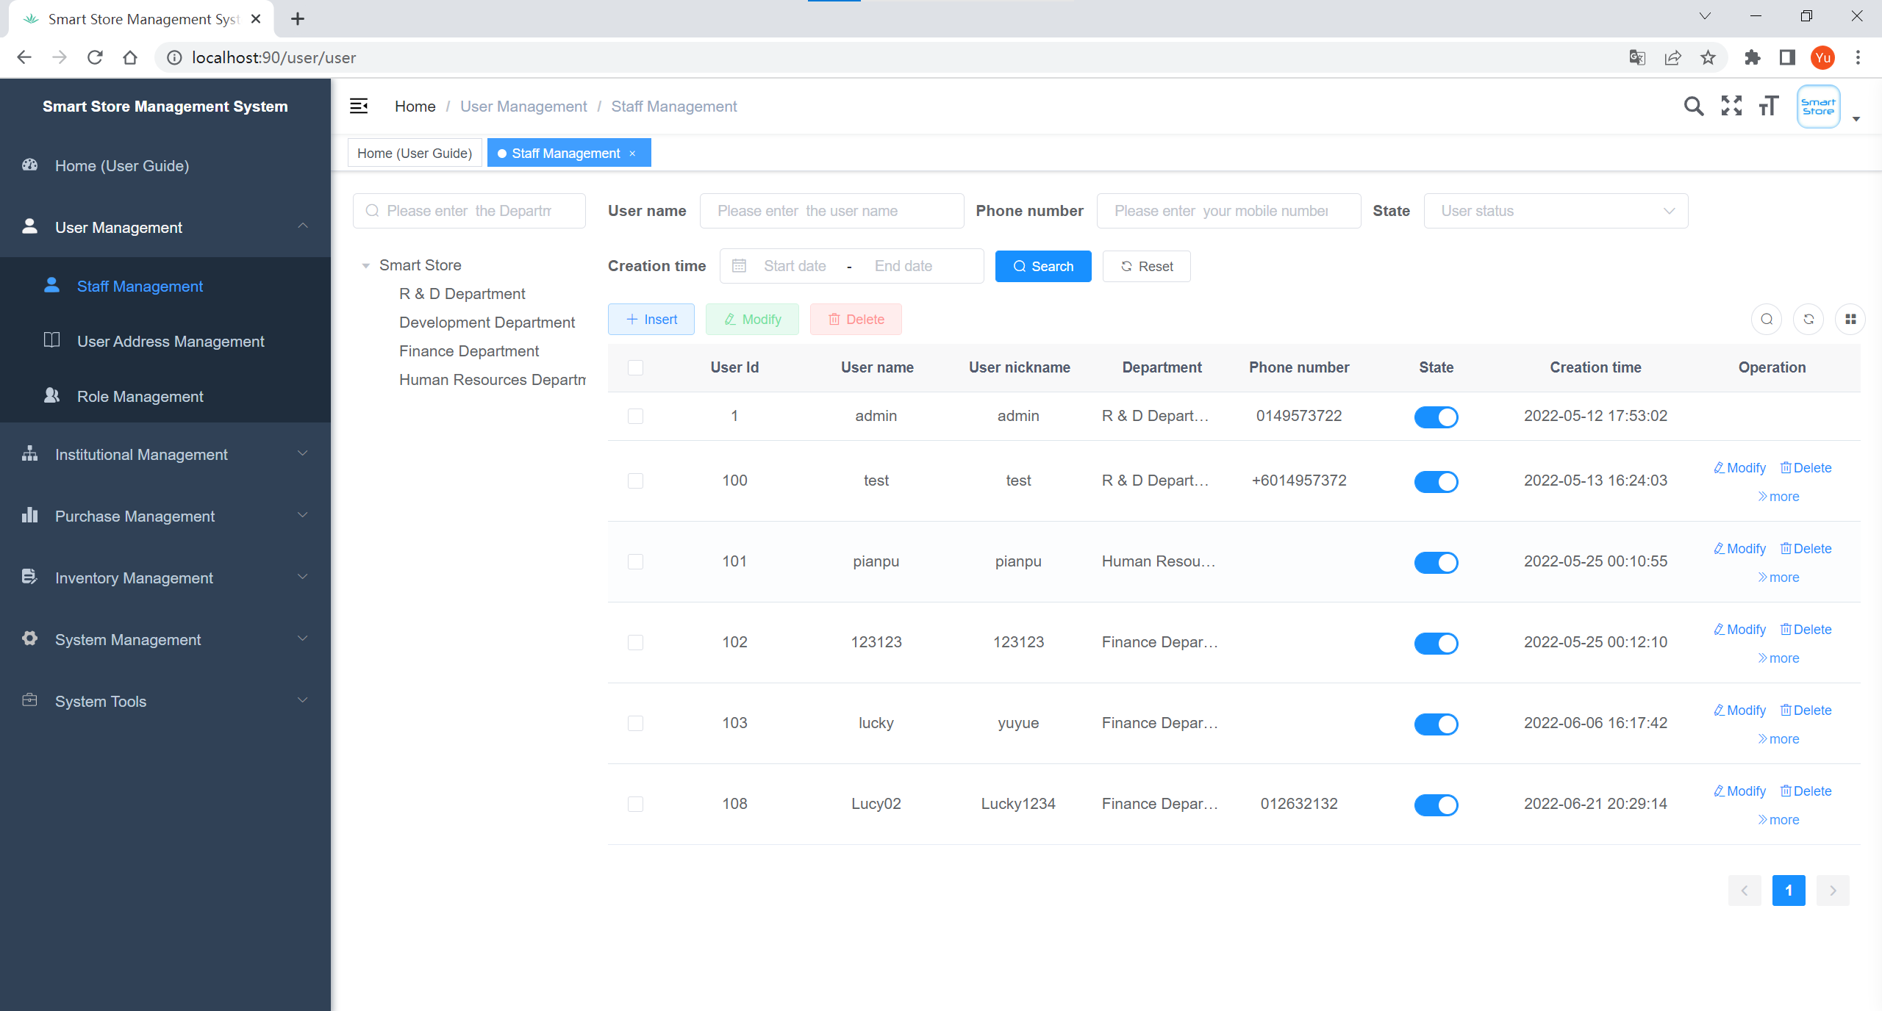

Figure 4.16 Staff Management Page for the User Management module of the application

|  |  |  |
| --- | --- | --- |
| Interface: **Staff Management** | | |
| Purpose: The page displayed after the administrator clicks Staff Management, under which the administrator can manage the staff's information. | | |
| **Item** | **Purpose** | **Data Type/ Implementation** |
| “Staff Management” (Label) | Name of the module | Text Label |
| Department | Receive the department name from the administrator to filter the details of the staff of the corresponding department | String |
| Username | Username of the staff, where the administrator can enter the user name to filter the corresponding staff | String |
| Phone Number | The phone number of the staff, where the administrator can enter the phone number to filter the staff according to the phone number | String |
| State | Staff status, it is divided into normal and deactivate status, the administrator can select the status here to filter the staff with the corresponding status | Options Menu Control |
| Creation Time | Staff’s account registration time, the administrator can select the corresponding time range here to filter the staff whose registration time is within this time range | Date Picker |
| Search | Search button, when the administrator has finished inputting all the fields, click this button, it will find the corresponding staff information in the database according to the inputted data, and return the staff information that meets the filtering criteria to this page | Button |
| Reset | Reset button, by clicking this button, the administrator can reset all the filter conditions that have been entered, and then the user will be redirected to the page where all the staff information is displayed. | Button |
| Insert | Insert button, administrator can click this button to create a new employee account profile, the required information includes the employee's username, department name, phone number, email address, gender, status, title, role, amount, and remark detail | Button |
| Modify | Modify button, through which the administrator can modify the staff account profile, which includes the staff member's username, department name, phone number, email address, gender, status, position, role, amount, and note details | Button |
| Delete | Delete button, by clicking this button, the administrator will be asked whether to delete the staff account from the system, if we click Yes, the staff account will be removed from the system | Button |
| More | The More button, through which the administrator can perform more operations, such as reset password, allows the administrator to change the password for a staff account to log in to the system | Button |

### The User Management Module: Address Management

Figure 4.17 below shows the layout of the Address Management Page for the User Management module of the Store Management System

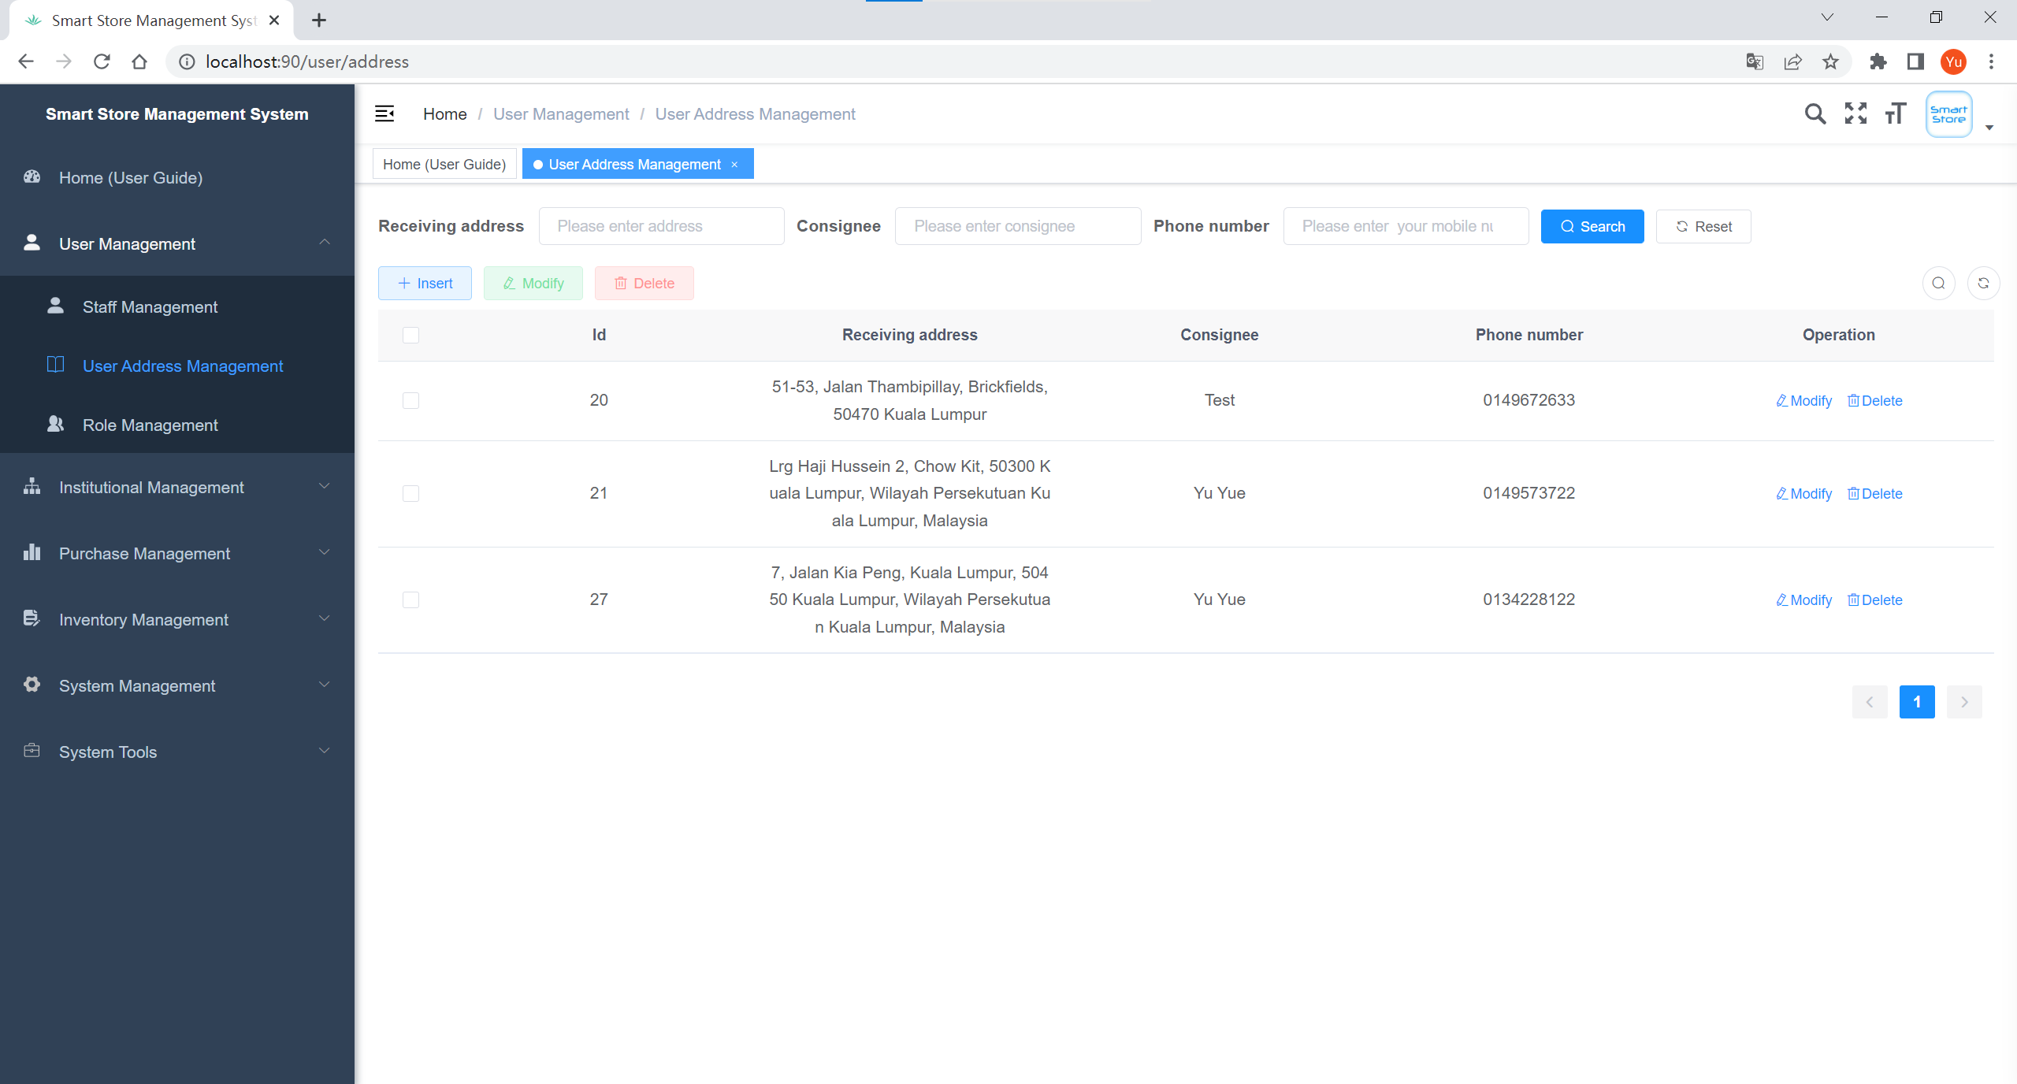

Figure 4.17 Address Management Page for the User Management module of the application

|  |  |  |
| --- | --- | --- |
| Interface: **Address Management** | | |
| Purpose: The page displayed after the administrator clicks Address Management, under which the administrator can manage the address information of customer users. | | |
| **Item** | **Purpose** | **Data Type/ Implementation** |
| “Address Management” (Label) | Name of the module | Text Label |
| Receiving Address | The customer's shipping address, where the administrator can enter the user's address information to filter the corresponding entries based on the address | String |
| Consignee | The customer's name, where the administrator can enter the user's name to filter the entries by name | String |
| Phone Number | Customer's phone number, the administrator can enter the user's phone number here to filter the corresponding entries based on the phone number | String |
| Search | Search button, when the administrator has finished entering all the fields, click on this button, it will find the corresponding address information in the database based on the data entered and return the entries that meet the filtering criteria to this page | Button |
| Reset | Reset button, the administrator can reset all the filter conditions that have been entered by clicking on this button, at this time the user will be redirected to the page where all the address information is displayed. | Button |
| Insert | Insert button, by clicking on this button, the administrator can add new recipient address information for the recipient, which includes the recipient address, the recipient's name, and the recipient's phone number information | Button |
| Modify | Modify button, through which the administrator can modify the address information of the customer user, including the receiving address, the name of the consignee, and the phone number of the consignee | Button |
| Delete | Delete button, by clicking this button, the administrator will be asked whether to delete the address information from the system, if we click Yes, the address will be removed from the database and the address management interface | Button |

### The User Management Module: Role Management

Figure 4.18 below shows the layout of the Role Management Page for the User Management module of the Store Management System

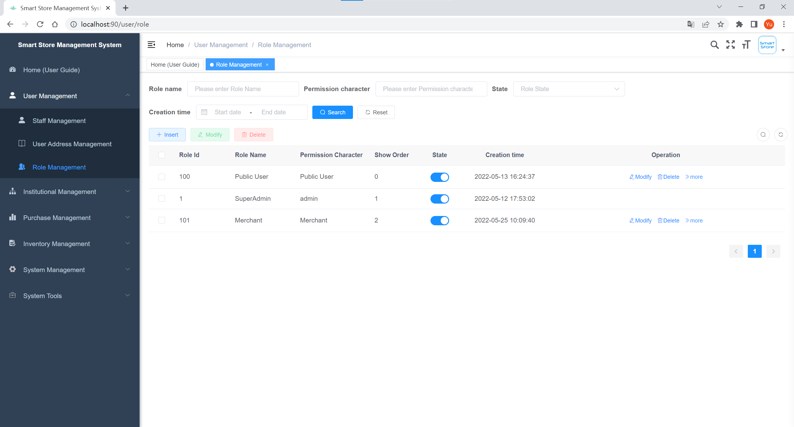

Figure 4.18 Role Management Page for the User Management module of the application

|  |  |  |
| --- | --- | --- |
| Interface: **Role Management** | | |
| Purpose: The page displayed after the administrator clicks on Role Management, under this page, the administrator can manage the user's Role and permissions. | | |
| **Item** | **Purpose** | **Data Type/ Implementation** |
| “Role Management” (Label) | Name of the module | Text Label |
| Role Name | User's Role name, where the administrator can enter the user's Role name to filter the corresponding Role type based on the Role name | String |
| Permission Character | The unique identifier of the Role, where the administrator can enter the Permission Character of the Role to filter the corresponding Role according to the unique identifier | String |
| State | The status of the Role, it is divided into normal and deactivate status, the administrator can select the status here to filter the corresponding status of the Role | Options Menu Control |
| Creation Time | The creation time of the Role, the administrator can select the corresponding time range here filter the roles created within this time range | Date Picker |
| Search | Search button, when the administrator has finished entering all the data in the fields, click this button, it will find the corresponding Role information in the database according to the data entered, and return the Role information that meets the filtering criteria to this page | Button |
| Reset | Reset button, the administrator can reset all the filter criteria that have been entered by clicking on this button, at this time the user will be redirected to the page where all the Role information is displayed. | Button |
| Insert | The Insert button allows the administrator to click on this button to create a new Role type with information such as Role Name, Permission Character, Role Order, State, primary permission assignment for the role, and notes. | Button |
| Modify | The Modify button allows the administrator to modify the system's Role information, which includes the Role Name, Permission Character, Role Order, State, the role's primary privilege assignment, and notes. | Button |
| Delete | Delete button, by clicking this button, the administrator will be asked whether to delete the Role type from the system, if we click Yes, the Role will be removed from the database and the Role management interface. | Button |
| More | The More button, through which the administrator can perform more operations, such as assigning a User, allows the administrator to authorize the Role to a user, giving the user permissions under the Role, or removing the user's permissions under the Role. | Button |

### The Institutional Management Module: Department Management

Figure 4.19 below shows the layout of the Department Management Page for the Institutional Management module of the Store Management System

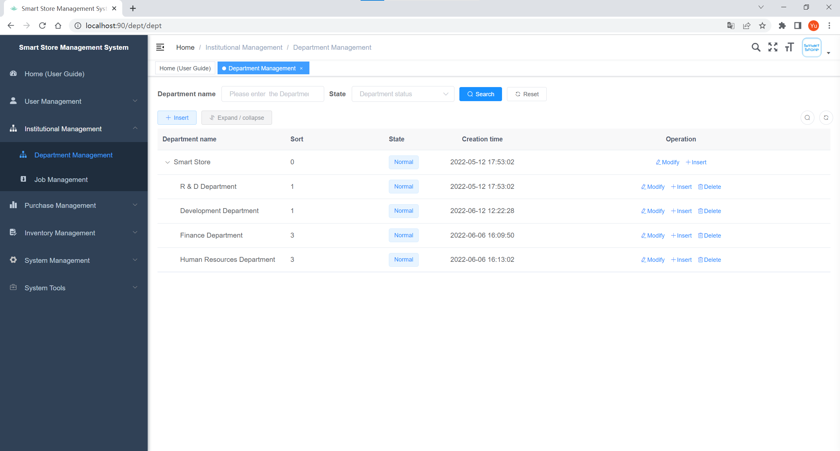

Figure 4.19 Department Management Page for the Institutional Management module of the application

|  |  |  |
| --- | --- | --- |
| Interface: **Department Management** | | |
| Purpose: The page displayed after the administrator clicks Department Management, under this page, the administrator can manage the department information of the Institution. | | |
| **Item** | **Purpose** | **Data Type/ Implementation** |
| “Department Management” (Label) | Name of the module | Text Label |
| Department name | The name of the organization's department, where the administrator can enter a part of the department's name to filter the corresponding part according to it | String |
| State | The status of the department, it is divided into normal and deactivate status, the administrator can select the status here to filter the department by the corresponding status | Options Menu Control |
| Search | Search button, when the administrator finished inputting all the field data, click this button, it will find the corresponding department information in the database according to the inputted data, and return the department information that meets the filtering criteria to this page | Button |
| Reset | Reset button, the administrator can reset all the filters entered by clicking this button, then the user will be redirected to the page where all the department information is displayed. | Button |
| Insert | The Insert button allows the administrator to create a new department by clicking on it. The information to be uploaded includes the Superior Department to which the department belongs, the name of the department, the person in charge of the department, the contact information of the department, the email address, and the status of the department. | Button |
| Expand / collapse | Expand or Collapse button, which expands or collapses the parent data details. In this interface, by clicking the button, we can show or hide the department information of the institution. | Button |
| Modify | The Modify button allows the administrator to modify the department information of the institution. The information that can be modified includes the Superior Department to which the department belongs, the name of the department, the person in charge of the department, the contact number of the department, the email address, and the status of the department (Normal / Deactivate). | Button |
| Delete | The Delete button, by clicking on it, will ask the administrator if the department should be deleted from the system, if we click on Yes, the department will be removed from the database and from the department administration interface, but if the department has been assigned employees, the department cannot be deleted. | Button |

### The Institutional Management Module: Job Management

Figure 4.20 below shows the layout of the Job Management Page for the Institutional Management module of the Store Management System

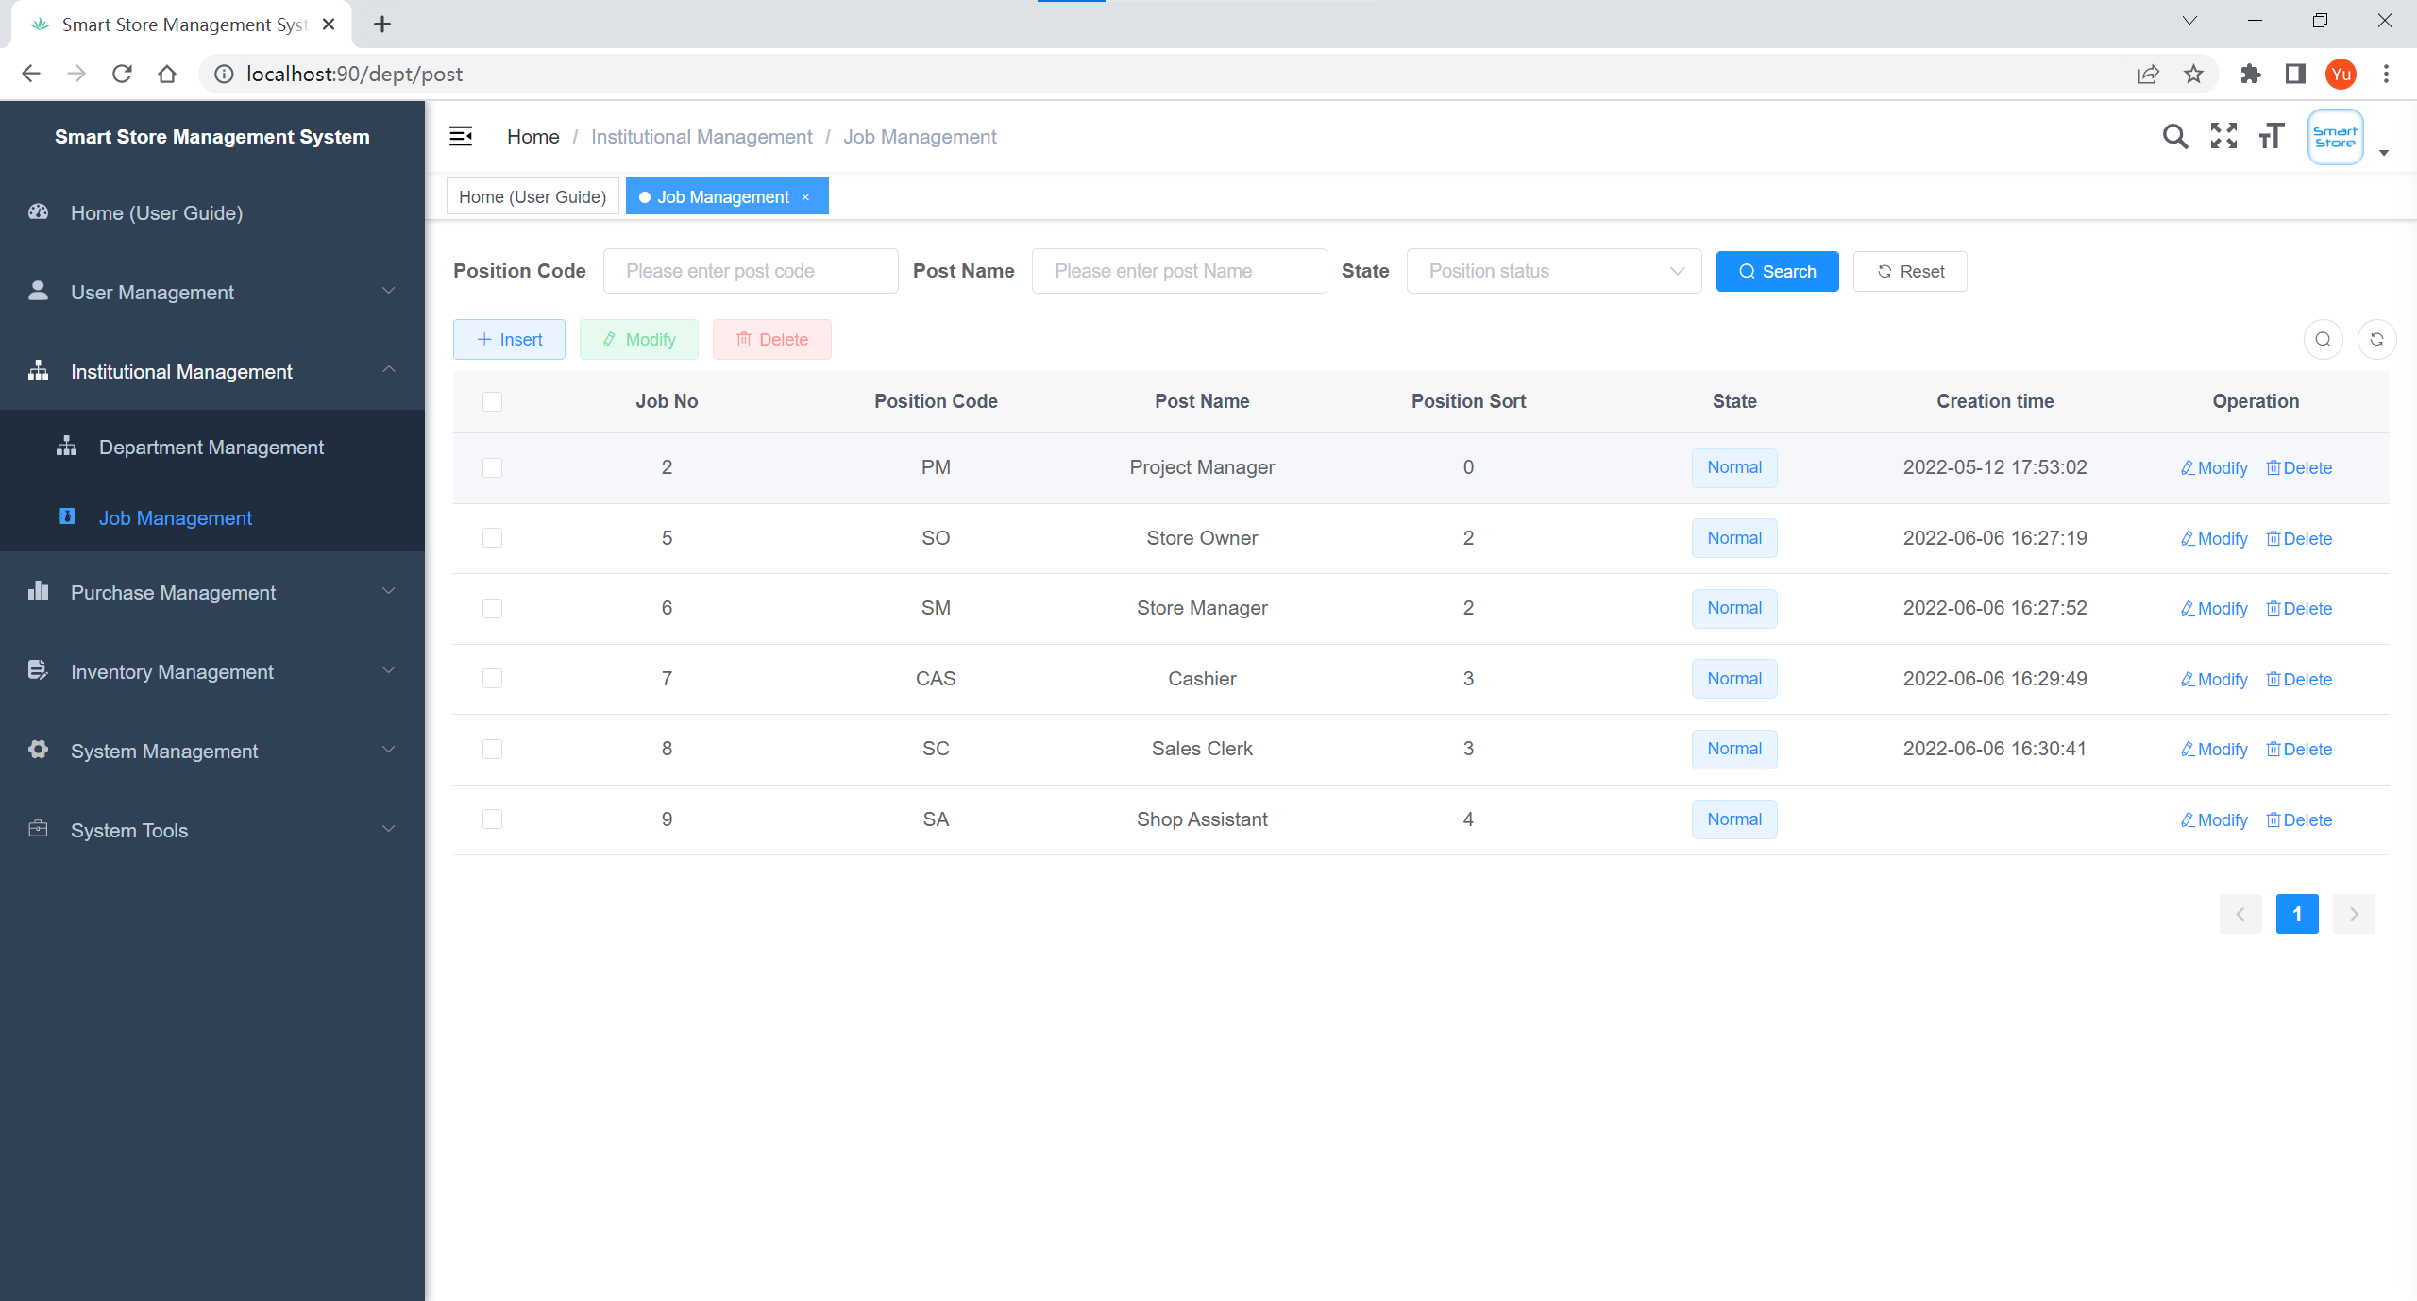

Figure 4.20 Job Management Page for the Institutional Management module of the application

|  |  |  |
| --- | --- | --- |
| Interface: **Job Management** | | |
| Purpose: The page displayed after the administrator clicks Job Management, under this page, the administrator can manage the job information of the Institution. | | |
| **Item** | **Purpose** | **Data Type/ Implementation** |
| “Job Management” (Label) | Name of the module | Text Label |
| Position Code | Position Code uniquely identifies a position, where the administrator can enter the Position Code of the position to find the corresponding position information based on the Position Code | String |
| Post Name | Position name, where the administrator can enter a part of the position name to filter the corresponding position according to it | String |
| State | Position status, it is divided into normal and deactivate status, the administrator can select the status here to filter the corresponding the position | Options Menu Control |
| Search | Search button, when the administrator has finished entering all the fields, click on this button, it will find the corresponding job information in the database according to the data entered, and return the job information that meets the filtering criteria to this page | Button |
| Reset | Reset button, the administrator can reset all the filters entered by clicking this button, then the user will be redirected to the page where all the job information is displayed. | Button |
| Insert | The Insert button allows the administrator to create a new job by clicking on this button. The information to be uploaded includes the job name, job code, job status (Normal/Deactivate), and the job remarks. | Button |
| Modify | Modify button, through which the administrator can modify the job information of the institution. The information that can be modified includes the name of the job, the Code of the job, the status of the job (Normal / Deactivate), and the remarks of the job. | Button |
| Delete | Delete button, by clicking this button, will ask the administrator whether to delete the job from the system, if we click Yes, the job will be removed from the database and the job management interface, but if the job has been assigned employees, then the job cannot be deleted. | Button |

### The Purchase Management Module: View Product Customer View

Figure 4.21 below shows the layout of the View Product Customer View Page for the Purchase Management module of the Store Management System

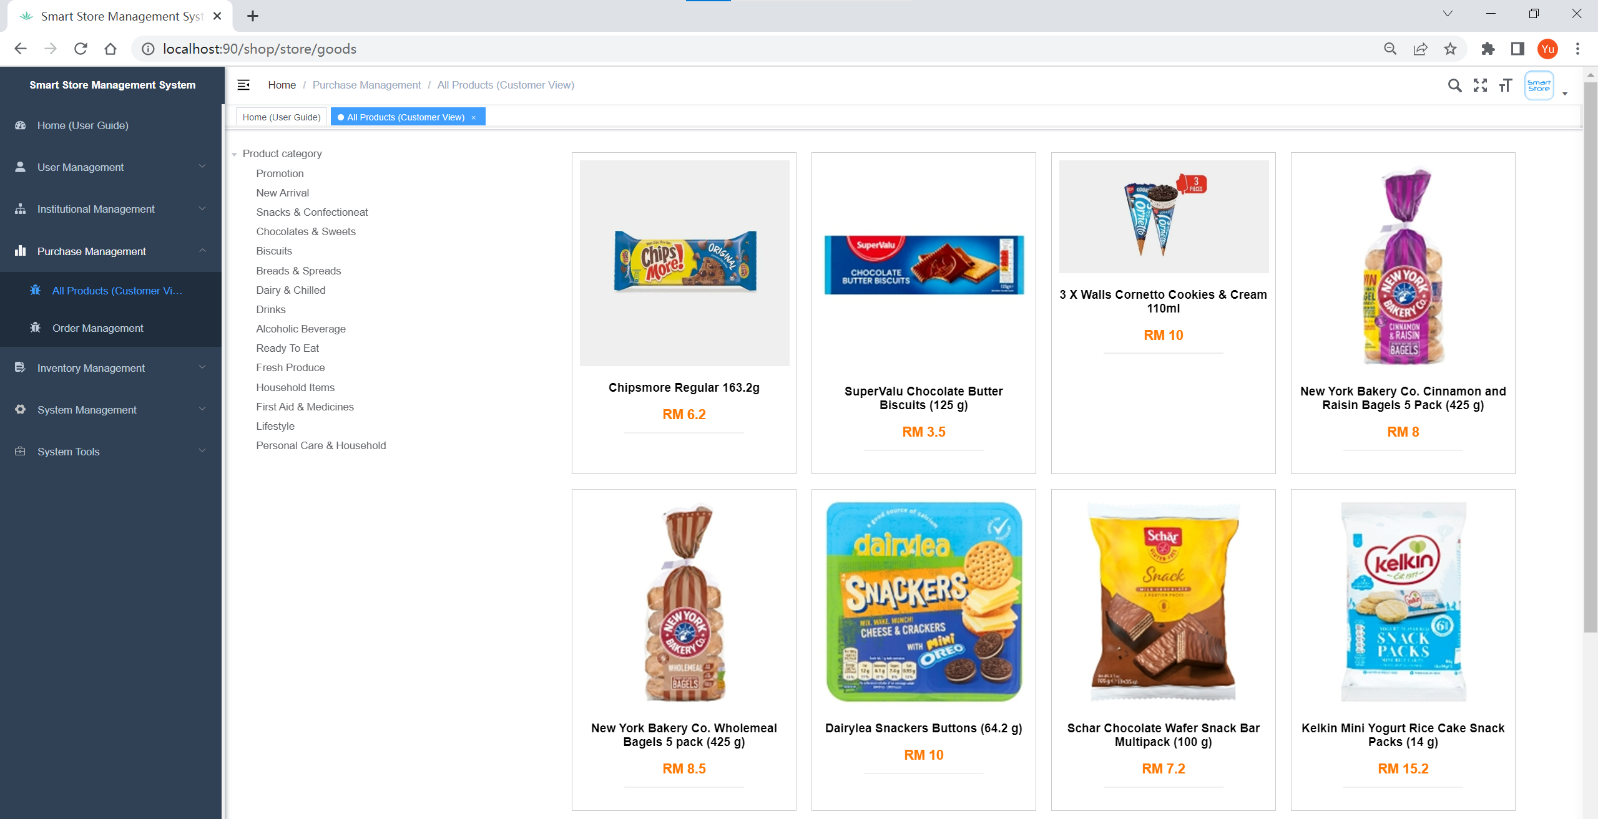

Figure 4.21 View Product Customer View Page for the Purchase Management module of the application

This page displayed after the administrator clicks on All Products (Customer View). Under this page, we can view all the products available for purchase in the Smart Shop from the customer user's perspective, including product types, product prices, product pictures and other details, we can classify and retrieve products, and this information is synchronized with the display of all products in the customer mall interface, which is convenient for administrators to manage store goods.

### The Purchase Management Module: Order Management

Figure 4.22 below shows the layout of the Order Management Page for the Purchase Management module of the Store Management System

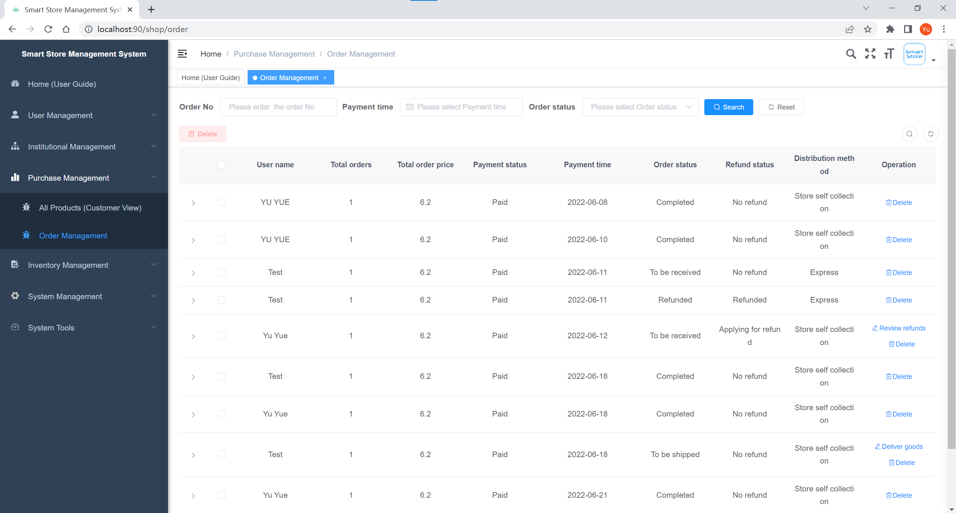

Figure 4.22 Order Management Page for the Purchase Management module of the application

|  |  |  |
| --- | --- | --- |
| Interface: **Order Management** | | |
| Purpose: The page displayed after the administrator clicks Order Management. Under this page, the administrator can manage the order information of the products purchased by customers in the store. | | |
| **Item** | **Purpose** | **Data Type/ Implementation** |
| “Order Management” (Label) | Name of the module | Text Label |
| Order No | Order No uniquely identifies a corresponding order, the administrator can enter the Order No. of the order here to find the corresponding order information according to the Order No. | String |
| Payment time | The order payment time, the administrator can select the corresponding time range here to filter the orders whose payment time is within this time range. | Date Picker |
| Order status | The status of the position, it is divided into Completed, Apply for refund, No refund, Refunded, To be shipped, To be received, Received goods seven kinds of status, the administrator can select the status here, in order to filter the corresponding status of the order | Options Menu Control |
| Search | Search button, when the administrator has finished inputting all the fields, click this button, it will find the corresponding order information in the database according to the inputted data, and return the order information that meets the filtering conditions to this page | Button |
| Reset | Reset button, by clicking this button, the administrator can reset all the filtering conditions that have been entered, at this time the user will be redirected to the page where all the order information is displayed. | Button |
| Delete | Delete button, by clicking this button, the administrator will be asked whether to delete the order information from the system, if we click Yes, the order will be removed from the database and from the Order management interface. | Button |
| Review refunds | Review Refund button, if the buyer has a problem with the purchased product and request to return it, they can apply for a refund from the seller, the refund information will be displayed here, by clicking this button, the administrator can view the refund information and status under this order. | Button |
| Deliver goods | Shipping button, if the buyer has purchased the product in the store and made a monetary transaction with the merchant, then the order will be created and the shipping button will be displayed here, then the store administrator can ship the goods here, there are two ways of shipping, one is store pickup, and the other is express delivery | Button |

### The Inventory Management Module: Product Category Management

Figure 4.23 below shows the layout of the Product Category Management Page for the Inventory Management module of the Store Management System

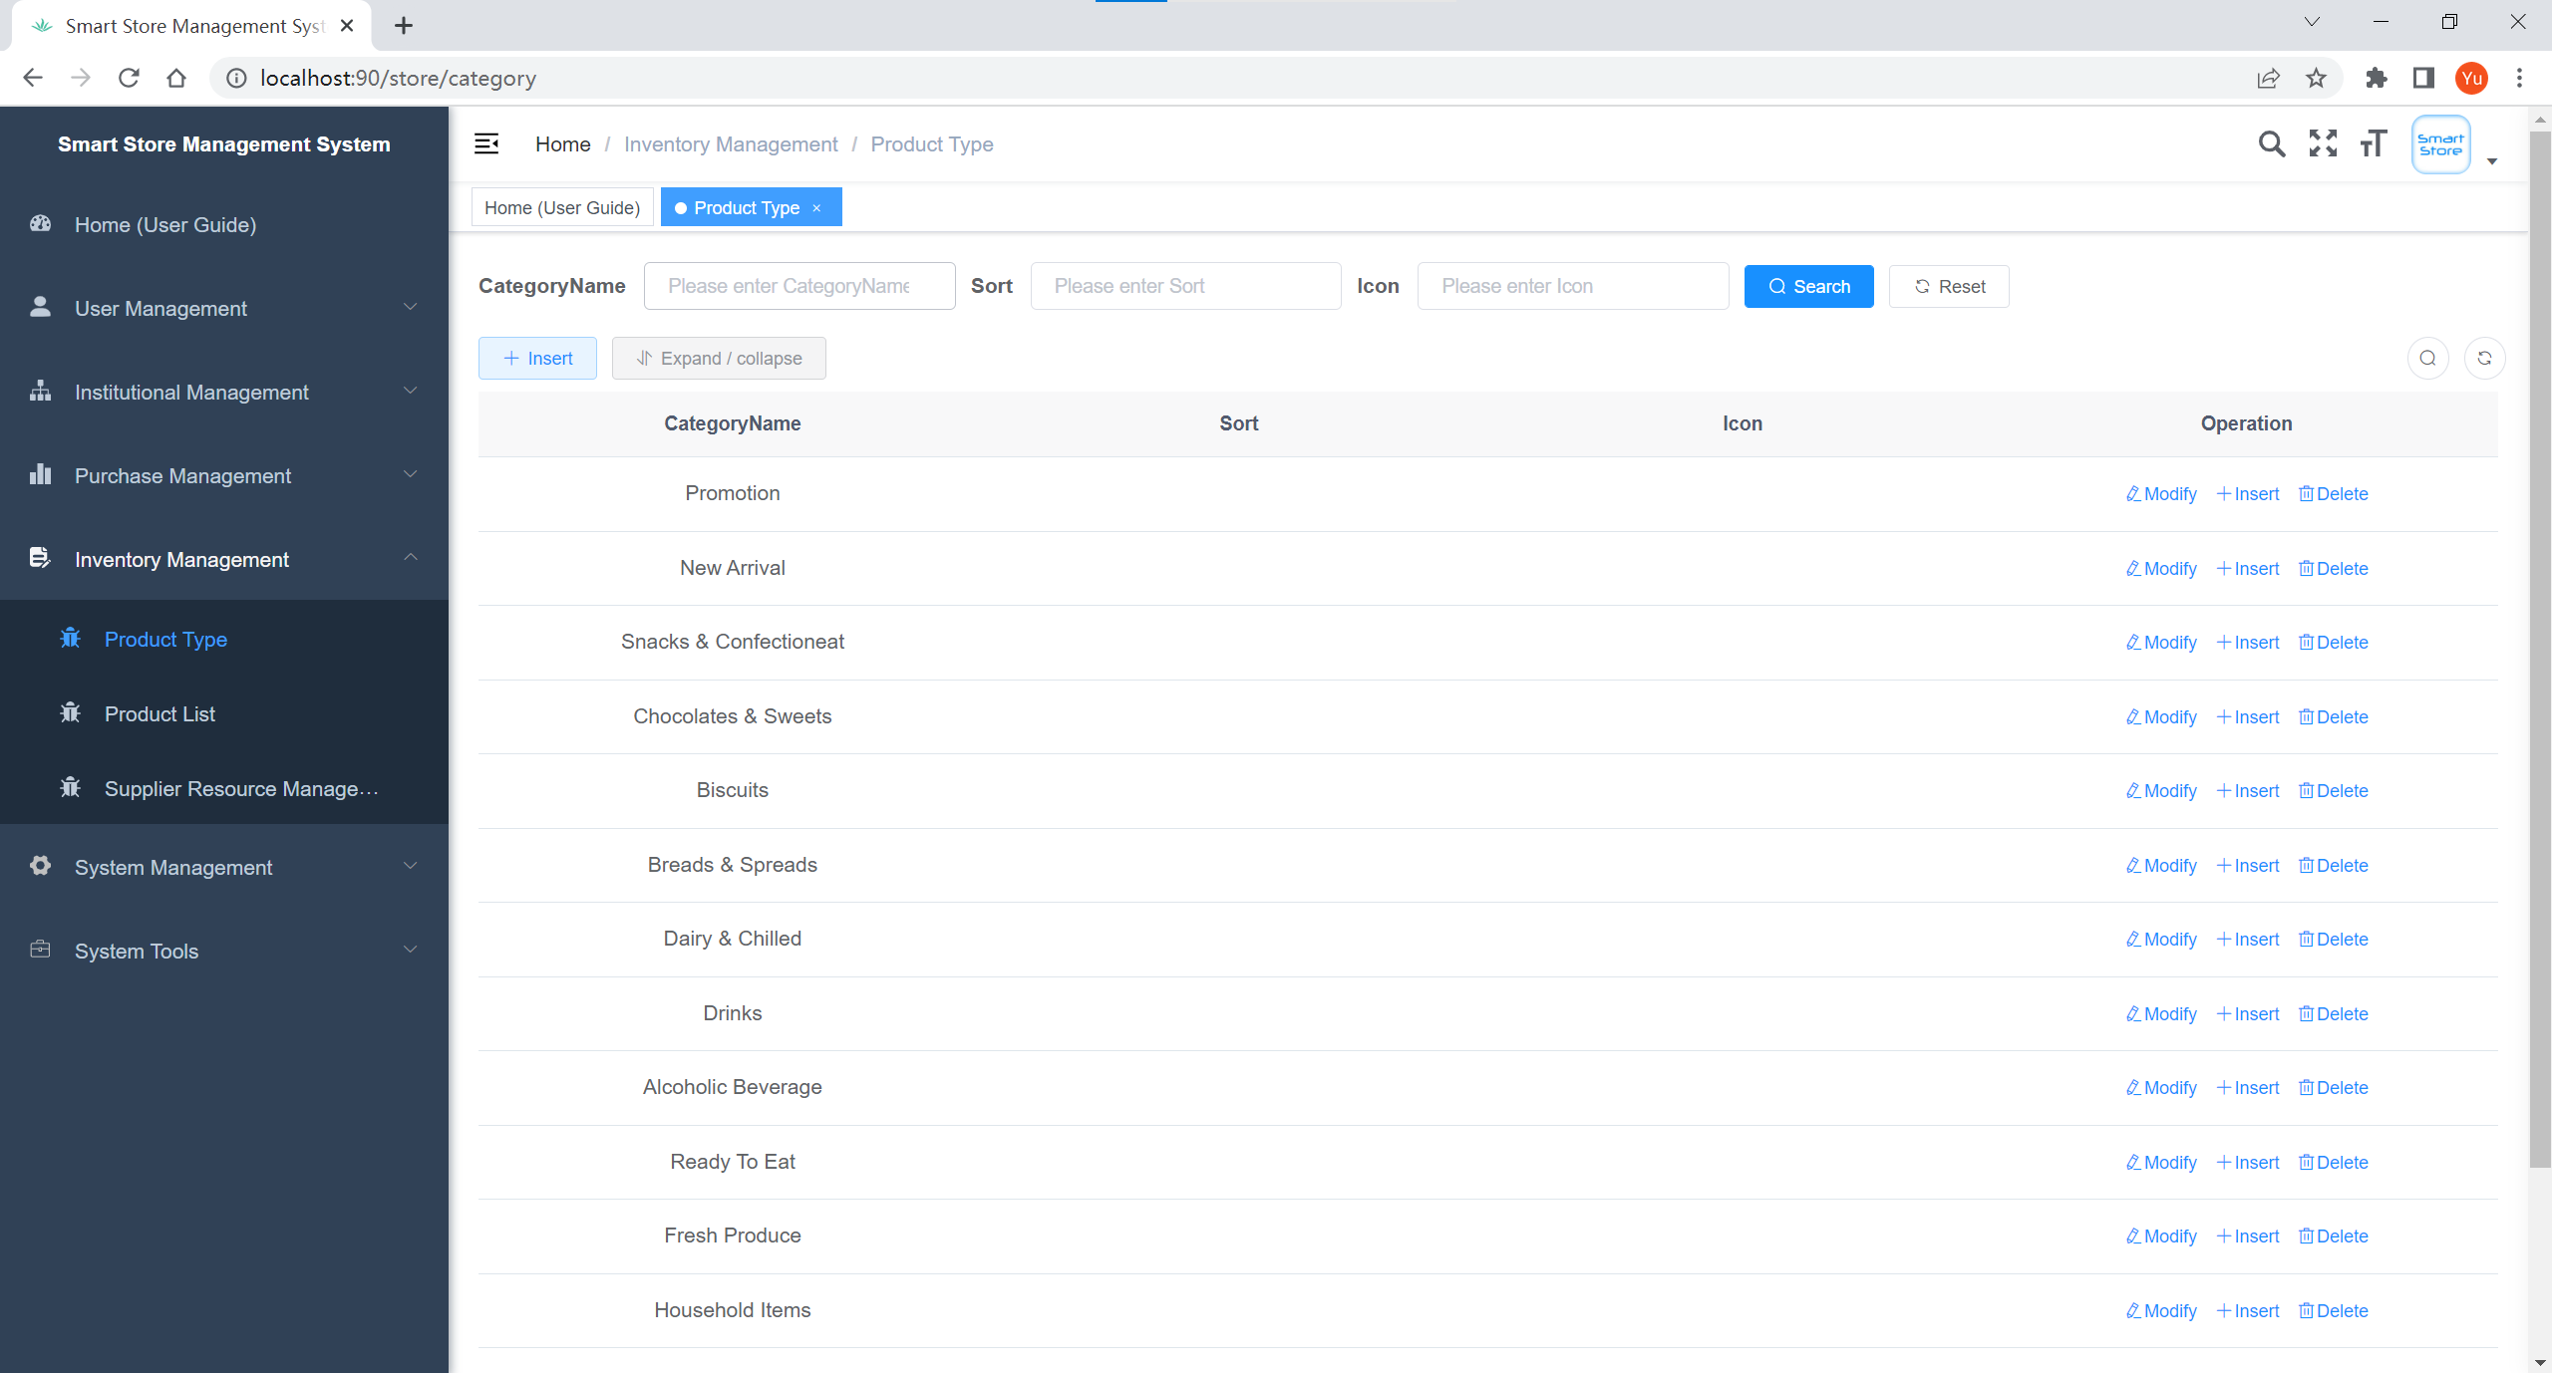

Figure 4.23 Product Category Management Page for the Inventory Management module of the application

|  |  |  |
| --- | --- | --- |
| Interface: **Product Category Management** | | |
| Purpose: The page displayed after the administrator clicks Product Type, under this page, the administrator can manage Product type information in the inventory | | |
| **Item** | **Purpose** | **Data Type/ Implementation** |
| “Product Type” (Label) | Name of the module | Text Label |
| Category Name | The name of the product type in the inventory, where the administrator can enter a part of the product type name to filter the corresponding product type according to it | String |
| Sort | The display order of the types of products in the inventory on the management interface or the front-end store interface, where the sort value is a number, and the smaller the value, the higher the position in the interface. The administrator can enter the Sort value of the product type here to filter the corresponding product type according to it | Integer |
| Search | Search button, when the administrator has entered all the fields, click on this button, it will find the corresponding product type information in the database according to the data entered, and return the product type information that meets the filtering criteria to this page | Button |
| Reset | Reset button, the administrator can reset all the filter conditions that have been entered by clicking on this button, at this time the user will be redirected to the page where all the product type information is displayed. | Button |
| Expand / collapse | Expand or Collapse button, which expands or collapses the parent data details, in this screen, by clicking on this button, we can show or hide the product's subtype information. | Button |
| Insert | Insert button, through which the administrator can create new product type information by clicking on this button. The information to be filled in includes the parent type to which the product type belongs, the name of the product type, the sort in which the product types are listed in the management interface or the front store interface, and the icon of the product type. | Button |
| Modify | Modify button, through which the administrator can modify the type information of the existing products in the system. The information that can be modified includes the parent type of the product type, the name of the product type, the sort of the product type in the management interface or the front store interface, and the icon of the product type. | Button |
| Delete | Delete button, by clicking this button, the administrator will be asked whether to remove the product type information from the system, and if we click Yes, the product type will be removed from the database and the Product Category management interface. | Button |

### The Inventory Management Module: Inventory Product Listing Management

Figure 4.24 below shows the layout of the Inventory Product Listing Management Page for the Inventory Management module of the Store Management System

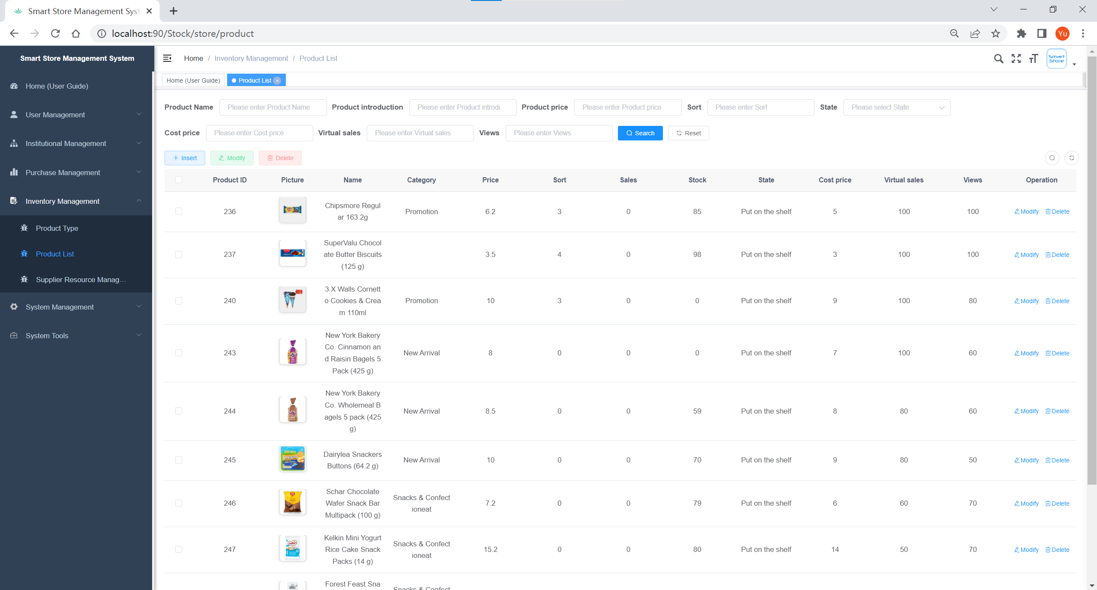

Figure 4.24 Inventory Product Listing Management Page for the Inventory Management module of the application

|  |  |  |
| --- | --- | --- |
| Interface: **Inventory Product Listing Management** | | |
| Purpose: The page displayed after the administrator clicks on the Product List, under this page, the administrator can manage the product information in the inventory. | | |
| **Item** | **Purpose** | **Data Type/ Implementation** |
| “Product List” (Label) | Name of the module | Text Label |
| Product Name | The name of the product in the inventory, where the administrator can enter a part of the product name to filter the corresponding product information | String |
| Product Introduction | Product description, the administrator can enter the product description to filter the product information according to it. | String |
| Product Price | The price of the product in the inventory, the administrator can enter the price of the product here to filter the corresponding product information according to it. | Double |
| Sort | The display order of the products in the inventory in the management interface. The sort value consists of numbers, the smaller the value, the higher the position in the interface. The administrator can enter the sort value of the product here to filter the products in the corresponding position. | Integer |
| State | The status of the product in the inventory, it includes two statuses: put on the shelf and not put on the shelf. The administrator can select the status here to filter the corresponding product information | Options Menu Control |
| Cost Price | The cost price of the product in the inventory, the administrator can enter the cost price of the product here to filter the corresponding product information according to it | Double |
| Virtual Sales | Virtual sales of the products in the inventory, where the administrator can enter the virtual sales of the products to filter the corresponding product information | Integer |
| Views | Views of products in inventory, where the administrator can enter the expected number of views of the product, he/she wants to find, in order to filter the product information according to it | Integer |
| Search | Search button, when the administrator has finished entering all the fields, click on this button, it will search for the corresponding product information in the database based on the data entered and return the product information that meets the filtering criteria to this page | Button |
| Reset | Reset button, the administrator can reset all the filter criteria entered by clicking this button, then the user will be redirected to the page where all the product information is displayed. | Button |
| Insert | Insert button, administrator can click this button to create new product information, the information to be uploaded includes the picture of the product, the name of the product, product category, product price, product sort, product status (put on the shelf / no put on the shelf), product description, product remaining inventory, product cost price, product virtual sales, and product virtual pageview | Button |
| Modify | Modify button, through this button, the administrator can modify the existing product information in the system. The modifiable information includes the picture of the product, the name of the product, product category, product price, product sort, product status (put on the shelf / not put on the shelf), product description, product remaining inventory, product cost price, product virtual sales, and product virtual pageview. | Button |
| Delete | Delete button, by clicking this button, the administrator will be asked whether to delete the product information from the system, if we click Yes, the product will be removed from the database and the product listing management interface. | Button |

### The Inventory Management Module: Supplier Resource Management

Figure 4.25 below shows the layout of the Supplier Resource Management Page for the Inventory Management module of the Store Management System

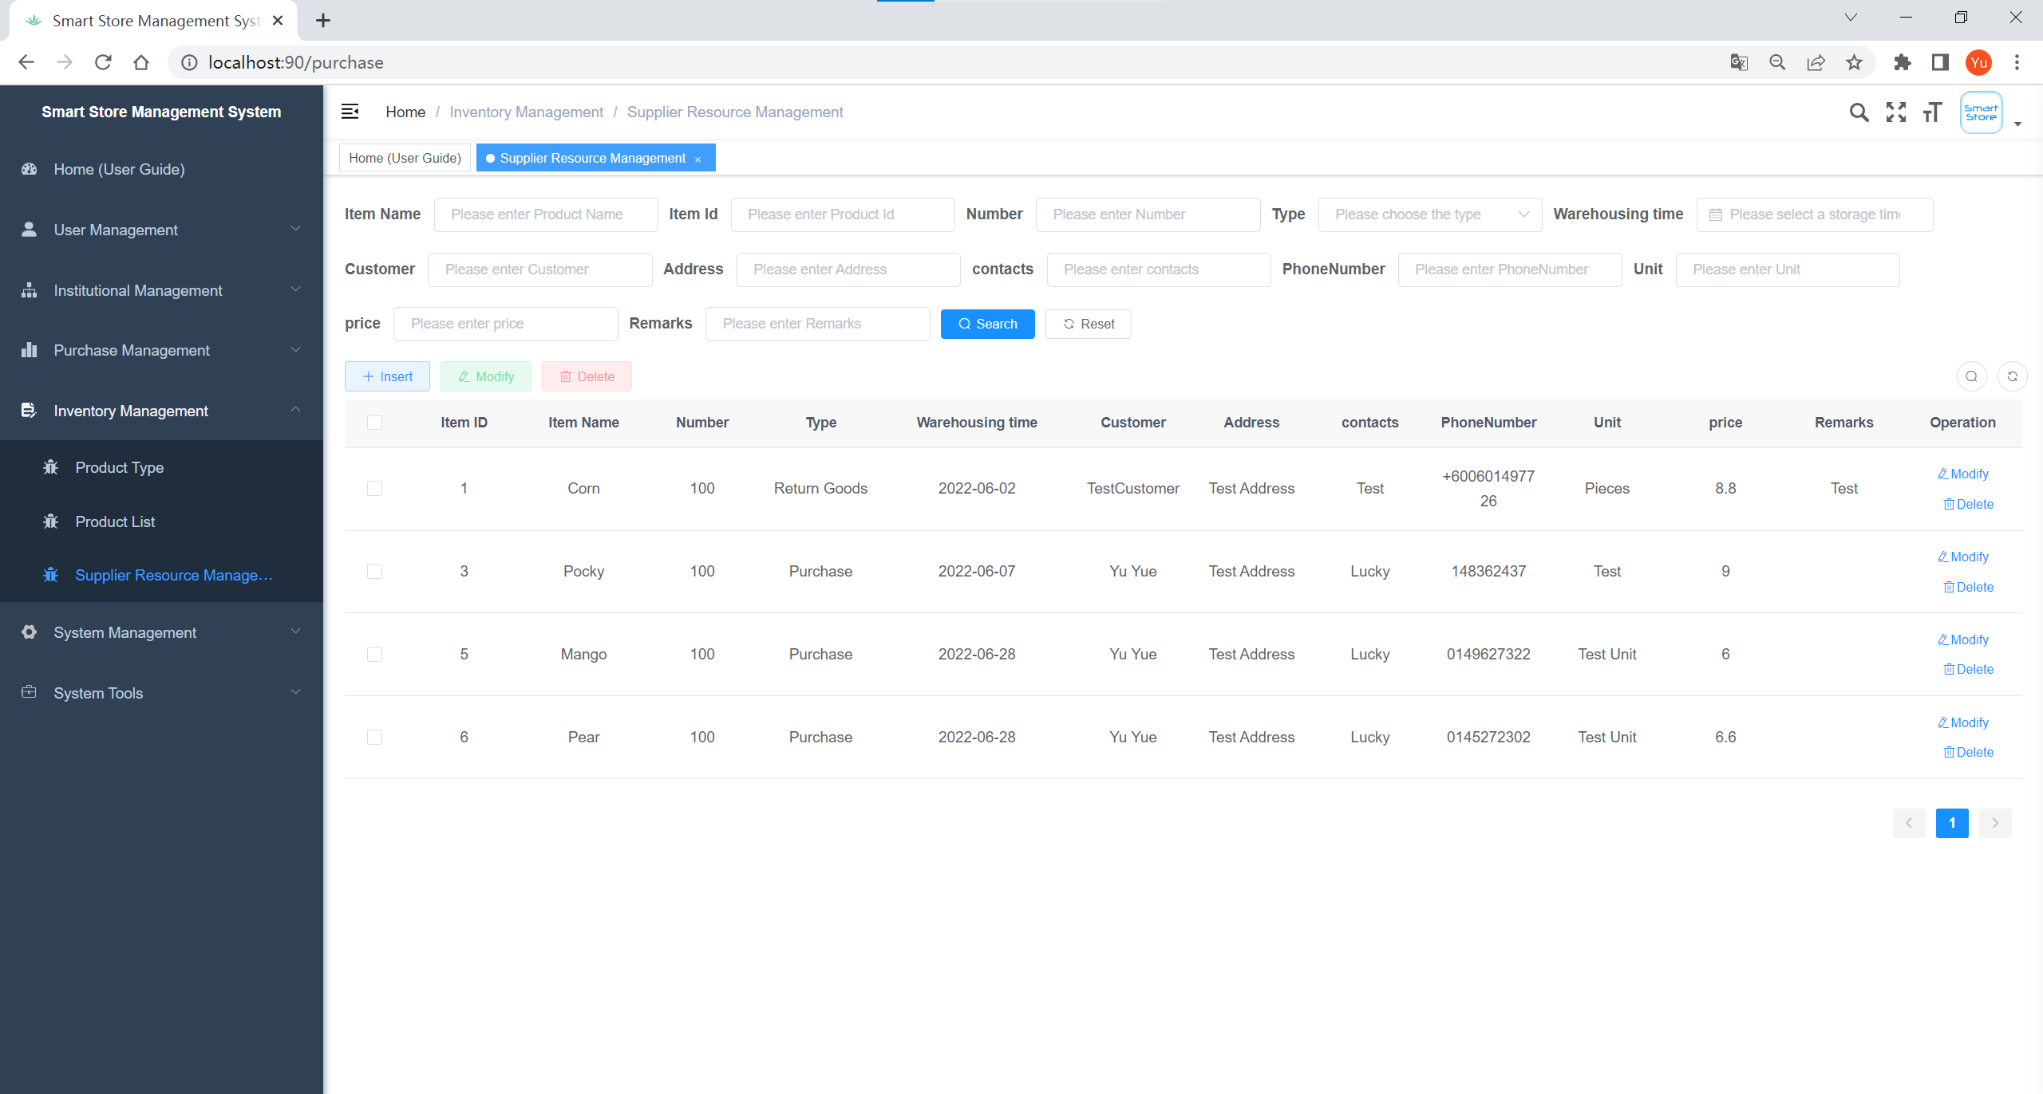

Figure 4.25 Supplier Resource Management Page for the Inventory Management module of the application

|  |  |  |
| --- | --- | --- |
| Interface: **Supplier Resource Management** | | |
| Purpose: The page displayed after the administrator clicks Supplier Resource Management, under this page, the administrator can manage the information of the products purchased by the store from suppliers. | | |
| **Item** | **Purpose** | **Data Type/ Implementation** |
| “Supplier Resource Management” (Label) | Name of the module | Text Label |
| Item Name | The name of the product that the store purchased from the supplier, the administrator can enter a part of Item Name here to filter the corresponding purchase information based on it. | String |
| Item ID | Item ID uniquely identifies a store's purchase from a supplier, and the administrator can enter the Item ID of the purchase here to filter the corresponding purchase information based on the Item ID. | Integer |
| Number | The quantity of products purchased from the supplier by the store, the administrator can enter the quantity of products purchased here to filter the corresponding purchase information based on it. | Integer |
| Type | The status type of the store's purchases from suppliers, which is divided into three types: Purchase, Return Goods, and Exchange Goods, and the administrator can select the type here to filter the corresponding purchase information. | Options Menu Control |
| Warehousing Time | The incoming time of the products purchased from suppliers, where the administrator can input the incoming time of the purchased products to filter the corresponding purchase information. | Date Picker |
| Customer | The purchaser of a product purchased from the supplier, the administrator can enter the name of the purchaser here to filter the corresponding purchase information according to it. | String |
| Address | Delivery address of the purchased product, where the administrator can enter the delivery address information to filter the corresponding purchase information based on it | String |
| Contacts | The name of the supplier organization for the purchase, where the administrator can enter the name of the supplier organization to filter the purchase information according to it. | String |
| Phone Number | The purchaser's phone number, where the administrator can enter the purchaser's phone number to filter the purchase information according to it | String |
| Unit | The name of the standard of measurement of a product purchased, where the administrator can enter the unit of the product purchased to filter the corresponding purchasing information according to it | String |
| Price | The unit price of a product purchased, where the administrator can enter the price of the product purchased to filter the corresponding purchase information. | Double |
| Remarks | The remark information of a product purchased by the store from the supplier, the administrator can input the remark information of the corresponding purchase here to filter the corresponding purchase information according to it. | String |
| Search | Search button, when the administrator has entered all the fields, click on this button, it will find the corresponding purchase information in the database according to the data entered, and return the purchase information that meets the filtering criteria to this page | Button |
| Reset | Reset button, the administrator can reset all the filtering criteria entered by clicking this button, then the user will be redirected to the page where all the purchasing information is displayed. | Button |
| Insert | Add the purchase information, the administrator can click this button to create new purchase information. The required information includes the name of the product purchased by the store from the supplier, the quantity of the purchased product, the status type of the purchase, the warehousing time of the purchased product, the buyer's name, the delivery address of the purchased product, the supplier's organization name, the buyer's phone number, the unit of the purchased product, the unit price of the purchased product, and the remark information for purchasing the product. | Button |
| Modify | Modify the purchase information, through this button, the administrator can modify the purchase information created by the system. The information that can be modified includes the name of the purchased product, the quantity of the purchased product, the status type of the purchase, the warehousing time of the purchased product, The name of the purchaser, the delivery address of the purchased product, the name of the supplier's organization, the purchaser's phone number, the unit of the purchased product, the unit price of the purchased product, and the remark information for purchasing the product. | Button |
| Delete | The Delete button, by clicking on it, will ask the administrator whether to delete the purchase information from the system, if we click on Yes, the purchase item will be removed from the database and from the Supplier Resource Management interface. | Button |

# CHAPTER 5: EVALUATION

## Chapter Introduction

The purpose of this chapter is to evaluate the work done to complete this project and to find out if the application was developed correctly and if it meets the goals of this project. Also, the evaluation process is important to determine the limitations of the developed application and to identify areas for future improvement. In Section 5.1 System Testing & Test Cases, all the necessary tests to ensure the quality of the developed application are included. In addition, performance evaluation and user experience surveys are already being conducted and documented in Section 5.2 Performance Evaluation & User Experience Survey. Finally, the Chapter Summary in Section 5.3 summarizes the main points of Chapter 5.

## System Testing & Test Cases

Testing is one of the important processes in the implementation and development phase to examine if a component, subsystem, or system is developed correctly and to check if it has any defects. System tests have been executed in order to eliminate errors in the application. The testing process starts with planning and creating test cases for each interface and then executing the test cases. The test cases ID 1 to 9 and the test results are summarized in each of the following sections and are grouped by module.

### Test Case for Staff Management Interface

Test Case ID 1 below is to created and executed to test the functionality for Staff Management Interface. All the test scenarios in Test Case ID 1 are pass.

|  |  |  |  |  |
| --- | --- | --- | --- | --- |
| Test Case ID: 1 | | | | |
| Test Case Description:  (a) Ensure that staff information can be retrieved according to the set filtering criteria and the results are returned to the interface for display  (b) Make sure the function of adding staff information works well  (c) Ensure that the function of modifying staff information works well  (d) Ensure that the function of deleting staff information works well | | | | |
| Module/Interface: Staff Management Interface | | | | |
| **No #** | **Item** | **Test Scenario** | **Expected Result** | **Test Status** |
| 1 | Department | Enter the department name of the existing organization and click the Search button to view the details of the staff in the corresponding department | The details of the staff of the corresponding department are filtered from the database and displayed correctly and completely on the Interface | Pass |
| 2 | Username | Enter the employee's username and click the Search button to view the details of the corresponding employee | The details of the staff member with the corresponding username are filtered from the database and displayed correctly and completely on the Interface | Pass |
| 3 | Phone Number | Enter the employee's phone number and click the Search button to view the details of the employee with the corresponding phone number | The details of the staff member with the corresponding phone number are filtered from the database and displayed correctly and completely on the Interface | Pass |
| 4 | State | Select the employee's status (normal/deactivated) and click the Search button to view the details of the employee with the corresponding status | The details of the staff with the corresponding status are filtered from the database and displayed correctly and completely on the Interface | Pass |
| 5 | Creation Time | Select the employee's account creation time period, and then click the Search button to view the details of the employee whose account was registered within that time period | The details of staff with the corresponding account registration time are filtered from the database and displayed correctly and completely on the Interface | Pass |
| 6 | Search | After entering a field for any employee, click the Search button to check if all employees under the filter are displayed | The details of the staff with the corresponding filter criteria are filtered from the database and displayed correctly and completely on the Interface | Pass |
| 7 | Reset | After entering any employee's information in the input box, click the Reset button to check if all the filter criteria entered have been reset | All filter criteria that have been entered have been reset and the user is redirected to the page where all employee information is displayed | Pass |
| 8 | Insert | Create a new employee account profile, fill in the employee's username, department name, phone number, email address, gender, status, title, role, amount, and remark details, then check the interface and database whether the staff account information has been added | The new staff account profile created is displayed in the database and interface | Pass |
| 9 | Modify | Modify an employee's account information, which includes the employee's username, department name, phone number, email address, gender, identity, position, role, and amount information, and then check if the employee's account information has been modified in Interface and database | All information for the employee account has been modified in the database and in the Interface | Pass |
| 10 | Delete | Delete an employee's account from the system, and then check in the Interface and database if the employee's account information has been deleted | All information about the employee's account has been deleted from the database and from the Interface | Pass |
| 11 | More | Check if more function buttons are displayed by clicking this button, including Reset Password, Assign Permission | More actions can be performed in this Interface, including changing the password of the employee's account or assigning permissions to the employee | Pass |

### Test Case for Address Management Interface

Test Case ID 2 below is to created and executed to test the functionality for Address Management Interface. All the test scenarios in Test Case ID 2 are pass.

|  |  |  |  |  |
| --- | --- | --- | --- | --- |
| Test Case ID: 2 | | | | |
| Test Case Description:  (a) Ensure that address information can be retrieved based on the set filtering criteria and return the results to the interface for display  (b) Ensure that the function of adding address information works well  (c) Ensure that the function of modifying address information works well  (d) Ensure that the delete address information function works well | | | | |
| Module/Interface: Address Management Interface | | | | |
| **No #** | **Item** | **Test Scenario** | **Expected Result** | **Test Status** |
| 1 | Receiving Address | Enter the customer user's shipping address and click the Search button to view the corresponding address entry | The details of the corresponding receiving address are filtered from the database and displayed correctly and completely on the Interface | Pass |
| 2 | Consignee | Enter the name of the customer user and click the Search button to view the details of the corresponding receiving address | The recipient address information for the customer by name is filtered from the database and displayed correctly and completely on the Interface | Pass |
| 3 | Phone Number | Enter the user's phone number and click the Search button to view the details of the corresponding receiving address | The recipient address information of the customer whose contact information is this number is filtered from the database and displayed correctly and completely on the Interface | Pass |
| 4 | Search | After entering a field data of any receiving address, click the Search button to check whether all address information under the filter condition is displayed | The details of the receiving address under the corresponding filter conditions are filtered from the database and displayed correctly and completely on this Interface | Pass |
| 5 | Reset | After entering the filter conditions of any address in the input box, then click the reset button to check whether all the filter conditions that have been entered have been reset. | All filter criteria that have been entered have been reset and the user is redirected to a page showing all address information | Pass |
| 6 | Insert | Add the details of the new receiving address, including the receiving address information, the consignee's name, and the consignee's phone number information, and then check in the Interface and database whether the receiving address information has been added | The details of the new recipient address added will be displayed in the database and interface | Pass |
| 7 | Modify | Modify the details of the consignee's receiving address, including the receiving address information, the consignee's name, and the consignee's phone number information, and then check whether the receiving address information has been modified in the Interface and database | All information of the recipient address in the database and interface has been modified | Pass |
| 8 | Delete | Delete a user's receiving address information from the system, and then check in the interface and database whether the receiving address information has been deleted | All information for this recipient address in the database and interface has been deleted | Pass |

### Test Case for Role Management Interface

Test Case ID 3 below is to created and executed to test the functionality for Role Management Interface. All the test scenarios in Test Case ID 3 are pass.

|  |  |  |  |  |
| --- | --- | --- | --- | --- |
| Test Case ID: 3 | | | | |
| Test Case Description:  (a) Ensure that the role information can be retrieved based on the set filtering criteria and the results returned to the interface for display  (b) Ensure that the function of adding Role type information works well  (c) Ensure that the function of modifying Role type information works well  (d) Ensure that the delete role type information function works well | | | | |
| Module/Interface: Role Management Interface | | | | |
| **No #** | **Item** | **Test Scenario** | **Expected Result** | **Test Status** |
| 1 | Role Name | Enter the user's role name and click the search button to view the details of the corresponding role | The Role details corresponding to the Role name are filtered from the database and displayed correctly and completely on the Interface | Pass |
| 2 | Permission Character | Enter the permission character of the role, then click the search button to filter the corresponding role based on the unique identifier | The details of the Role corresponding to the Permission Character are filtered from the database and displayed correctly and completely on the Interface | Pass |
| 3 | State | Select the status of the role (normal status/disabled status), and then click the Search button to filter the roles of the corresponding status | The details of the role of the corresponding state are filtered from the database and displayed correctly and completely on the interface | Pass |
| 4 | Creation Time | Select the creation time period of the role, and then click the Search button to filter the roles whose creation time is within this time range | The details of the Roles corresponding to the creation time of this time period are filtered from the database and displayed correctly and completely on the Interface | Pass |
| 5 | Search | After entering a field information of any role, click the Search button to check whether all the Role information under the filter condition is displayed | The details of the role under the corresponding filter conditions are filtered from the database and displayed correctly and completely on the interface | Pass |
| 6 | Reset | After entering the filter conditions of any role in the input box, click the reset button to check whether all the filter conditions that have been entered have been reset. | All filter criteria that have been entered have been reset and the user is redirected to a page showing all Role information | Pass |
| 7 | Insert | Add new Role type information, the information includes Role Name, Permission Character, Role Order, State, the role's main permission assignment, and remarks information, and then check whether the Role type information has been added in the Interface and database | The added new Role type information will be displayed in the database and interface | Pass |
| 8 | Modify | Modify the details of a Role type, including the Role Name, the Permission Character, Role Order, State, the main permission assignment of the role, and remarks information, and then check whether the Role type information has been modified in the Interface and database | All information of the Role in the database and interface has been modified | Pass |
| 9 | Delete | Delete a certain Role type information from the system, and then check whether the Role information has been deleted in the interface and database | All information about this Role in the database and interface has been deleted | Pass |
| 10 | More | Check if more function buttons are displayed by clicking this button | More actions can be performed in this interface, including assigning data permissions to a role or assigning role to user | Pass |

### Test Case for Department Management Interface

Test Case ID 4 below is to created and executed to test the functionality for Department Management Interface. All the test scenarios in Test Case ID 4 are pass.

|  |  |  |  |  |
| --- | --- | --- | --- | --- |
| Test Case ID: 4 | | | | |
| Test Case Description:  (a) Ensure that department information can be retrieved based on the set filtering criteria, and return the results to the interface for display  (b) Ensure that the function of adding department information works well  (c) Ensure that the function of modifying department information works well  (d) Ensure that the function of deleting department information works well | | | | |
| Module/Interface: Department Management Interface | | | | |
| **No #** | **Item** | **Test Scenario** | **Expected Result** | **Test Status** |
| 1 | Department name | Enter the department name of the institution and click the Search button to view the details of the corresponding department | The department details corresponding to the department name are filtered from the database and displayed correctly and completely on the Interface | Pass |
| 2 | State | Select the state of the department (normal state/deactivated state), and then click the Search button to filter the department information of the corresponding state | The details of the department in the corresponding state are filtered from the database and displayed correctly and completely on this Interface | Pass |
| 3 | Search | After entering a field information of any department, then click the Search button to check whether all department information under the filter condition is displayed | The details of the departments under the corresponding filter conditions are filtered from the database and displayed correctly and completely on the interface | Pass |
| 4 | Reset | After entering the filter conditions of any department in the input box, then click the reset button to check whether all the filter conditions that have been entered have been reset. | All filter criteria that have been entered have been reset and the user is then redirected to a page showing all department information | Pass |
| 5 | Insert | Add new department information, the information includes the Superior Department to which the department belongs, the name of the department, the person in charge of the department, the contact information of the department, the email address, and the status of the department, and then check in the Interface and database whether the department has been create | The added new department information will be displayed in the database and interface | Pass |
| 6 | Expand / collapse | Click this button, and then check whether the department information of the institution has been hidden in the department management interface | In the department management interface, it can be found that the department information of all institutions has been hidden | Pass |
| 7 | Modify | Modify the details of a department of the institution, including the Superior Department to which the department belongs, the name of the department, the person in charge of the department, the contact information of the department, the email address, and the status of the department, and then check the department in the interface and database whether the information has been modified | All information of the department in the database and interface has been modified | Pass |
| 8 | Delete | Delete a department of an institution from the system, then check in the interface and database whether the department information has been deleted | All information on this department in the database and interface has been deleted | Pass |

### Test Case for Job Management Interface

Test Case ID 5 below is to created and executed to test the functionality for Job Management Interface. All the test scenarios in Test Case ID 5 are pass.

|  |  |  |  |  |
| --- | --- | --- | --- | --- |
| Test Case ID: 5 | | | | |
| Test Case Description:  (a) Ensure that job information can be retrieved based on the set filter criteria and the results are returned to the interface for display  (b) Ensure that the function of adding job information works well  (c) Ensure that the function to modify job information works well  (d) Ensure that the delete job information function works well | | | | |
| Module/Interface: Job Management Interface | | | | |
| **No #** | **Item** | **Test Scenario** | **Expected Result** | **Test Status** |
| 1 | Position Code | Enter the Position Code of a position, then click the Search button, and then view the detailed information of the corresponding position | The details of the positions corresponding to the Position Code are filtered from the database and displayed correctly and completely on the interface | Pass |
| 2 | Post Name | Enter the name of a job, then click the Search button to filter the details of the job | The job details for the job title are filtered from the database and displayed correctly and completely on the interface | Pass |
| 3 | State | Select the status of the position (normal status/deactivated status), and then click the Search button to filter the job information of the corresponding status | The details of the positions corresponding to the status are filtered from the database and displayed correctly and completely on the interface | Pass |
| 4 | Search | After entering a field information of any position, then click the Search button to check whether all the position information under the filter condition is displayed | The details of the jobs under the corresponding filter conditions are filtered from the database and displayed correctly and completely on the interface | Pass |
| 5 | Reset | After entering the filter conditions of any position in the input box, then click the reset button to check whether all the filter conditions that have been entered have been reset. | All filter criteria that have been entered have been reset and the user is redirected to a page showing all job information | Pass |
| 6 | Insert | Add new job information, the information includes the job title, job code, job status (Normal/Deactivate), and job remark information, and then check whether the job has been added in the Interface and database | The new job information added will be displayed in the database and interface | Pass |
| 7 | Modify | Modify the details of a position, including the name of the position, the code of the position, the status of the position (Normal/Deactivate), and the remark information of the position, and then check whether the position information has been modified in the Interface and database | All information for this position in the database and interface has been modified | Pass |
| 8 | Delete | Delete a position from the system, then check in the interface and database whether the position information has been deleted | All information for this position in the database and interface has been deleted | Pass |

### Test Case for Order Management Interface

Test Case ID 6 below is to created and executed to test the functionality for Order Management Interface. All the test scenarios in Test Case ID 6 are pass.

|  |  |  |  |  |
| --- | --- | --- | --- | --- |
| Test Case ID: 6 | | | | |
| Test Case Description:  (a) Ensure that order information can be retrieved based on the set filtering criteria and the results returned to the interface for display  (b) Ensure that the delete order information function works well  (c) Ensure that the delivery of goods function works well | | | | |
| Module/Interface: Order Management Interface | | | | |
| **No #** | **Item** | **Test Scenario** | **Expected Result** | **Test Status** |
| 1 | Order No | Enter the Order No of an order, then click the Search button, and then view the details of the corresponding order | The details of the order corresponding to the Order No are filtered from the database and displayed correctly and completely on this interface | Pass |
| 2 | Payment time | Select the payment time period for the order, and then click the Search button to filter orders with payment time within this time range | The details of orders for which the corresponding payment time is in this time period are filtered from the database and displayed correctly and completely on the interface | Pass |
| 3 | Order status | Select the status of the order, which includes seven statuses: Completed, Apply for refund, No refund, Refunded, To be shipped, To be received, Received goods, and then click the Search button to filter the order information of the corresponding status | The details of the corresponding status orders are filtered from the database and displayed correctly and completely on this interface | Pass |
| 4 | Search | After entering a field information of any order, click the Search button to check whether all the order information under this filter condition is displayed | The details of the orders under the corresponding filter conditions are filtered from the database and displayed correctly and completely on this Interface | Pass |
| 5 | Reset | After entering the filter conditions of any order in the input box, then click the reset button to check whether all the filter conditions that have been entered have been reset | All filter criteria that have been entered have been reset and the user is redirected to a page showing all order information | Pass |
| 6 | Delete | Delete an order information from the system, then check in the interface and database whether the order information has been deleted | All information about this order in the database and interface has been deleted | Pass |
| 7 | Review refunds | The buyer requests to return the purchased product with a problem and applies for a refund to the seller. By clicking this button, the function of browsing the refund information and status under the order is tested. | Full information about the order and the status of the refund can be viewed in the database and in the interface. | Pass |
| 8 | Deliver goods | After the buyer purchases a product in the store, the order is created, and the delivery button will be displayed. Click this button to test the delivery function of the goods under the order, including both store pickup and express delivery shipping methods | Both delivery methods are available, and when the deliver goods button is clicked, you will be able to select the delivery method of the goods, and when the corresponding delivery method is executed, the status of the corresponding order will be updated in the database and on the interface | Pass |

### Test Case for Product Category Management Interface

Test Case ID 7 below is to created and executed to test the functionality for Product Category Management Interface. All the test scenarios in Test Case ID 7 are pass.

|  |  |  |  |  |
| --- | --- | --- | --- | --- |
| Test Case ID: 7 | | | | |
| Test Case Description:  (a) Ensure that product type information can be retrieved based on the set filtering criteria, and return the results to the interface for display  (b) Ensure that the function of adding product type information works well  (c) Ensure that the function of modifying product type information works well  (d) Ensure that the delete product type information function works well | | | | |
| Module/Interface: Product Category Management Interface | | | | |
| **No #** | **Item** | **Test Scenario** | **Expected Result** | **Test Status** |
| 1 | Category Name | Enter the name of a product category and click the Search button to view the details of the corresponding product type | The product type details corresponding to the product type name are filtered from the database and displayed correctly and completely on this interface | Pass |
| 2 | Sort | Enter the sort value of a product category (the sort value consists of a number, which indicates the order of the product type displayed in the management interface or the front store interface), and then click the Search button to filter the corresponding product type information according to it. | The details of the product type corresponding to the sort value are filtered from the database and displayed correctly and completely on this interface | Pass |
| 3 | Search | After entering a field information of any product category, click the Search button to check whether all product type information under the filter condition is displayed | The details of the product types under the corresponding filter conditions are filtered from the database and displayed correctly and completely on this Interface | Pass |
| 4 | Reset | After entering the filter conditions of any product category in the input box, then click the reset button to check whether all the filter conditions that have been entered have been reset. | All filter criteria that have been entered have been reset and the user is redirected to a page showing information on all product categories | Pass |
| 5 | Expand / collapse | Click this button, and then check whether the sub-type information of all product categories has been hidden in the Product Category Management Interface | In the product category management interface, it can be found that the subtype information of all product category has been hidden | Pass |
| 6 | Insert | Add new product category information, the information includes the parent type to which the product type belongs, the name of the product type, the arrangement order of the product type in the management interface or the front-end store interface, and the icon of the product type, and then check whether the product type has been created in the interface and database | The added new product category information will be displayed in the database and interface | Pass |
| 7 | Modify | Modify the details of a product category information, including the parent type to which the product type belongs, the name of the product type, the order of the product type in the management interface or the front-end store interface, and the icon of the product type, and then in the interface and database check if the product type information has been modified | All information for this product category in the database and interface has been modified | Pass |
| 8 | Delete | Delete a product category information from the system, then check in the interface and database whether the product category information has been deleted | All information on this product category in the database and interface has been deleted | Pass |

### Test Case for Inventory Product Listing Management Interface

Test Case ID 8 below is to created and executed to test the functionality for Inventory Product Listing Management Interface. All the test scenarios in Test Case ID 8 are pass.

|  |  |  |  |  |
| --- | --- | --- | --- | --- |
| Test Case ID: 8 | | | | |
| Test Case Description:  (a) Ensure that product information in the inventory can be retrieved based on the set filter criteria and the results are returned to the interface for display  (b) Ensure that the add product information function works well  (c) Ensure that the function of modifying product information works well  (d) Ensure that the delete product information function works well | | | | |
| Module/Interface: Inventory Product Listing Management Interface | | | | |
| **No #** | **Item** | **Test Scenario** | **Expected Result** | **Test Status** |
| 1 | Product Name | Enter the name of a product and click the Search button to view the details of the corresponding product | The product details corresponding to the product name are filtered from the database and displayed correctly and completely on this Interface | Pass |
| 2 | Product Introduction | Enter the description of a product and click the Search button to filter the details of the corresponding product | Product details corresponding to this description are filtered from the database and displayed correctly and completely on this Interface | Pass |
| 3 | Product Price | Enter the price of a product and click the Search button to view the details of the product at the corresponding price | The details of the product corresponding to the price are filtered from the database and displayed correctly and completely on the Interface | Pass |
| 4 | Sort | Enter the sort value of a product (the sort value consists of a number, indicating the display order of the product in the management interface), and then click the Search button to filter the product information in the corresponding position according to it | The details of the products corresponding to the sort value are filtered from the database and displayed correctly and completely on the Interface | Pass |
| 5 | State | Select the state of the product, it includes two states of put on the shelf and no put on the shelf, and then click the Search button to filter the product information of the corresponding state | The product details of the corresponding status are filtered from the database and displayed correctly and completely on this Interface | Pass |
| 6 | Cost Price | Enter the cost price of a product and click the Search button to view the details of the product with the corresponding cost price | The product details corresponding to this cost price are filtered from the database and displayed correctly and completely on this Interface | Pass |
| 7 | Virtual Sales | Enter the virtual sales of a product, and then click the Search button to filter the details of the products with the corresponding virtual sales | The product details corresponding to the virtual sales are filtered from the database and displayed correctly and completely on this Interface | Pass |
| 8 | Views | Enter the expected pageviews for a product and click the Search button to filter the details of the products corresponding to the expected pageviews | The product details for the corresponding pageview are filtered from the database and displayed correctly and completely on this Interface | Pass |
| 9 | Search | After entering a field information of any product, click the Search button to check whether all product information that meets the filter conditions is displayed | The product details under the corresponding filter criteria are filtered from the database and displayed correctly and completely on the Interface | Pass |
| 10 | Reset | After entering the filter conditions of any product in the input box, then click the reset button to check whether all the filter conditions that have been entered have been reset | All filter criteria that have been entered have been reset and the user is then redirected to a page showing all product information | Pass |
| 11 | Insert | Create a new product information, the information includes the picture of the product, the name of the product, product category, product price, product sort, product status (Put on the shelf / not Put on the shelf), product description, product remaining inventory, product cost price, product virtual sales, and product virtual pageview, then check in Interface and database if the product has been added | Added new product information will be displayed in the database and interface | Pass |
| 12 | Modify | Modify the details of a product, including the product image, product name, product category, product price, product sort, product status (Put on the shelf / No put on the shelf), product description, product remaining inventory, product cost price, product virtual sales, and product virtual pageview, and then check whether the product information has been modified in the Interface and database | All information about the product in the database and interface has been modified | Pass |
| 13 | Delete | Delete a product from the system, then check in the interface and database whether the product information has been deleted | All information about this product in the database and interface has been deleted | Pass |

### Test Case for Supplier Resource Management Interface

Test Case ID 9 below is to created and executed to test the functionality for Supplier Resource Management Interface. All the test scenarios in Test Case ID 9 are pass.

|  |  |  |  |  |
| --- | --- | --- | --- | --- |
| Test Case ID: 9 | | | | |
| Test Case Description:  (a) Ensure that purchasing information can be retrieved based on the set filtering criteria and the results returned to the interface for display  (b) Ensure that the function of adding product information works well  (c) Ensure that the function of modifying product information works well  (d) Ensure that the delete product information function works well | | | | |
| Module/Interface: Supplier Resource Management Interface | | | | |
| **No #** | **Item** | **Test Scenario** | **Expected Result** | **Test Status** |
| 1 | Item Name | Enter the name of the product that a store purchases from the supplier, then click the Search button, and then view the details of the corresponding purchase | The purchase information for the product with the item name is filtered from the database and displayed correctly and completely on this Interface | Pass |
| 2 | Item ID | Enter the item ID of a purchase and click the Search button to filter the details of the corresponding purchase | The purchase details for this item ID are filtered from the database and displayed correctly and completely on this Interface | Pass |
| 3 | Number | Enter the number of products that a store purchases from a supplier, then click the Search button to filter the details of the corresponding purchase | The details of purchases corresponding to purchase quantities are filtered from the database and displayed correctly and completely on the Interface | Pass |
| 4 | Type | Select the status type of the purchase, which includes purchase, return, and exchange, and then click the Search button to filter the purchase information of the corresponding type | The details of the corresponding type of purchases are filtered from the database and displayed correctly and completely on this Interface | Pass |
| 5 | Warehousing Time | Select the in-stock time period for items purchased by the store from the supplier, and then click the Search button to filter orders whose in-stock time falls within this time range | The details of the purchases with the corresponding inbound time are filtered from the database and displayed correctly and completely on the Interface | Pass |
| 6 | Customer | Enter the buyer of a purchase, and then click the Search button to filter the details of the corresponding purchase | The purchaser's purchase details are filtered from the database and displayed correctly and completely on the Interface | Pass |
| 7 | Address | Enter the delivery address of a purchased product, and then click the Search button to filter the details of the corresponding purchase | The purchase details of the corresponding delivery address are filtered from the database and displayed correctly and completely on this Interface | Pass |
| 8 | Contacts | Enter the purchase from the relevant supplier organization name and click the Search button to filter the details of the corresponding purchase | The details of purchases from relevant supplier organizations are filtered from the database and displayed correctly and completely on this Interface | Pass |
| 9 | Phone Number | Enter the mobile phone number of the purchaser of a purchase, and then click the Search button to filter the detailed information of the corresponding purchase | The details of purchases related to the corresponding purchaser's phone number are filtered from the database and displayed correctly and completely on the Interface | Pass |
| 10 | Unit | Enter the unit of measure name of the product that a store purchases from the supplier, and click the search button to filter the details of the corresponding purchase | The details of purchases using the corresponding unit of measure are filtered from the database and displayed correctly and completely on this Interface | Pass |
| 11 | Price | Enter the unit price of a purchased product, and then click the search button to filter the details of the corresponding purchase | The purchase details of the corresponding purchase unit price are filtered from the database and displayed correctly and completely on this Interface | Pass |
| 12 | Remarks | Enter the remark information of the product purchased by a store from the supplier, and then click the search button to filter the details of the corresponding purchase | The details of the purchase associated with the remark information are filtered from the database and displayed correctly and completely on the Interface | Pass |
| 13 | Search | After entering a certain field information of any purchase, click the Search button to check whether all purchase information that meets the filter conditions is displayed | The details of the purchases under the corresponding filter conditions are filtered from the database and displayed correctly and completely on this Interface | Pass |
| 14 | Reset | After entering the filter conditions of any purchasing information in the input box, click the reset button to check whether all the filter conditions that have been entered have been reset. | All filter criteria that have been entered have been reset and the user is then redirected to a page showing all purchasing information | Pass |
| 15 | Insert | Create new purchase information, the information includes the name of the product purchased by the store from the supplier, the quantity of the purchased product, the status type of the purchase, the storage time of the purchased product, the name of the purchaser, the delivery address of the purchased product, and the organization of the supplier Name, phone number of the buyer, the unit of the purchased product, the unit price of the purchased product, and the remark information of the purchased product, and then check whether the purchasing information has been added in the interface and database | The new purchase information added will be displayed in the database and interface | Pass |
| 16 | Modify | Modify the details of a purchase, including the name of the product purchased by the store from the supplier, the quantity of the purchased product, the status type of the purchase, the storage time of the purchased product, the buyer's name, the delivery address of the purchased product, the supplier's name of the organization, phone number of the buyer, the unit that purchased the product, the unit price of the purchased product, and the remark information of the purchased product, and then check whether the purchasing information has been modified in the interface and database | All information about the purchase in the database and interface has been modified | Pass |
| 17 | Delete | Delete a purchase from the system, then check in the interface and database whether the purchase information has been deleted | All information on this purchase in the database and interface has been deleted | Pass |

## Performance Evaluation & User Experience Survey

In order to evaluate the performance of this retail store management system, we will conduct a post-development survey which will help to ensure the overall acceptance rate of the newly proposed application. This survey will be conducted through the UTAUT model by collecting a large amount of information on Performance Expectancy Data (in Section 5.2.1), Effort Expectation Data (in Section 5.2.2), and Facilitating Conditions Data (in Section 5.2.3), with the aim of testing user acceptance of the application and identifying parts that can be improved in future development. A total of 16 users will be invited to participate in the user experience survey. The questionnaire will be distributed via Google Forms to each participant who has been using the system for some time, and users will be required to fill out the form based on their own experiences after testing and using the proposed application.

### Performance Expectancy Data Collection

Performance Expectation is used to identify how the individual trust that using this system will improve his job performance, it focuses on task accomplishment.

#### Statement: “I find it useful to manage product inventory information through this store management application”

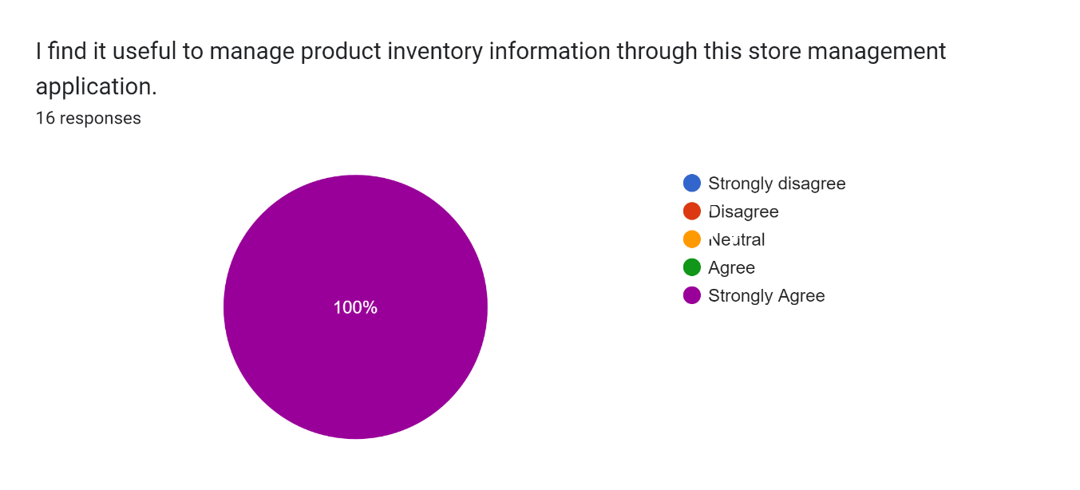

Figure 5.1 Level of agreement with the statement: It is useful to manage product inventory information

This pie chart in Figure 5.1 above represents the extent to which all participants agreed with the statement, “I find it useful to manage product inventory information through this store management application”. Here, we can clearly see that all participants strongly agreed with this statement. Therefore, we can conclude that most of the participants have positive experience in using the proposed application to manage the stock product information of the store, they are satisfied with the proposed application and believe that this application will be more helpful for more retail stores and customers.

#### Statement: “With this Smart Store management system, I can manage my stores more effectively”

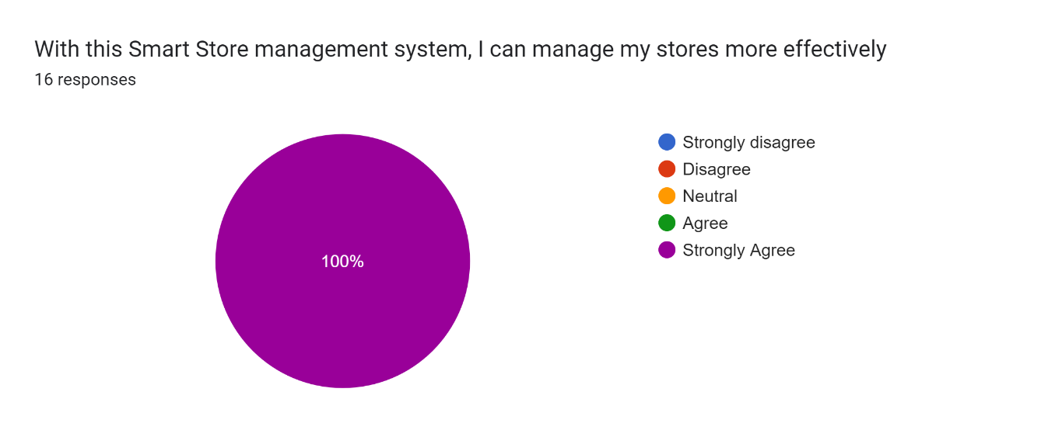

Figure 5.2 Level of agreement with the statement: It makes managing the store more efficient

This pie chart in Figure 5.2 above shows the extent to which all participants agreed with the statement “With this Smart Store management system, I can manage my stores more effectively”. Here, we can clearly see that all participants strongly agree with this statement. Therefore, we can conclude that all participants can use the proposed application to manage stores more effectively, which is in line with the aim of this project "Develop a web-based smart store management system to help retail store managers improve management efficiency and performance", which has been successfully developed and it also fulfills the overall user experience.

#### Statement: “Smart Store has added online channels to sell products, opening up new markets and customers for me”

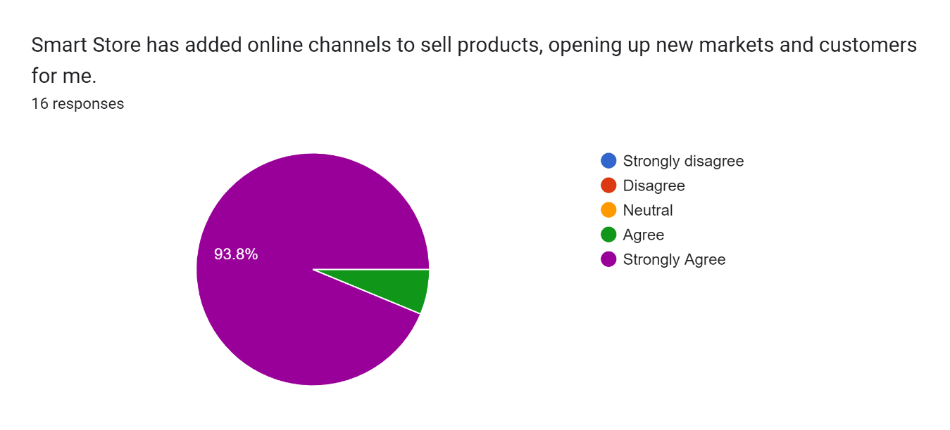

Figure 5.3 Level of agreement with the statement: It opened up new markets for me

This pie chart in Figure 5.3 above shows the extent to which all participants agree with the statement “Smart Store has added online channels to sell products, opening up new markets and customers for me”. Here we can clearly see that most of the participants strongly agree with this statement with 93.8%, while very few more or less agree and no respondents disagree. Thus from this chart, we can conclude that by using the proposed application, most of the retail store managers can sell their products through the online channel by using the proposed application, which makes the retail store sales channel less too homogeneous and it meets the goal of this project: by creating a combination of online and offline sales channels to address the limited number of customers that traditional offline retail stores can reach. The module has been successfully developed and has provided a positive user experience.

#### Statement: “The good user interface motivates me to use this Smart Store management application”

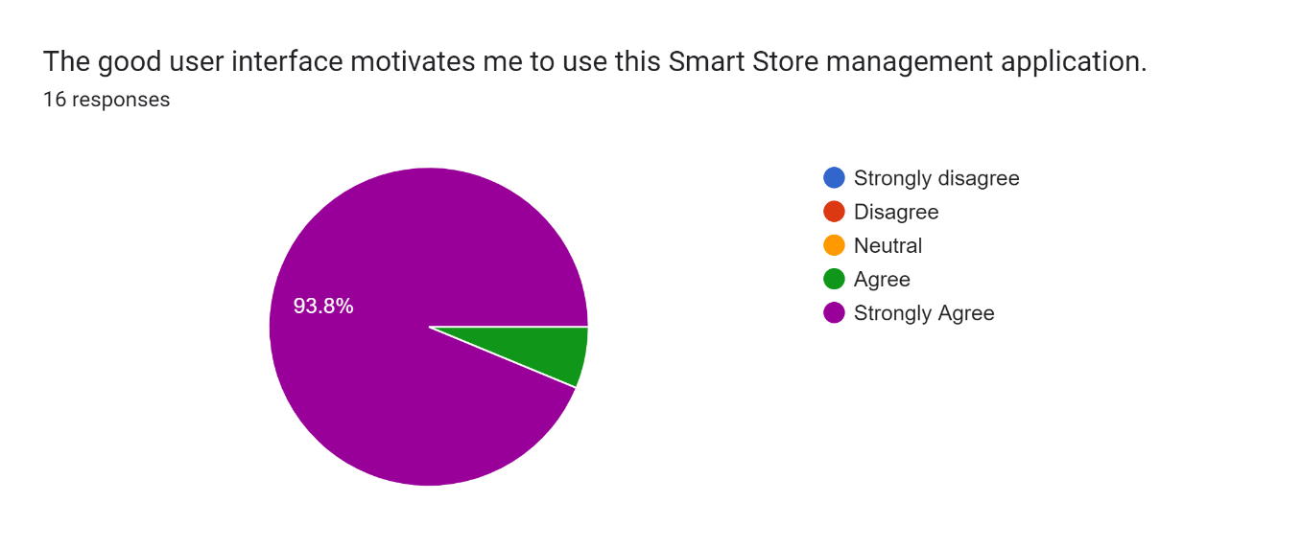

Figure 5.4 Level of agreement with the statement: Good user interface motivates me to use it

This pie chart in Figure 5.4 above represents the extent to which all participants agreed with the statement “The good user interface motivates me to use this Smart Store management application”. Here, we can clearly see that most of the participants strongly agreed with this statement, 93.8%, while very few more or less agreed and no respondents disagreed. So, from this chart, we can conclude that most of the participants are satisfied with the user interface of this store management application, and it has improved the overall experience of store managers while performing browsing and management operations, it helps the store manager or store owner to manage the store more easily by giving them a positive experience of using it.

### Effort Expectancy Data Collection

Effort Expectancy is used to investigate how to ease the system to be used and accepted by the individual.

#### Statement: “Using this store management application to manage the store is stress-free and it allows me to manage the store more easily”

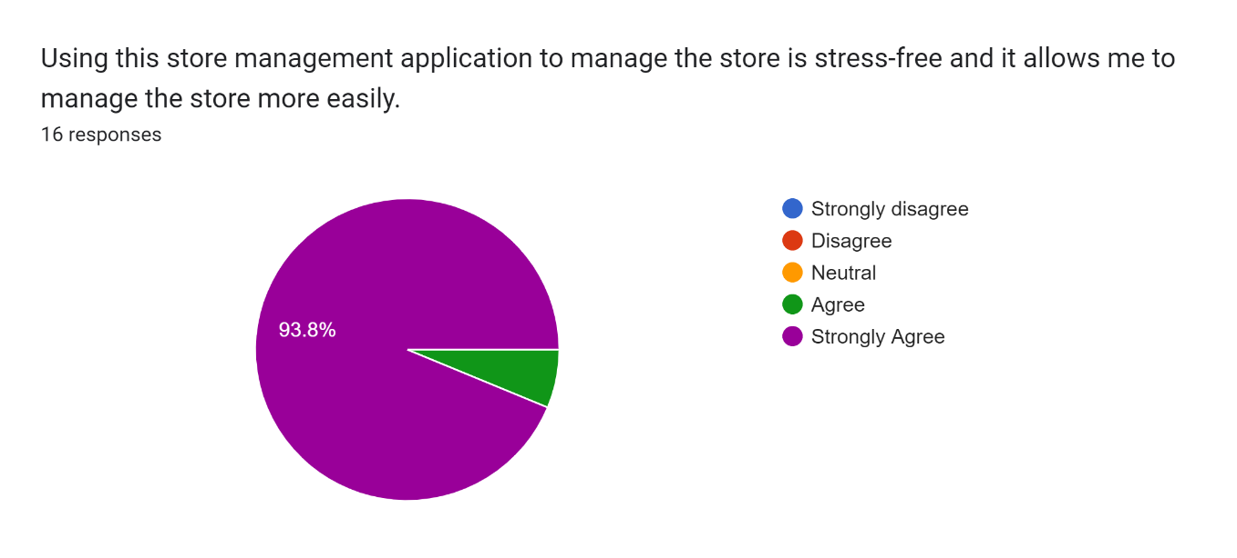

Figure 5.5 Level of agreement with the statement: It allows me to manage the store more easily

This pie chart in Figure 5.5 above represents the extent to which all participants agreed with the statement “Using this store management application to manage the store is stress-free and it allows me to manage the store more easily” to the extent that they agreed with the statement. Here we can clearly see that most of the participants strongly agreed with this statement with 93.8%, while very few more or less agreed and no respondent disagreed. So from this chart, we can conclude that most of the participants are satisfied with the proposed application and that managing the store through this store management application makes the flow of operations easier, which enhances the overall experience of the store manager when performing operations such as browsing and managing store information.

#### Statement: “I don't need a lot of technical knowledge to use this Smart Store management application”

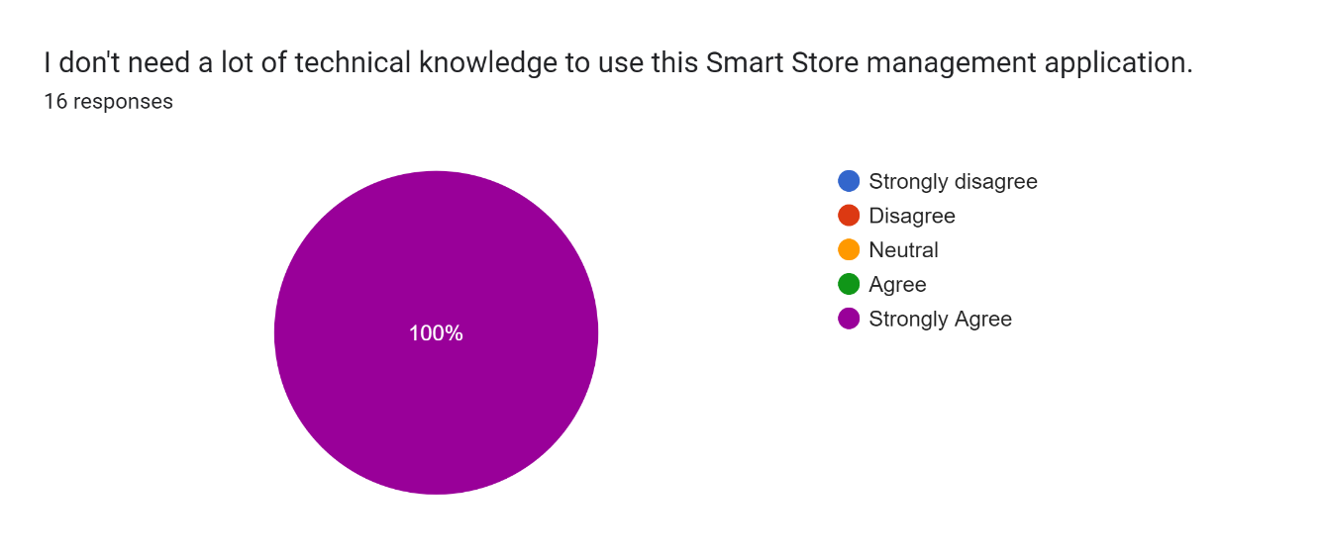

Figure 5.6 Level of agreement with the statement: It doesn’t require much technical knowledge to use it

This pie chart in Figure 5.6 above represents the extent to which all participants agreed with the statement “I don't need a lot of technical knowledge to use this Smart Store management application”. Here, we can clearly see that all participants strongly agreed with this statement with 100% and no respondents disagreed. Therefore, from this chart, we can see that most of the participants are very satisfied with the proposed application and because of the simplicity of the process, store managers do not need to learn a lot of additional technical knowledge to use this Smart Store management application to manage their stores, which not only improves the overall experience of store managers in managing store information, but also helps to improve the way store managers manage their stores more efficiently

#### Statement: “Using this Smart Store application can reduce the capital cost and labor cost of my store”

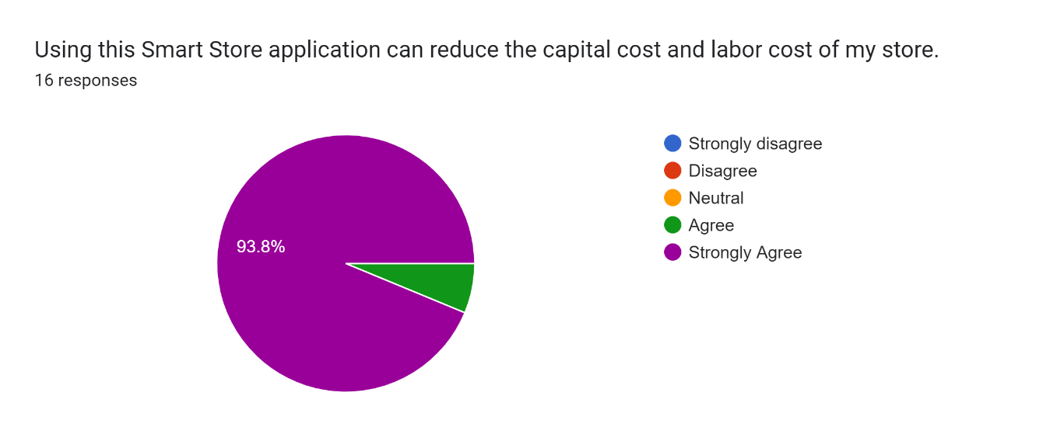

Figure 5.7 Level of agreement with the statement: It reduces capital costs and labor costs in the store

This pie chart in Figure 5.7 above represents the extent to which all participants agree with the statement “Using this Smart Store application can reduce the capital cost and labor cost of my store”. Here, we can clearly see that most of the participants strongly agreed with this statement, 93.8%, while very few more or less agreed and no respondents disagreed. So from this chart, we can conclude that most of the participants are satisfied with this store management application and it also meets the goal of this project which is to design a combined online and offline store management system to solve the high operational cost problem of retail stores. Because it can effectively help stores to reduce the cumbersome business, make the process of operation simpler, reduce the capital cost and labor cost of retail operation, and make it possible for retail managers or store owners to accomplish simpler and more effective store management through this application.

#### Statement: “Smart Store gives me a very good experience of using it”

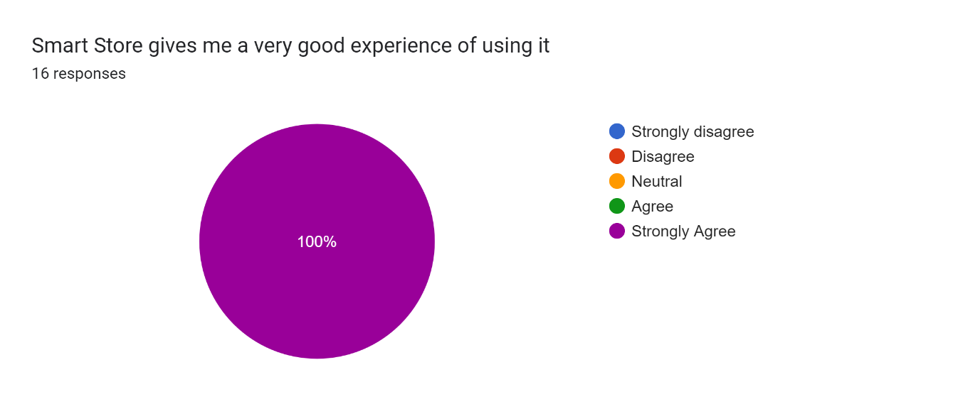

Figure 5.8 Level of agreement with the statement: It gives me a very good experience using it

This pie chart in Figure 5.8 above represents the extent to which all participants agree with the statement “Smart Store gives me a very good experience of using it”. Here we can clearly see that all participants strongly agree with this statement with 100% and no respondent disagrees. Therefore, from this chart, we can conclude that most of the participants are satisfied with this store management application and that the system has been successfully developed and it has successfully improved the overall experience of store managers in conducting store management operations, and through this application, it has made it easier for store managers or store owners to manage their stores, and it is believed that the application will be more helpful to more retail stores and customers in the future.

### Facilitating Conditions Data Collection

Facilitating conditions is used to find an influence on the usage of the application is important to help and support the organizations to manage the activity.

#### Statement: “I find it very convenient and easy to manage the store through this store management application”

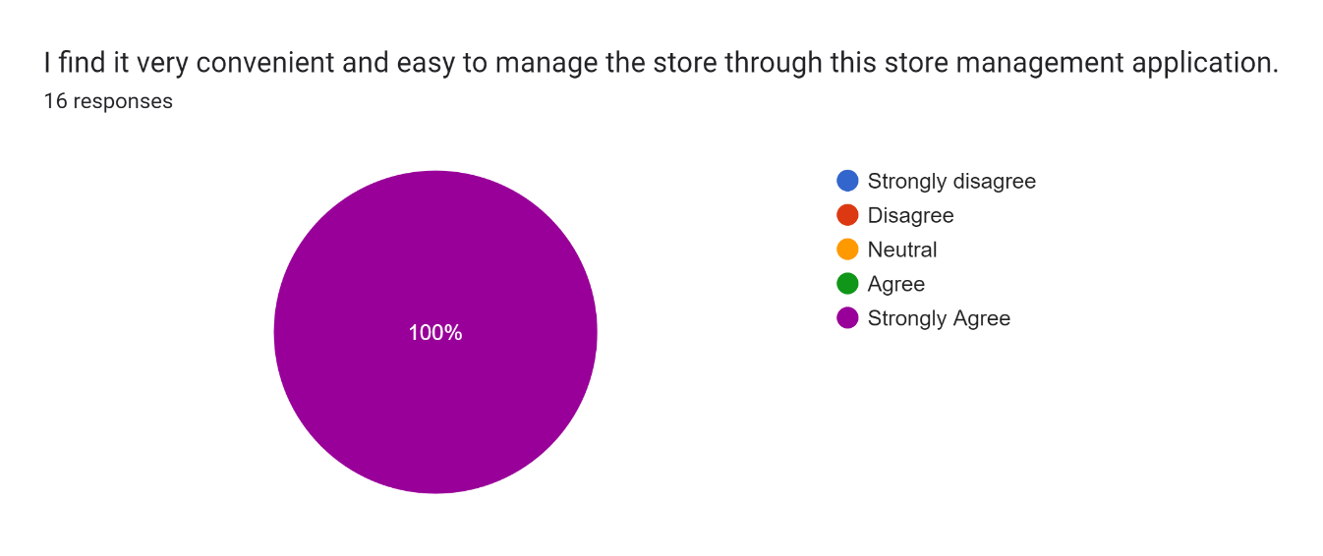

Figure 5.9 Level of agreement with the statement: It is easy to manage the store through this system

This pie chart in Figure 5.9 above represents the level of agreement of all participants with the statement “I find it very convenient and easy to manage the store through this store management application”. Here we can clearly see that all participants strongly agreed with this statement with 100% and no respondent disagreed. Therefore, from this chart, we can conclude that most of the participants are satisfied with this store management application and the system has been successfully developed and it meets the original purpose of this project to make it easier for store managers or store owners to manage their stores through this application.

#### Statement: “With this store management application, I can quickly and easily know the status of my store”

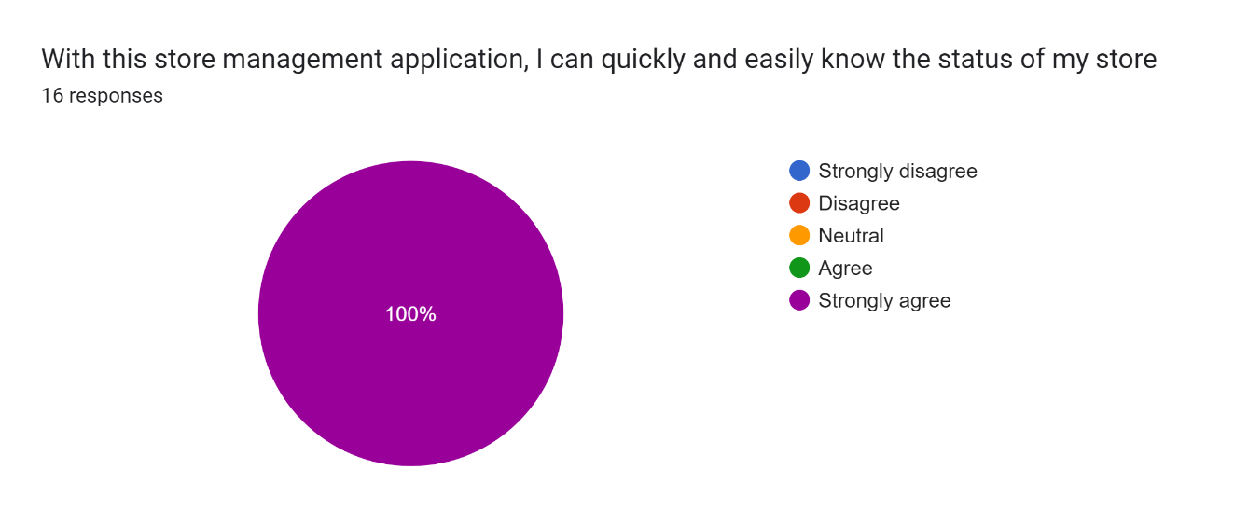

Figure 5.10 Level of agreement with the statement: I can quickly see the status of the store

This pie chart in Figure 5.10 above represents the extent to which all participants agreed with the statement “With this store management application, I can quickly and easily know the status of my store”. Here, we can clearly see that all participants strongly agree with this statement with 100% and no respondent disagrees. So, from this chart, we can conclude that with the proposed application, most retail store managers can quickly and easily know the status of their stores by using the proposed application, which makes it easier for merchants to manage their stores, easier to operate and have a clearer picture of their stores. By developing store sales statistics module and product statistics module, store data can be counted, store data can be monitored in real time, and suggestions can be given to merchant stores through analysis, all of which help merchants to manage their stores more easily or make improvements to their stores, which is important to improve the efficiency of store management.

### The Summary of The Survey Result

Based on this survey, we can conclude that most store managers are very satisfied with this proposed application to manage stores, through this store management application to help them achieve effective management of store order information, purchase information, inventory information and user information, etc. This is in line with the aim of this project, “Develop a web-based intelligent store management system to help retail store managers to improve management efficiency and performance,” and the survey results also showed that it improved the overall experience of store managers when performing browsing and management operations through a good user interface, helping them to manage their stores more easily. In addition, the survey results also showed that Smart Store helped retail store managers to be able to sell their products through online channels by adding channels to sell products online, and it made the retail store's sales channels less homogeneous, solving the problem of the limited number of customers that traditional retail stores can reach. Finally, after comparing each of the objectives of this project and each of the results achieved, it can be concluded that all the objectives of this project have been successfully achieved, the system has been successfully developed and it meets the overall user experience.

## Chapter Summary

In summary, this chapter evaluates each of the work done to complete the project, and in the System Testing & Test Cases, all the necessary tests were performed to ensure the quality of the developed application. In the Performance Evaluation & User Experience Survey, 16 users were invited to participate in the user experience survey to ensure that the proposed application was developed to meet the needs of the end-users. The results of the user experience survey were summarized by comparing the project objectives with each of the results achieved to ensure that the application was indeed developed in accordance with the objectives of this project, and finally, the chapter was concluded here.

# CHAPTER 6: CONCLUSION AND RECOMMENDATION

## Chapter Introduction

This chapter summarizes the contributions of this project, the limitations of the study, and recommendations for future work. The Conclusions & Contributions are included in Section 6.1, while the Limitations of The Study are included in Section 6.2. Section 6.3 is the Future Works, and Section 6.4 covered Chapter Summary.

## Conclusion & Contributions

In recent years, with the continuous development of computer technology and network technology, more and more stores are gradually adopting information management in order to achieve effective management of merchandise, inventory and sales in stores. According to the survey, most retail business managers or store owners want a better tool to help them achieve effective management of their stores to improve store management efficiency and performance. In addition, they also want their stores to be able to sell products through online channels. However, there are still some traditional retail stores that operate mostly with manual labor, and with store rent and labor costs rising year by year, coupled with the impact of Internet e-commerce, the customer traffic of physical stores is getting less and less.

For all these problems, the development of this project will be of great help to them, enabling store managers to synchronize online and offline merchandising and develop marketing strategies that maximize results, which will not only provide store customers with more choices of purchasing methods, but also help increase store sales and profits. In addition, this study identified the limitations of existing store management applications, after which solutions were generated to address these limitations. By improving the existing system, the store management system developed in this study has not only the basic functions of store management, but also can manage store department information, inventory information, order information, and staff information at the same time, in addition, the system has convenient system management tools, such as users can create new menus or catalogs, and store managers can leave messages with store customers through the message management function, which these functions can help the merchants to improve the efficiency of store management, which are the intelligent aspects of the store management system.

Finally, it can be said that the system has been developed throughout the various phases of the project, making it effective in establishing and achieving the main goals of the project. The main objective was to develop a web-based intelligent store management system application that would enable store managers to achieve effective management of their stores. For the proposed application has been implemented in a web-based platform and is compatible with Chrome, Microsoft Edge and other major browser applications. Although it is not perfect, it has successfully met all the objectives and improved the user experience according to the feedback from the participants who took part in the user acceptance tests. The proposed application can be further developed and enhanced in the future.

## The Limitations of The Study

The proposed application is not perfect due to some limitations of this study. First is the time constraint, developers can only have limited time to do research and learn the knowledge and skills required to develop a proposed application, this leads to some problems for the developers to implement all the features of the proposed application.

Also, due to cost constraints, the project will not be developed on any high specification physical server and the web application developed is using only normal PC as the base server for the application, the website occupies too much CPU and load which will lead to slow opening of the website.

In addition, there are some system limitations in the development of the proposed application, namely, the application does not support a multilingual and multi-currency interface, the operation of the application requires a client device connected to the Internet for access, and a browser application with the ability to receive data from the server.

Finally, there were some limitations also suggested by some participants. In the proposed application, there was sometimes a delay in page jumps in the product list management. In addition, the process of uploading products is a bit cumbersome, and it does not support store administrators to import and upload products in batches. In addition, there is no function to forget the password in the backend management interface, which can cause some trouble for store administrators if they forget the password.

## Future Works

Although the Smart Store Management System developed in this project has received high satisfaction from many users who use it, it could be improved by developing more features to get better. First, future researchers may continue this research and since the proposed application is a web-based application, it can be improved to be compatible with browsers of cell phones or tablet devices rather than just PC browsers, and by being compatible with devices of various screen sizes, the proposed application will be more attractive to the target users. Second, future researchers may continue this project by developing multilingual and multi-currency interfaces, which will lead to an increase in the number of users using the proposed application in different countries or regions, thus attracting the attention of more potential users. Third, future researchers may continue this research to improve and enhance the process of uploading data in the proposed application and support administrators to batch import data such as employee information, department information, product information, and order information into the system, as well as batch export data as Excel file format to the device for more flexible and convenient visual browsing of store details by users.

## Chapter Summary

In summary, this chapter describes the conclusions and contributions of this project. This chapter also discusses some of the limitations of this study, which suggest future work for future researchers to further improve the proposed system in the future.

# REFERENCES

1. B. Berman, J. R. Evans, and P. Chatterjee, *Retail management: A strategic approach*. Pearson Education Limited, 2018.
2. Y. Yin, R. Zhang, H. Gao, and M. J. I. T. o. C. S. S. Xi, "New retail business analysis and modeling: A Taobao case study," vol. 6, no. 5, pp. 1126-1137, 2019.
3. M. Hänninen, S. K. Kwan, L. J. T. I. R. o. R. Mitronen, Distribution, and C. Research, "From the store to omnichannel retail: looking back over three decades of research," vol. 31, no. 1, pp. 1-35, 2021.
4. S. Wang, Y. J. G. Zhang, and Change, "The new retail economy of Shanghai," vol. 36, no. 1, pp. 41-73, 2005.
5. S. Mou, D. J. Robb, and N. J. E. J. o. O. R. DeHoratius, "Retail store operations: Literature review and research directions," vol. 265, no. 2, pp. 399-422, 2018.
6. V. Shankar *et al.*, "How technology is changing retail," vol. 97, no. 1, pp. 13-27, 2021.
7. J. J. A. S. Gregory, "The Internet of Things: revolutionizing the retail industry," pp. 1-8, 2015.
8. N. Wadhawan and A. J. I. J. o. R. R. A. Seth, "Technology Revolutionizing Retail Practices in Digital Era," vol. 2, no. 1, pp. 60-62, 2016.
9. S. J. L. L. T. Luce, "Revolutionizing Retail: Workers, Political Action, and Social Change by Kendra Coulter," vol. 75, no. 1, pp. 265-266, 2015.
10. K. Willems, N. Verhulst, and M. Brengman, "How COVID-19 could accelerate the adoption of new retail technologies and enhance the (E-) servicescape," in *The Future of Service Post-COVID-19 Pandemic, Volume 2*: Springer, 2021, pp. 103-134.
11. J. Ilias *et al.*, "At-Thoyyib Shop Inventory Management System," vol. 2, no. 2, pp. 12-16, 2018.
12. R. Tanamal, Y. Nurdiansyah, and F. Firdaus, "Inventory Support System for Retail Shop," in *E3S Web of Conferences*, 2020, vol. 188, p. 00020: EDP Sciences.
13. G. D. Jyothi and K. Navya, "Design and implementation of a store management system," in *2017 International Conference on Intelligent Sustainable Systems (ICISS)*, 2017, pp. 1149-1151: IEEE.
14. F. Wei and Q. Zhang, "Design and implementation of online shopping system based on B/S Model," in *MATEC Web of Conferences*, 2018, vol. 246, p. 03033: EDP Sciences.
15. M. A. Rahim and R. Ara, "Implementation of Point of Sale Software in Mobile Shop."
16. D. Wang, Y. Yang, and Y. J. J. o. A. T. Wang, "Optimization of Distribution Path considering Cost and Customer Satisfaction under New Retail Modes," vol. 2021, 2021.
17. J. W. J. P. P. S. Knopf and Politics, "Doing a literature review," vol. 39, no. 1, pp. 127-132, 2006.
18. G. Raj, D. Singh, and A. Bansal, "Analysis for security implementation in SDLC," in *2014 5th International Conference-Confluence The Next Generation Information Technology Summit (Confluence)*, 2014, pp. 221-226: IEEE.
19. "UCSI University Object-Oriented Modeling, 2020. Object-Oriented Modeling Lecture Slide Chapter 2. p.1-24.."
20. S. Balaji, M. S. J. I. J. o. I. T. Murugaiyan, and B. Management, "Waterfall vs. V-Model vs. Agile: A comparative study on SDLC," vol. 2, no. 1, pp. 26-30, 2012.
21. A. I. Anton, "Goal-based requirements analysis," in *Proceedings of the second international conference on requirements engineering*, 1996, pp. 136-144: IEEE.
22. P. Le Guernic, J.-P. Talpin, J.-C. J. J. o. C. Le Lann, Systems,, and Computers, "Polychrony for system design," vol. 12, no. 03, pp. 261-303, 2003.
23. P. Ragunath, S. Velmourougan, P. Davachelvan, S. Kayalvizhi, R. J. I. J. o. C. S. Ravimohan, and N. Security, "Evolving a new model (SDLC Model-2010) for software development life cycle (SDLC)," vol. 10, no. 1, pp. 112-119, 2010.
24. P. Ammann and J. Offutt, *Introduction to software testing*. Cambridge University Press, 2016.
25. S. Georgiou, S. Rizou, and D. J. A. C. S. Spinellis, "Software development lifecycle for energy efficiency: techniques and tools," vol. 52, no. 4, pp. 1-33, 2019.
26. C. Gupta, P. R. Inácio, M. M. J. J. o. K. S. U.-C. Freire, and I. Sciences, "Improving software maintenance with improved bug triaging," 2021.
27. D. Tesch, T. J. Kloppenborg, and M. N. J. J. o. c. i. s. Frolick, "IT project risk factors: the project management professionals perspective," vol. 47, no. 4, pp. 61-69, 2007.
28. *"THE 17 GOALS | Sustainable Development", Sdgs.un.org, 2022.* Available: https://sdgs.un.org/goals
29. *Ts.4thservice.org. 2022. Beijing Zhongke Zhuoxin Software Testing Technology Center, Details of Service Providers*. Available: http://ts.4thservice.org/portal/vipAndSolution/detail/e2dec50d6aca4a28916e18dfffe0c9c6/1
30. S. Burt, L. J. J. o. R. Sparks, and C. services, "E-commerce and the retail process: a review," vol. 10, no. 5, pp. 275-286, 2003.
31. S. Helm, S. H. Kim, S. J. J. o. R. Van Riper, and C. Services, "Navigating the ‘retail apocalypse’: A framework of consumer evaluations of the new retail landscape," vol. 54, p. 101683, 2020.
32. J. Weltevreden, O. Atzema, and R. J. J. o. U. T. Boschma, "The adoption of the Internet by retailers: A new typology of strategies," vol. 12, no. 3, pp. 59-87, 2005.
33. I. MacKenzie, C. Meyer, and S. Noble, "How retailers can keep up with consumers. McKinsey & Company," ed, 2013.
34. X. X. G. Chen, "From Omni-Channel to Unmanned Retail: a Discussion on the Intelligent Development of New Retail," no. 6, pp. 33-36, 2019.
35. C. Liu, "Retail channel strategies of traditional retailers in response to competition from pure online retailers," 2019.
36. L. Zhu and X. D. Z. W. Y. Tian, "Analysis on China's Traditional Retail Model," in *6th International Conference on Economics, Management, Law and Education (EMLE 2020)*, 2021, pp. 140-143: Atlantis Press.
37. T. J. E.-I. Gillpatrick and E. Research, "The Digital Transformation of Marketing: Impact on Marketing Practice & Markets," vol. 7, no. 2, pp. 139-156, 2019.
38. D. W. Wallace, J. L. Giese, and J. L. J. J. o. r. Johnson, "Customer retailer loyalty in the context of multiple channel strategies," vol. 80, no. 4, pp. 249-263, 2004.
39. C. Forman, A. Ghose, and A. J. M. s. Goldfarb, "Competition between local and electronic markets: How the benefit of buying online depends on where you live," vol. 55, no. 1, pp. 47-57, 2009.
40. H.-H. Lee and J. J. J. o. M. C. Kim, "Investigating dimensionality of multichannel retailer's cross-channel integration practices and effectiveness: shopping orientation and loyalty intention," vol. 17, no. 4, pp. 281-312, 2010.
41. G. Wang and Z. Qiu, "Comparison and Collaborative Path Selection between Online and Physical Retailing of Retail Enterprises," vol. 33, no. 4, pp. 110-113, 2012.
42. R. Du and K. Jiang, "New Retailing: Connotation, Development Impetus and Key Problems," *Price:Theory & Practice,* 2018.
43. S. Zhao and X. Xu, "The Meaning, Model and Development Path of "New Retail"," *China Circulation Economy,* 2020.
44. R. Liu, "Introduction to the Development of "New Retail" Industry and Development Countermeasures," *Modern Economic Information,* 2019.
45. C. Han and B. Wang, "Research Status and Trends of "New Retail"," *China Distribution Economy,* 2018.
46. S. Wang and J. Yu, "Research Review and Prospect of China's "New Retail"," *Science and Technology Management,* 2020.
47. X. Hu, M. Wang, and Y. Sun, "The overviews on operation management for the new retail mode of online and offline integration," *Systems Engineering Theory and Practice,* 2020.
48. iQmetrix. (2022). Intelligent Retail Built for Telecom. Available at: https://www.iqmetrix.com/.
49. Retailpro.com (2022). *Build data-driven operations with Retail Pro*. Available at: https://www.retailpro.com/
50. P. RESEARCH. (2022). *B2B Reviews, Buying Guides & Best Practices. 2022. Top 7 Retail Management Software in 2022 - Reviews, Features, Pricing, Comparison - PAT RESEARCH: B2B Reviews, Buying Guides & Best Practices.* Available: https://www.predictiveanalyticstoday.com/top-retail-management-software/
51. ChainDrive.com. 2022. Retail Management Software : Scale your retail success with chaindrive. Available at: https://chaindrive.com/
52. P. RESEARCH. (2022). *B2B Reviews, Buying Guides & Best Practices. 2022. ChainDrive in 2022 - Reviews, Features, Pricing, Comparison - PAT RESEARCH: B2B Reviews, Buying Guides & Best Practices*. Available: https://www.predictiveanalyticstoday.com/chaindrive/
53. Spring-board.info. (2022). *Retail intelligence and shopper analytics.* Available at: https://www.spring-board.info/

# APPENDIX Ⅰ:

**Pre-Development Survey:**

**Survey on Store Managers’ Opinions on Retail Store Management System Development Requirements**

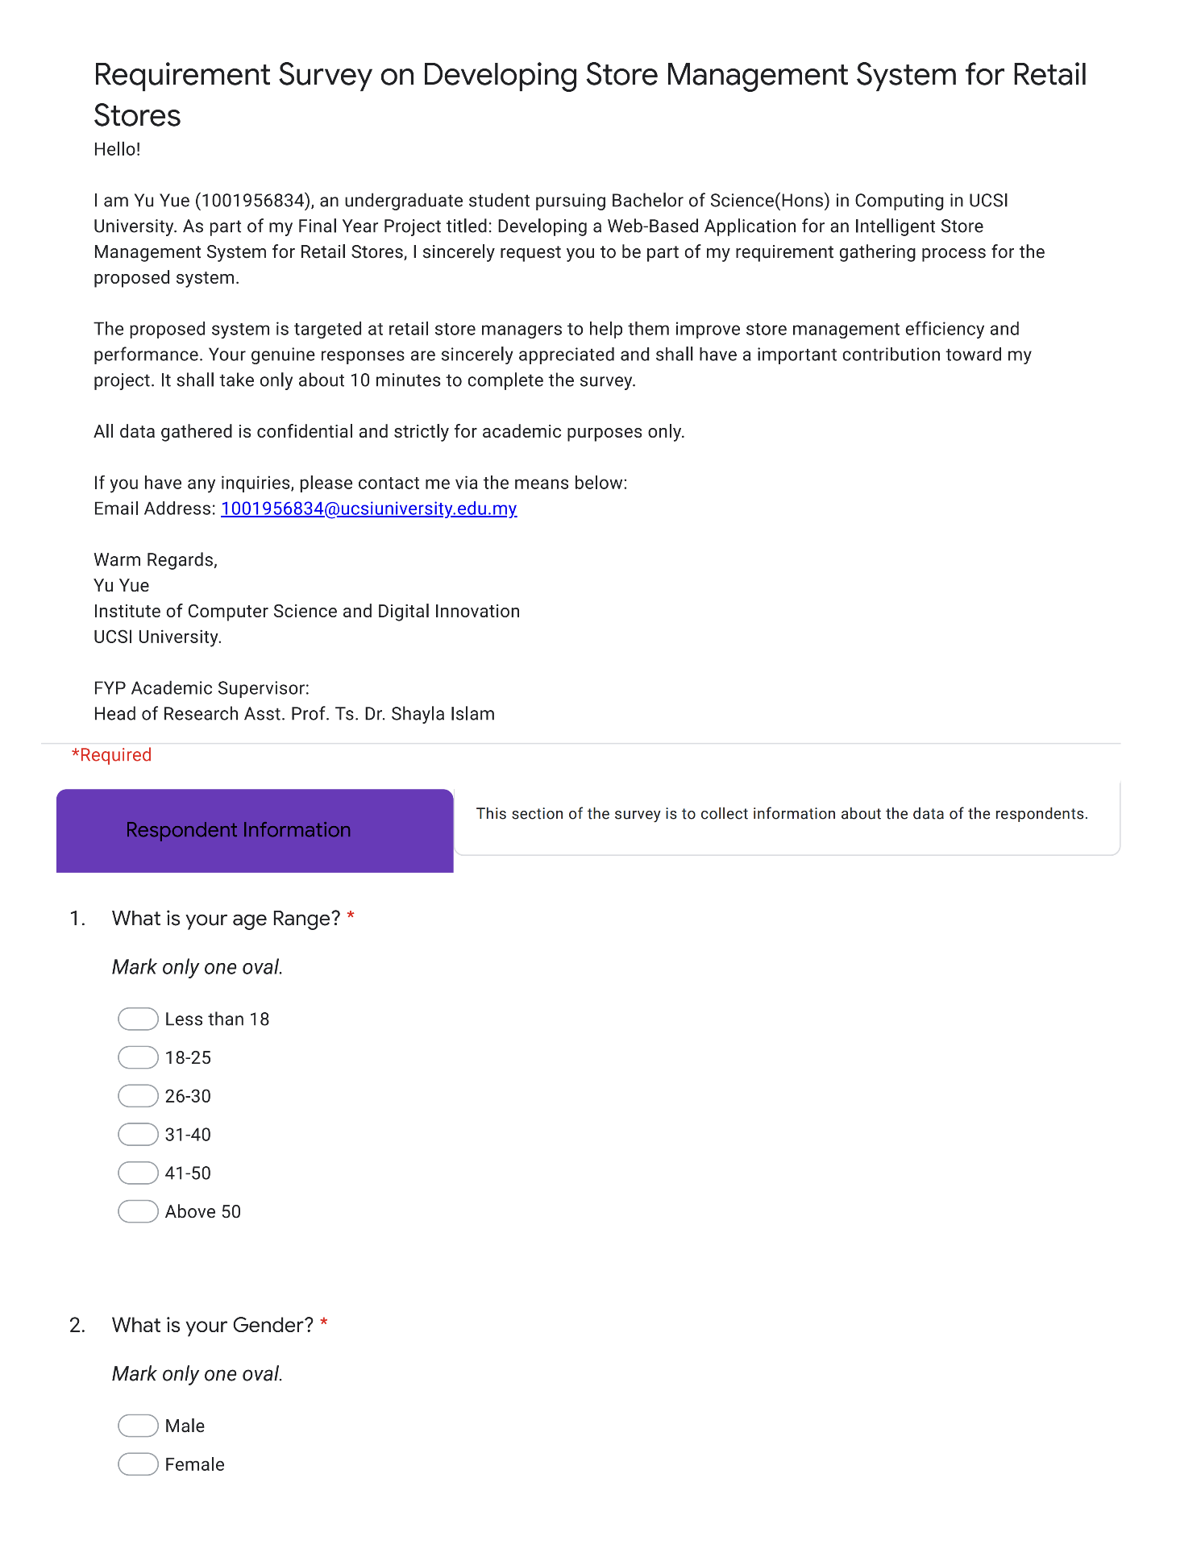

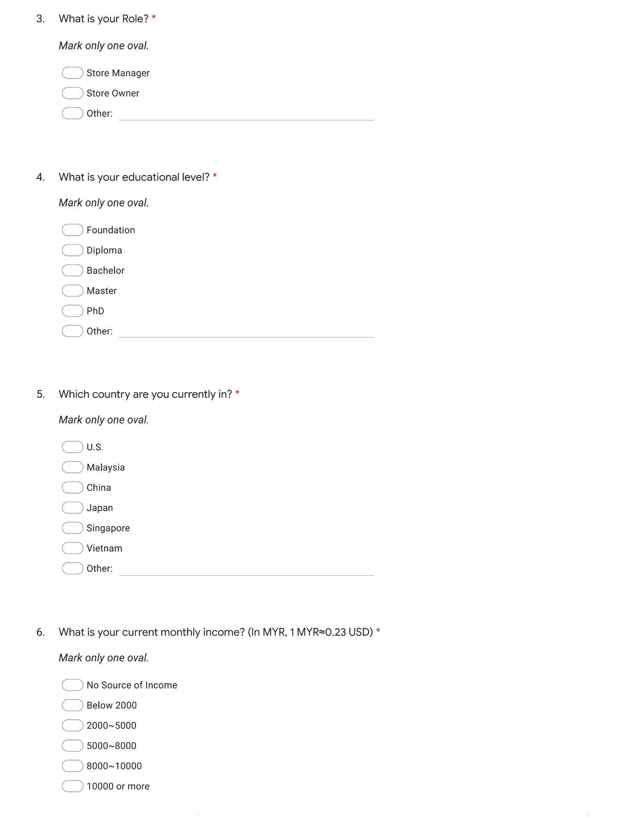

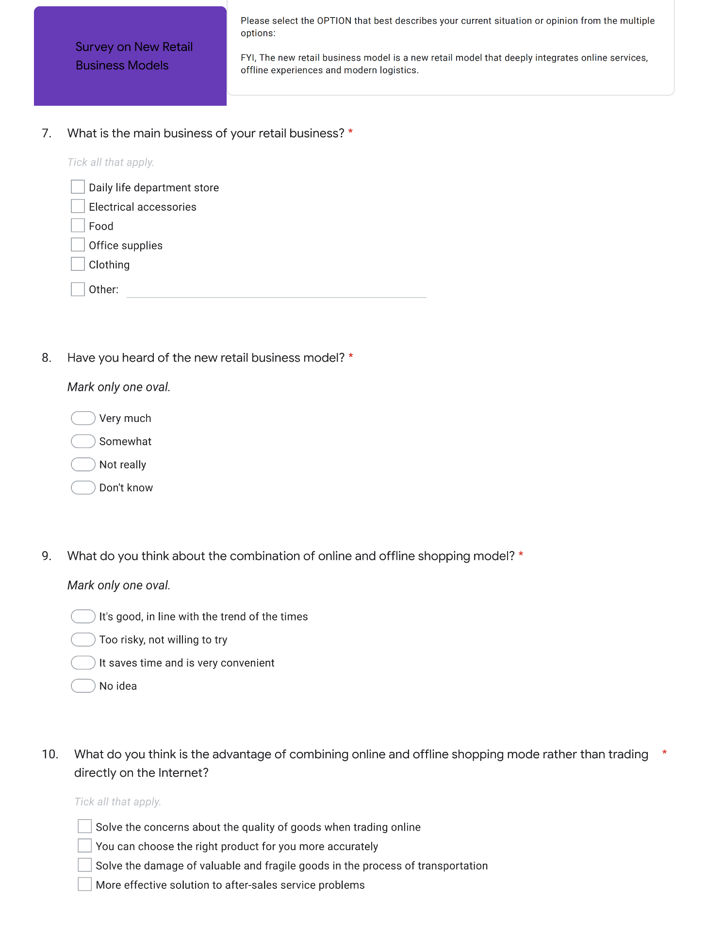

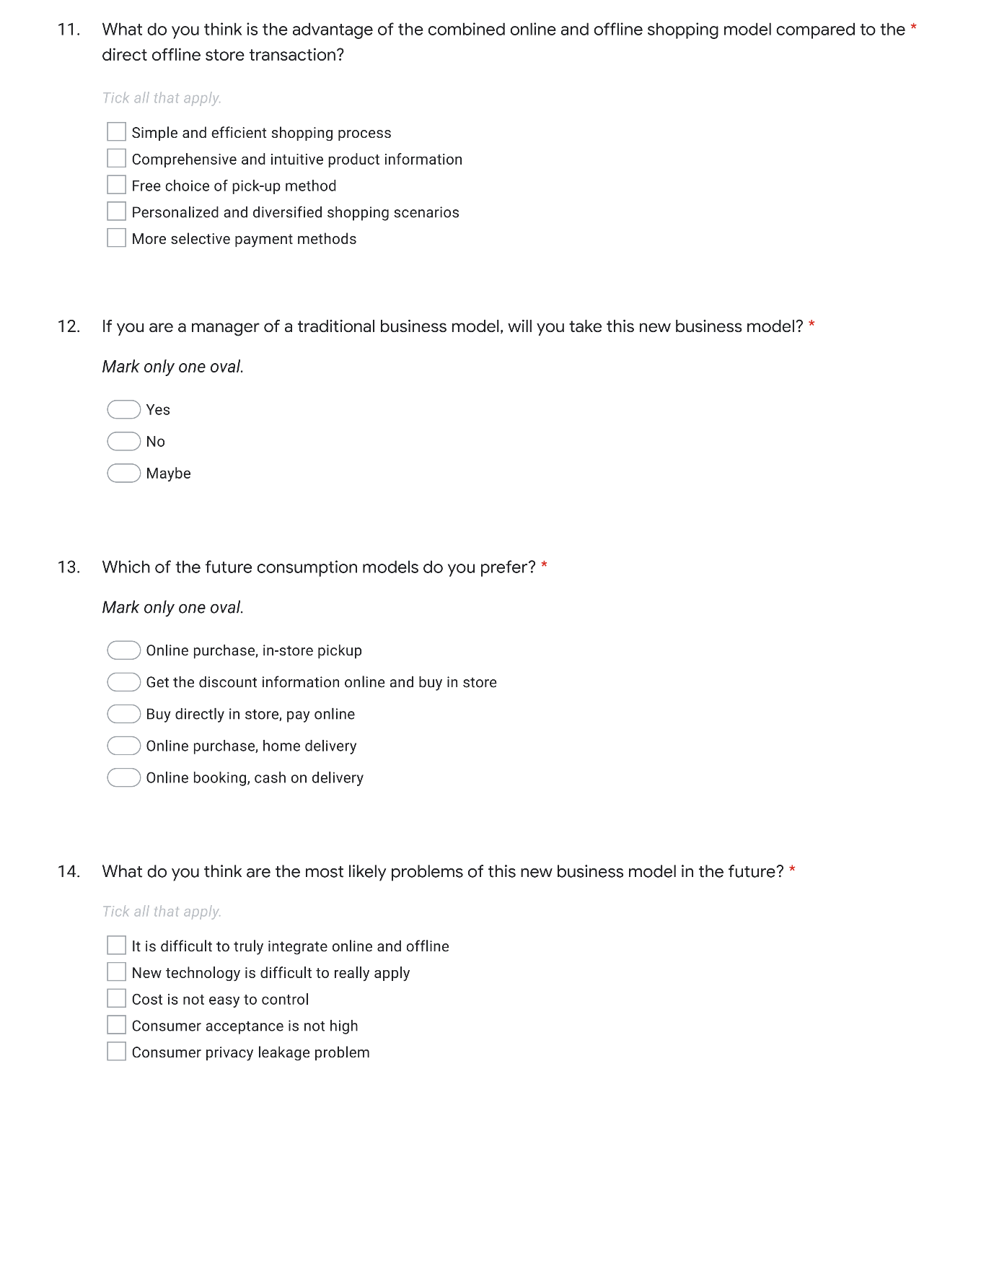

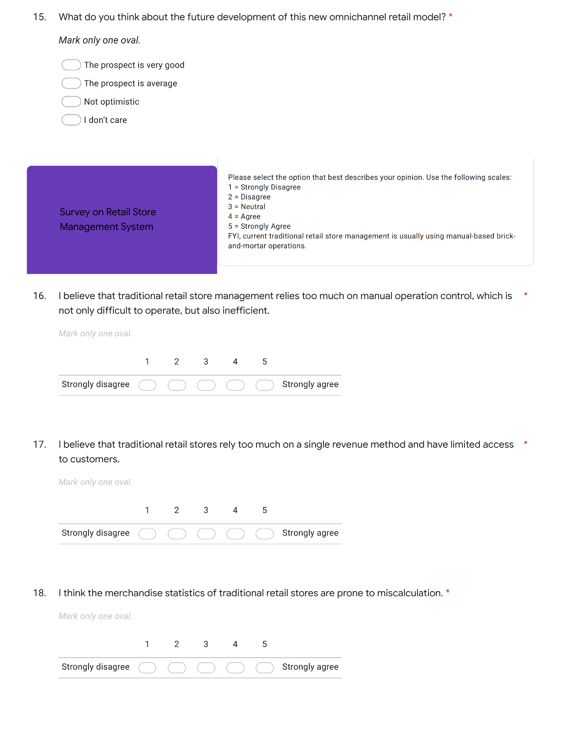

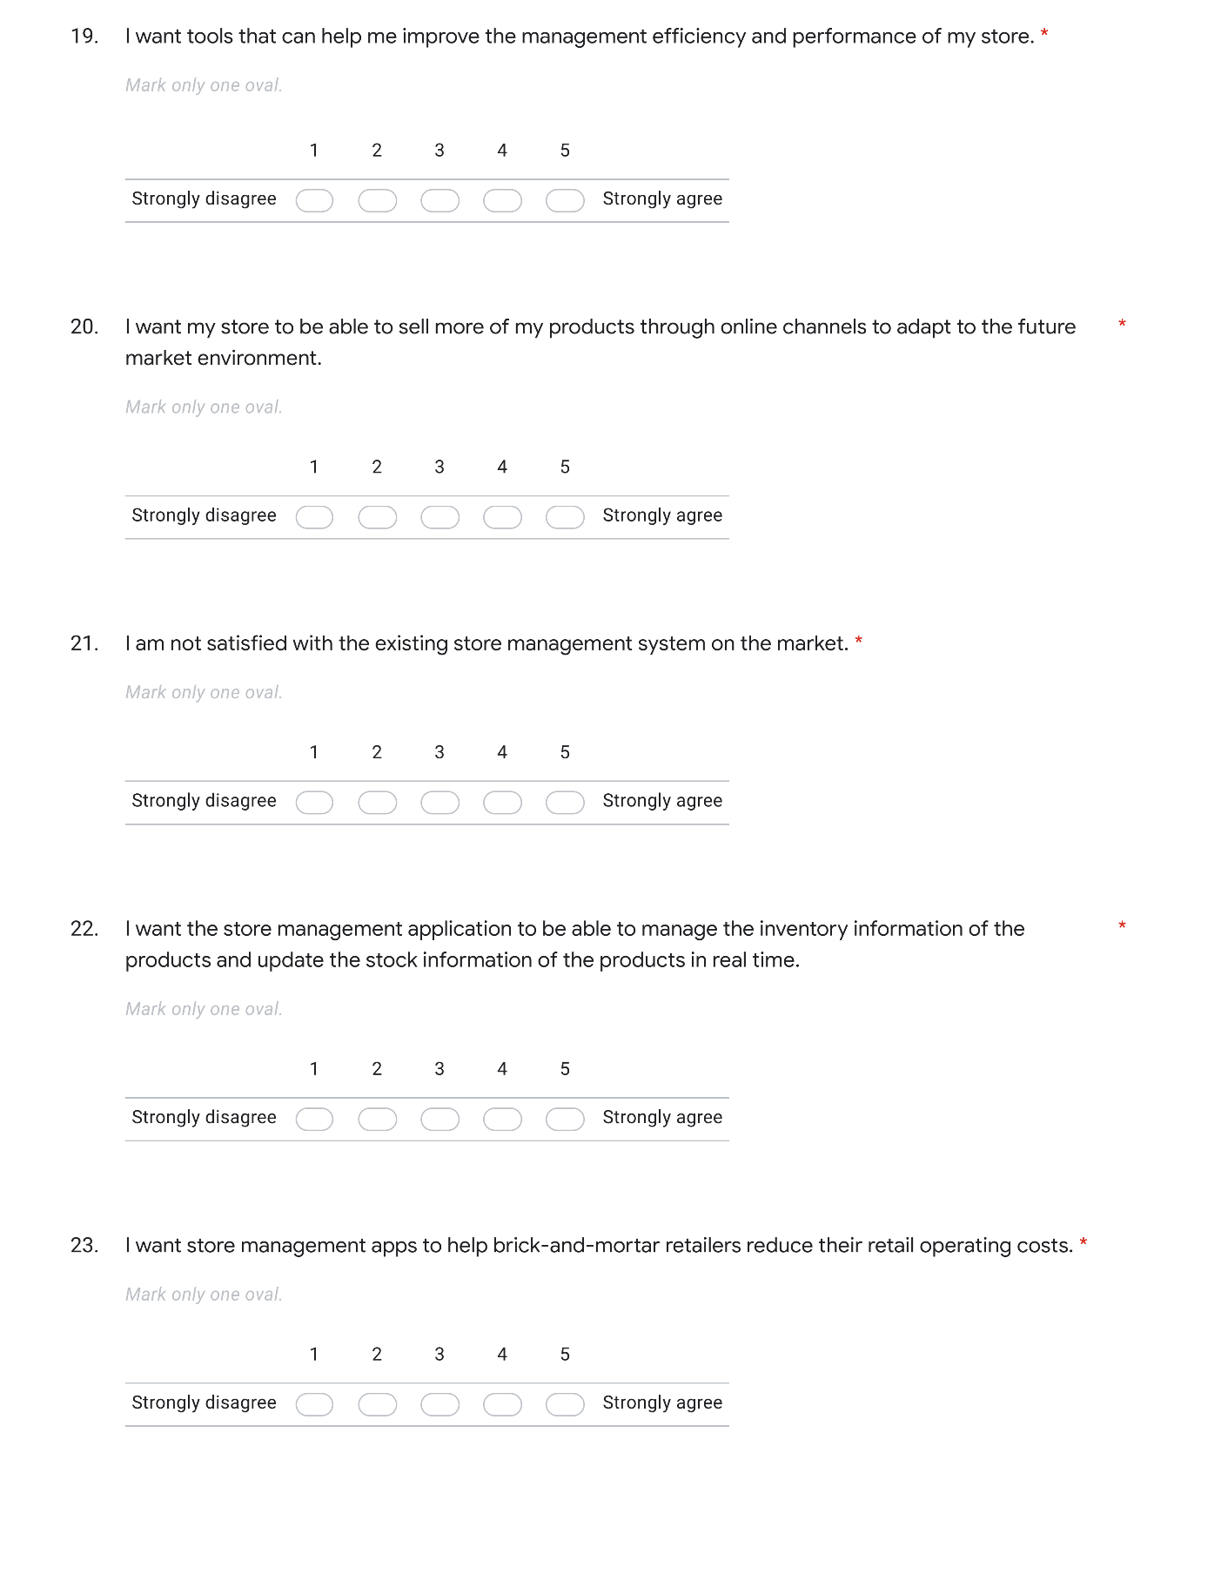

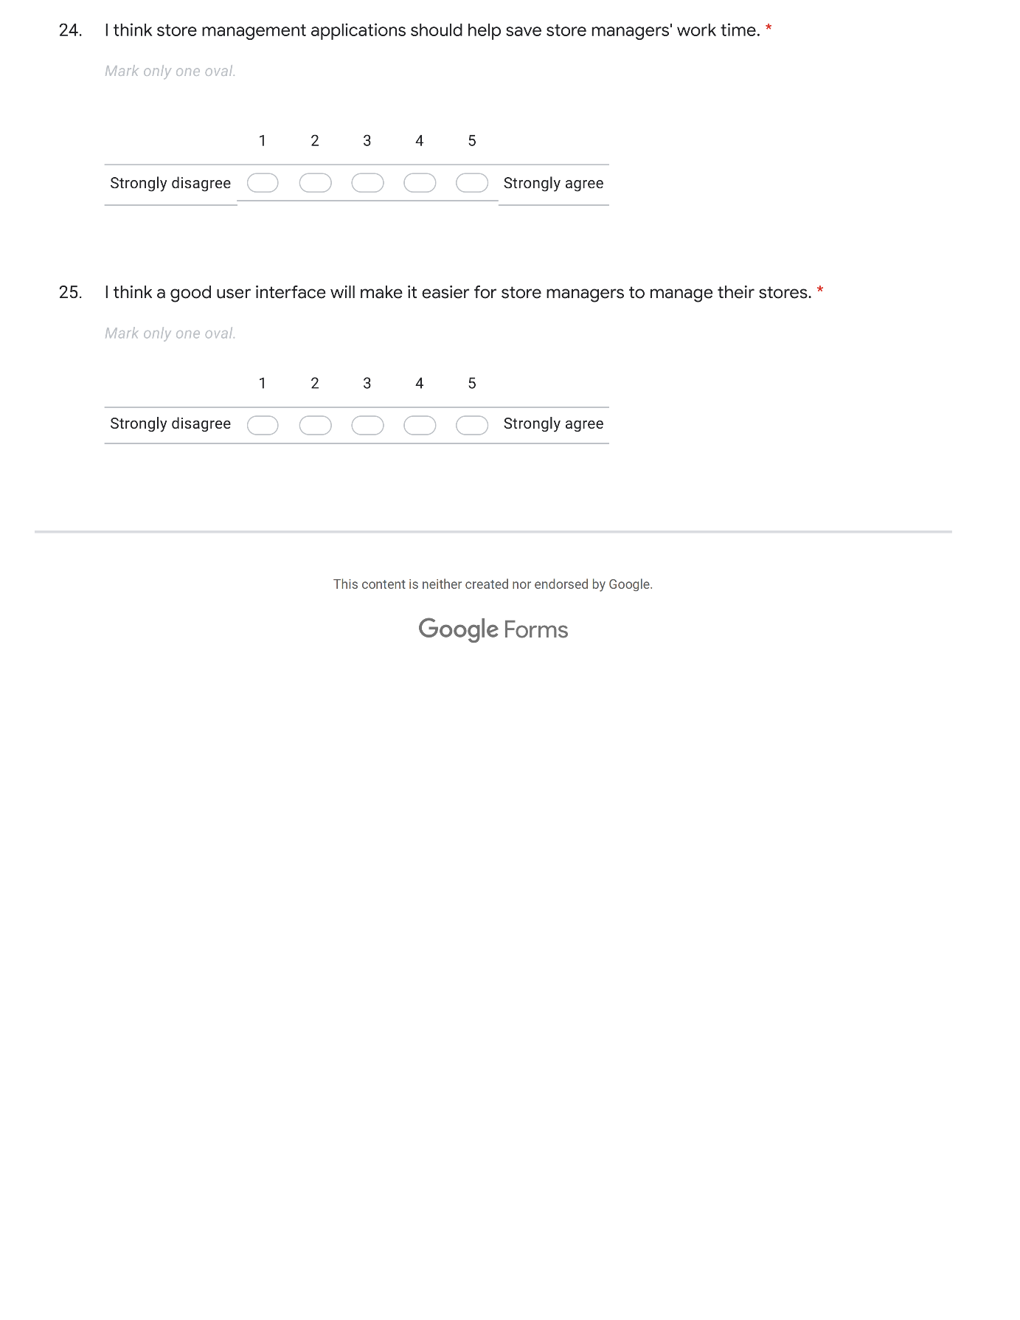

# APPENDIX Ⅱ:

**Post-Development Survey:**

**Performance Evaluation & User Experience Feedback on the Web-based Retail Store Management System**

